L21 – Worksheet – Solving Quadratic Equations /24 marks
Part 1a – Finding Zeroes in Standard Form using Factoring
Q1: With the equation $f\left(x\right)=2x^{2}+4x-6$, the zeroes are located at x₁ = -a and x₂ = b, where a and b are ___ and ___.
(Record your two-digit answer in the Numerical Response boxes below)

Q2: With the equation $y=2x^{2}-3x-9$, the zeroes are located at x₁ = $-\frac{a}{b}$ and x₂ = c, where a, b, and c are ___, ___, and ___.
(Record your three-digit answer in the Numerical Response boxes below)

Part 1b – Solving Equations in Standard Form using Factoring
Q3: Solve $x^{2}=2x+15$ using factoring. (1 mark) Q4: Solve $x^{2}+x=6$ using factoring. (1 mark)

Part 2a – Finding Zeroes in Vertex Form
Q5: Determine the zeroes of the function $f\left(x\right)={\left(x-2\right)}^{2}-6$ algebraically. (1 mark)

Q6: Convert the equation $y=-\frac{1}{2}x^{2}+2x+1$ to vertex form, and determine the zeroes algebraically. (2 marks)

Part 2b – Solving Equations by Converting to Vertex Form Completing the Square
Q7: Solve $2x+5=x^{2}$ by completing the square. (2 marks)

Q8: Solve $\frac{1}{2}x^{2}+3x=2$ by completing the square. (2 marks)

Part 3a – Finding Zeroes in Standard Form using Quadratic Equation
Q9: Determine the zeroes of the function $f\left(x\right)=2x^{2}+4x-1$ using the Quadratic Equation. Give your answer as an exact value. (2 marks)

Q10: Determine the zeroes of the function $f\left(x\right)=-3x^{2}-5x+6$ using the Quadratic Equation. Give your answer as an exact value. (2 marks)

Part 3b – Solving Equations in Standard Form using Quadratic Equation
Q11: Solve the equation $2x^{2}+4x=6$ using the Quadratic Equation. (2 marks)

Q12: Solve the equation $5x^{2}=x+2$ using the Quadratic Equation. (2 marks)

Part 4a – Finding Zeroes using Graphing
Q13: Determine the zeroes (approximate value) of the function $y=x^{2}-3x-6$ by graphing the function. (2 marks)
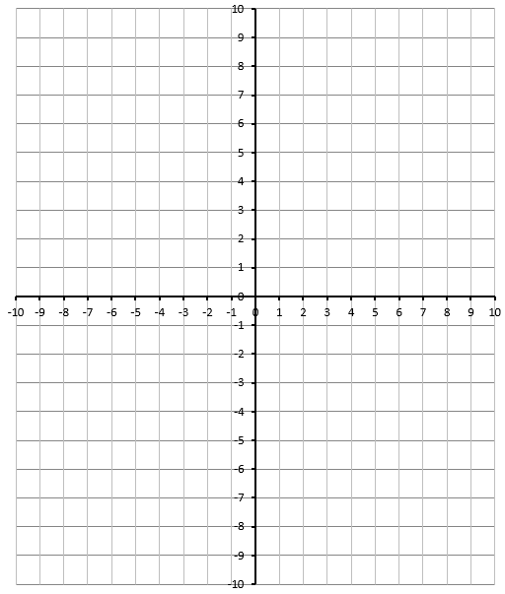
Part 4b – Solving Equations using Graphing
Q14: Solve the equation $2x^{2}=3x+4$ graphically. (3 marks)

