L22 – Word Problems
Area Problems
Use the following information to answer Q1:
A patio has a total area of 33m², and is proportioned per the diagram below.
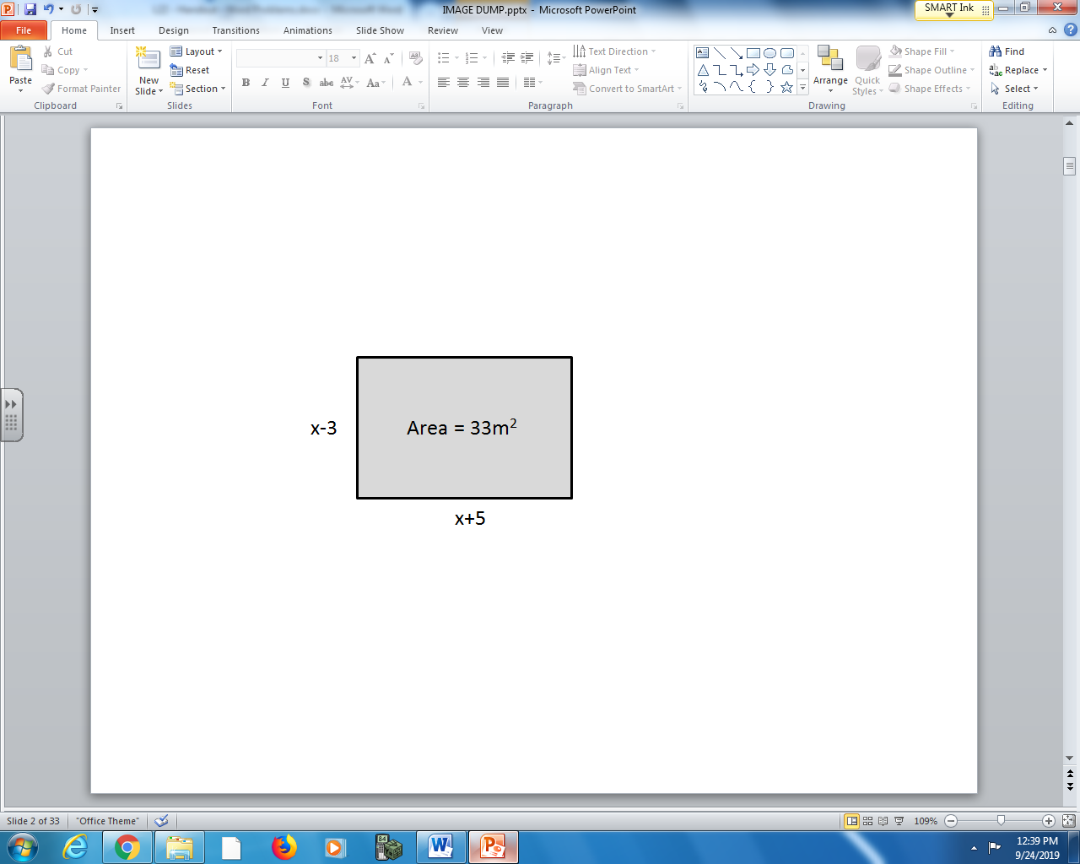

Q1: Set up a quadratic equation and solve to determine the value(s) of x.

Q2: A slightly smaller patio has the same proportions, but has a total area of 30m². Determine the value of x, to the nearest tenth.
(Record your answer in the Numerical Response boxes below)

Projectile Motion
Use the following information to answer Q3:
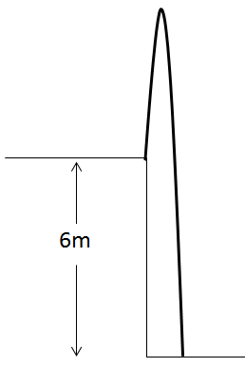
An object is launched vertically at 13m/s off a 6m tall ledge. The Physics 20 equation that can be used to determine time is given by:
$$∆d=v_{i}t+\frac{1}{2}at^{2}$$
Where the acceleration due to gravity is approximately -10 m/s². In Math 20-1, we can write this function as follows:
$$h\left(t\right)=-5t^{2}+13t+6$$

Q3: How long does it take the object to land? Support your work algebraically.
Using Factoring Using Vertex Form Using Quadratic Formula
Textbook Questions
Pg 230 #11: A rectangle has dimension $x+10$ and $2x-3$, where x is in centimeters. The area of the rectangle is 54 cm².
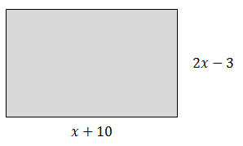
- What equation could you use to determine the value of x?
- What is the value of x?

Pg 230 #13: A flare is launched from a boat. The height, h, in meters, of the flare above the water is approximately modelled by the function $h\left(t\right)=150t-5t^{2}$, where t is the number of seconds after the flare is launched.
- What equation could you use to determine the time it takes for the flare to return to the water?
- How many seconds will it take for the flare to return to the water?

Pg 240 #9: Evan passes a flying disc to a teammate during a competition at the Flatland Ultimate and Cups Tournament in Winnipeg. The flying disc follows the path $h\left(d\right)=-0.02d^{2}+0.4d+1$, where h is the height, in meters, and d is the horizontal distance, in meters, that the flying disc has travelled from the thrower. If no one catches the flying disc, the height of the disc above the ground when it lands can be modelled by $h\left(d\right)=0$.
- What quadratic equation can you use to determine how far the disc will travel if no one catches it?
- How far will the disc travel if no one catches it? Express your answer to the nearest tenth of a meter.

Pg 240 #11: Brian is placing a photograph behind a 12-in. by 12-in. piece of matting. He positions the photograph so that the matting is twice as wide at the top and bottom as it is at the sides.
The visible area of the photograph is 54 sq. in. What are the dimensions of the photograph?
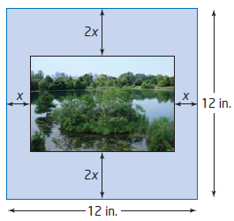

Pg 240 #15: Determine the roots of ${ax}^{2}+bx+c=0$ by completing the square. Can you use this result to solve any quadratic equation? Explain.

Pg 254 #8: To save materials, Choma decides to build a horse corral using the barn for one side. He has 30 m of fencing materials and wants the corral to have an area of 100 m². What are the dimensions of the corral?
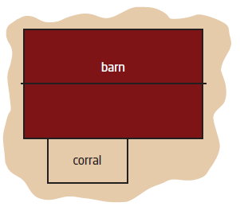

Pg 254 #10: Subtracting a number from half its square gives a result of 11. What is the number? Express your answers as exact values and to the nearest hundredth.

Pg 254 #12: An open-topped box is being made for a piece of cardboard measuring 12 in. by 30 in. The sides of the box are formed when four congruent squares are cut from the corners, as shown in the diagram. The base of the box has an area of 208 sq. in.
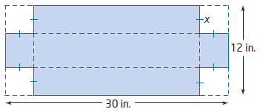
- What equation represents the surface area of the base of the box?
- What is the side length, x, of the square cut from each corner?
- What are the dimensions of the box?

Pg 254 #16: Two guy wires are attached to the top of a telecommunications tower and anchored to the ground on opposite sides of the tower, as shown. The length of the guy wire is 20 m more than the height of the tower. The horizontal distance from the base of the tower to where the guy wire is anchored to the ground is one-half the height of the tower. How tall is the tower, to the nearest tenth of a meter?
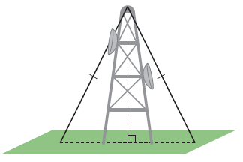

Pg 254 #20: Two small private planes take off from the same airport. One plane flies north at 150 km/h. Two hours later, the second plane flies west at 200 km/h. How long after the first plane takes off will the two planes be 600 km apart? Express your answer to the nearest tenth of an hour.

