L25 – 6.1 Graphs and Relations
Part 1 – Comparing Graphs
A student uses graphs to compare two NHL goalies in the 2014-15 hockey season. Ben Scrivens was a goalie for the Edmonton Oilers (blue line), and Jonas Hiller was a goalie for the Calgary Flames (red line).
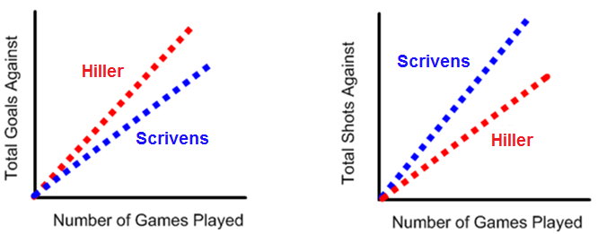

Q1: Using the graphs as evidence, which goalie is the better goalie? Explain.

Q2: Using the graphs as evidence, which team had the better defensemen? Explain.

Part 2 – Drawing Conclusions from a Graph
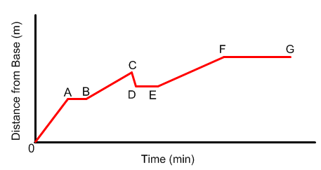
The following graph shows the distance a rock climber is from the base of a cliff.

Q3: Using the words “climbing”, “resting”, or “descending”, describe what the climber is doing during each segment.

Q4: For any section you labelled as “climbing”, how would you change the graph to show that the person is climbing faster? Explain.
Part 3 – Identifying the Correct Graph
Q5: Match each graph with a situation from the list. Explain your choice. Suggest titles for each axis to show the quantities being compared.

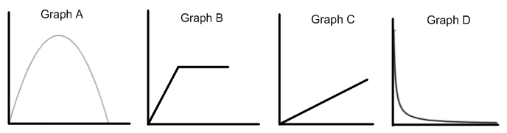
- The temperature of a cup of hot chocolate over time
- A car accelerating to a constant speed
- The distance a person walks during a hike
- The height of a punt across a field
Part 4 – “Big Picture” Idea of Rate of Change
A graph is an effective way to show the ___________ between two quantities. A constant ___________ is represented graphically by a _____________. The _________ of the line indicates the ______ of which one quantity is _____________ in relation to the other.
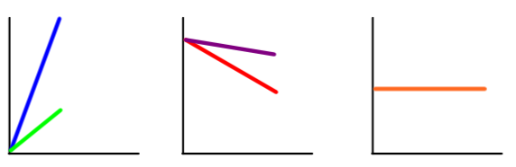
Not all relationships are represented by a ____________. A ________ shows that the __________ is not __________.
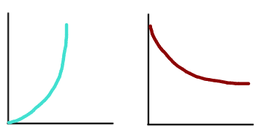
Part 5 – Textbook Practice
Pg. 274 #1,4,6,9,14,15

