First Name:______________________________ Last Name:______________________________

L26 - 6.1 - Formative Quiz– Graphs of Relations
Q1: Mr. Bayer decides to graph out his 80min jogging trip, starting from his house. Unfortunately he forgot some important parts of the graph. Complete the graph. (3 marks)
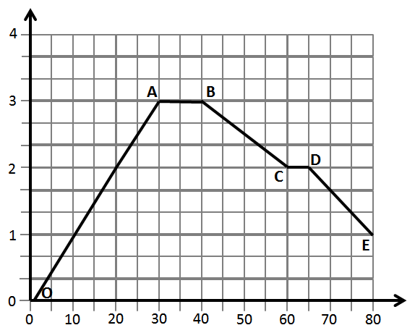

Q2: When is Mr. Bayer… (3 marks)
- Moving away from his house?

- Moving towards his house?

- Stationary?

MARKING
Beginning 0 – 2.5
Progressing 3 – 4
Competent 4.5 – 5.5
Exemplary 6

