L26 – 6.2 Linear Relations
Part 1 – Definitions
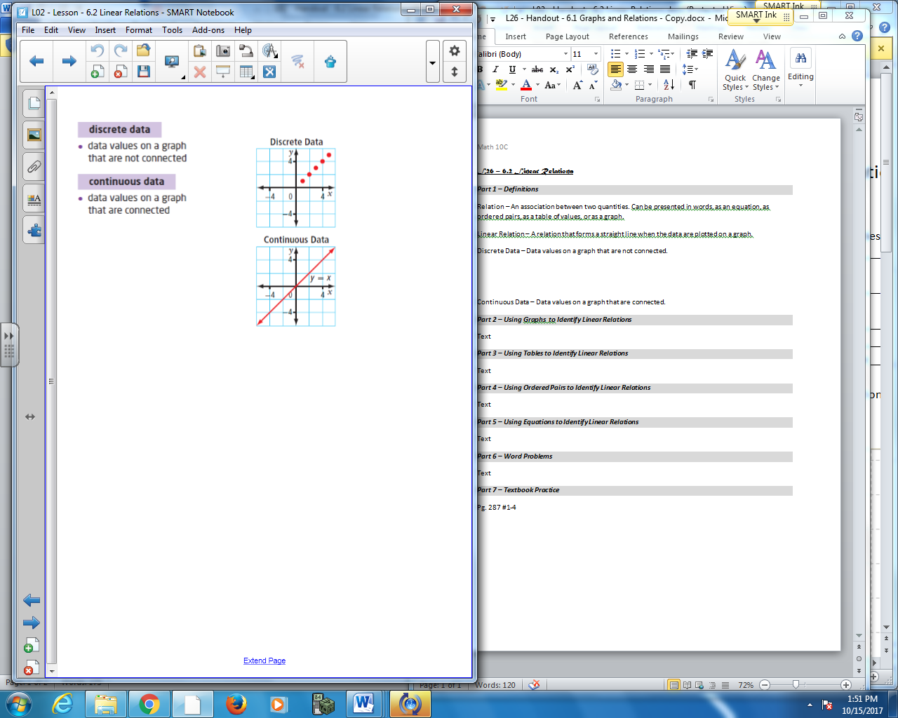
Relation – An association between _____________. Can be presented in _____, as an _________, as ___________, as a __________, or as a ________.
Linear Relation – A relation that forms a __________ when the data are plotted on a graph.
Discrete Data – Data values on a graph that are ______________.
Continuous Data – Data values on a graph that are ___________.
Independent Variable – The variable for which values are __________.
Dependent Variable – The variable whose values _________________ those of the independent variable.
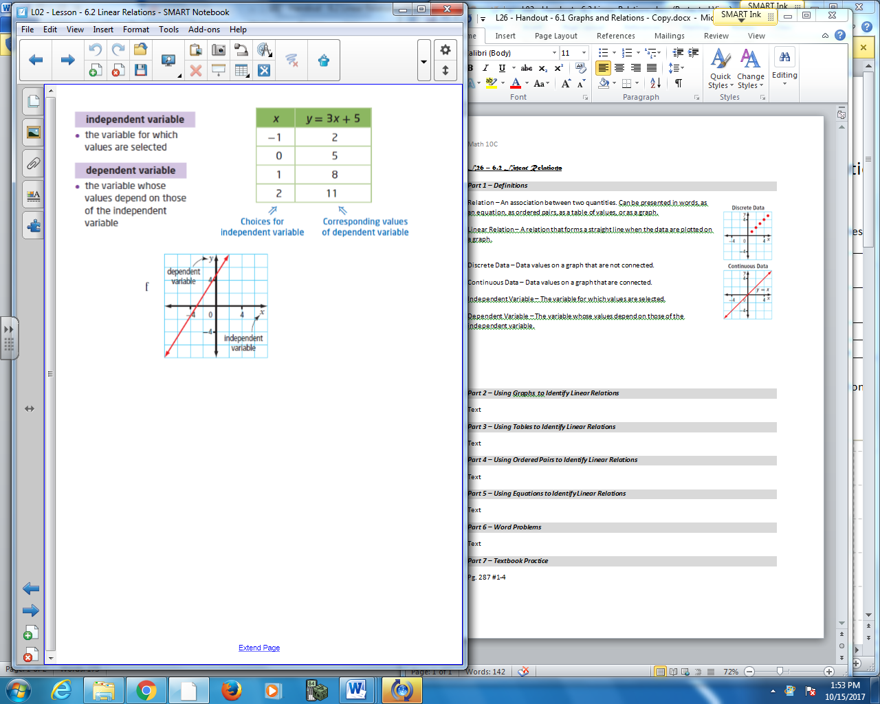
Part 2 – Examining Linear Relations using a Variety of Methods
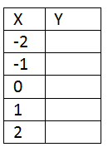
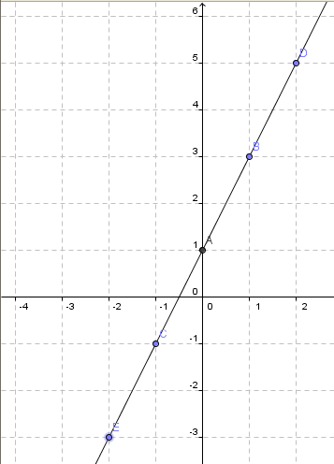
Q1: Write down the coordinate pairs (x,y) for the graph.
(-2, ) , (-1, ) , (0, ) , (1, ), (2, )
Q2: Complete the table for the graph

Q3: Without looking at the graph, how could you use the coordinate pairs or the table to determine whether the relationship is linear?
Part 3 – Using Tables to Identify Linear Relations
Q4: Do the following tables represent a linear relationship? Explain.

x | y
1 | 1
2 | 1
3 | 2
4 | 3
5 | 5

x | y
1 | 5
3 | 1
4 | -1
5 | -3

x | y
1 | 2
2 | 4
3 | 8
4 | 16
5 | 32

x | y
10 | 20
12 | 17
14 | 14
16 | 11
18 | 8

Part 4 – Using Ordered Pairs to Identify Linear Relations
Q5: Do the following ordered pairs represent a linear relationship? Explain.

(1,1) , (2,1) , (3,2) , (4,3) , (5,5) (1,5) , (3,1) , (4,-1) , (5,-3)

(4,6) , (5,8) , (6,9) , (7,10)

Q6: For what value of k is the following ordered pairs linear?

(5,7) , (8, k), (11, 5)

Part 5 – Using Equations to Identify Linear Relations
When a linear relation is written as an equation, it will contain one or two variables and its degree will be 1.
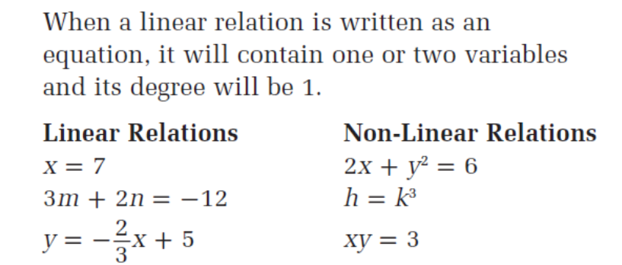

Q7: Which of the following equations represent a linear relation?
$y=2x-3$ $5x-2y+10=0$ $y=x^{2}+4x+3$ $y=100{(0.5)}^{\frac{x}{5}}$

Q8: For the linear relationship $y=2x+5$ , build a table of values and graph.
x | y
0
1
2
3
4
5
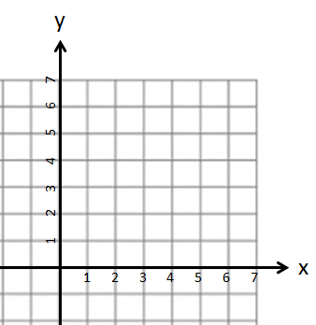

Part 6 – Word Problems
Q9: A white-tailed deer can sprint up to 48 km/h. One is walking at 8 km/h. Consider the relationship between the total distance, in kilometers, travelled by this deer and time, in hours.
- Assign a variable to represent each quantity in the relation. Identify the dependent variable and the independent variable.

- Assume the deer walks for 3 hours without stopping. Create a table of values for this relation.

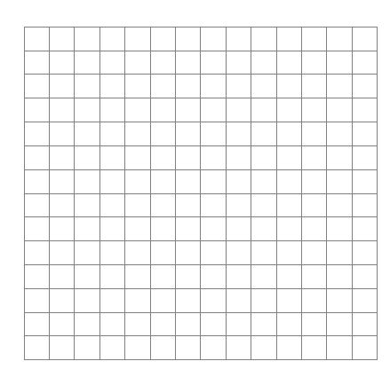
- Graph the relation.

- Is the relation linear or non-linear? Explain.

- Is the relation continuous or discrete? Explain.

Q10: A movie theatre charges $12 per ticket.
- Is this a linear or non-linear relationship? Explain how you know.

- Assign a variable to represent each quantity in the relation. Which variable is the dependent variable and which is the independent variable?

- Create a table of values for the scenario.

- Are the data discrete or continuous? Explain how you know.

- Graph the data.

Part 7 – Textbook Practice
Pg. 287 #1,2,3,4
Pg 288 #5,8,9

