L27 – 6.3 Domain and Range
Part 1 – Definitions
Domain is the set of all possible values for the independent variable in a relation. Most commonly the x-values.
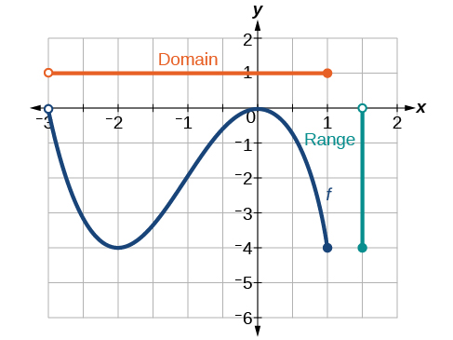
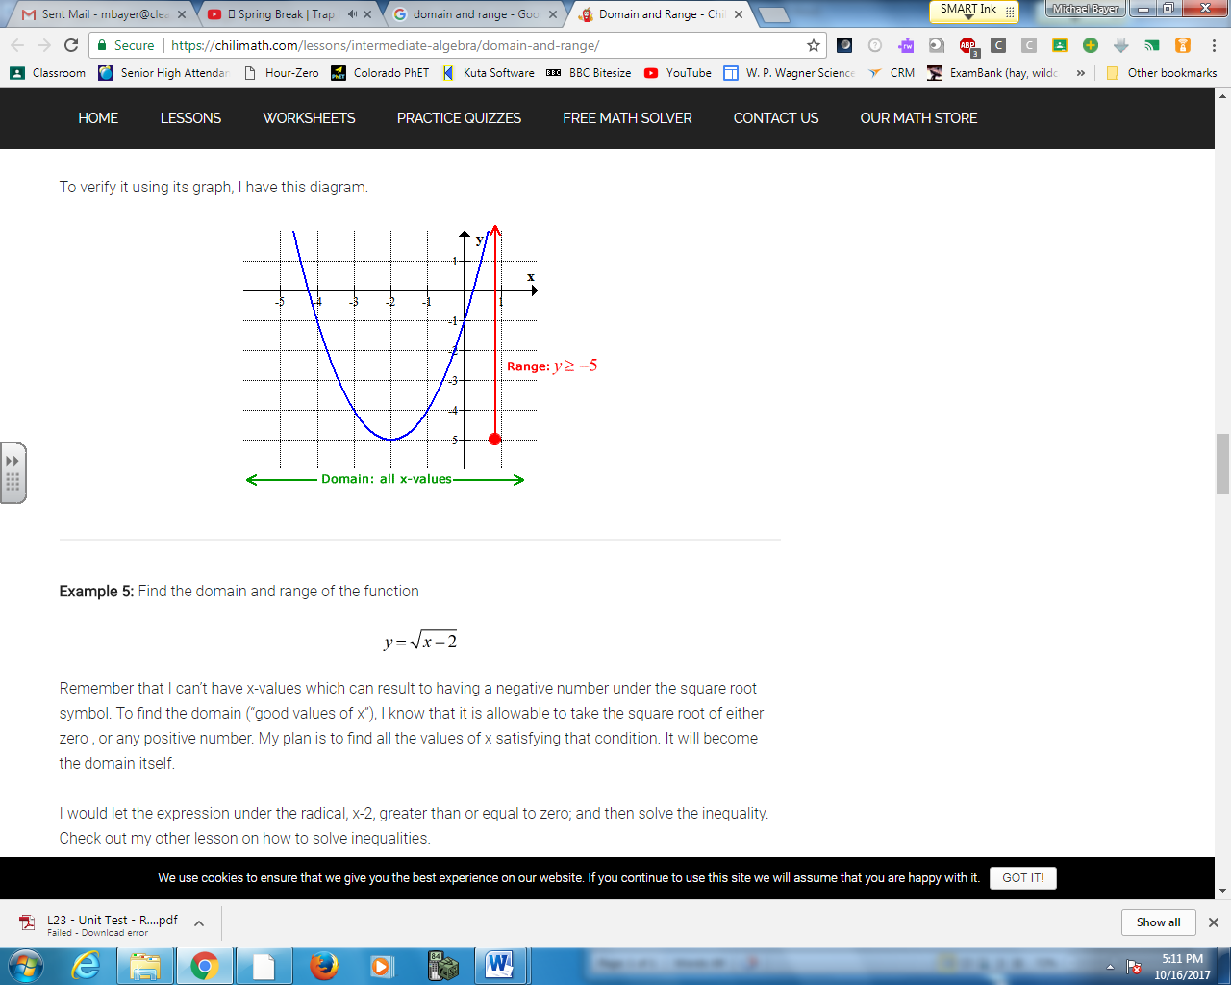
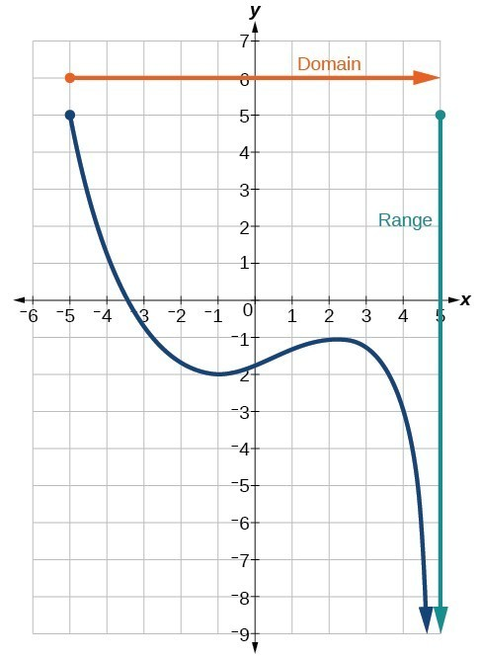
Range is the set of all possible values for the dependent variable in a relation. Most commonly y-values.

Part 2 – Examining Linear Relations using a Variety of Methods
Domain and Range can be written using the following methods:
- Words
- Set Notation
- Interval Notation
- Number Line
- List
Part 3 – Words
Words – Domain and Range can be expressed using sentences.

Part 4 – Set Notation
Set Notation – The most common of the methods. Set notation is a formal mathematical way to give the values of domain and range. When using this method it is important to remember the letters we use to describe NUMBER SETS.
{ } – Bird brackets – always used to describe a set
Є – means “belongs to” or “is an element of”
| - means “such that”
Part 5 – Interval Notation
Interval Notation – Uses different brackets to indicate an interval
  - Square brackets, [ ] – are used if the number can be equal to.
  - Round brackets, ( ) – are used if the number is close to, but not equal.
  - The infinity symbol, $∞$ - is used if there is no limit.

Part 6 – Number Line
Number Lines – Uses horizontal lines to convey both Domain and Range.

Part 7 – List
Lists - A list is useful for conveying Domain and Range for Discrete Values only. Lists don’t reference the number of repeated values, if any.
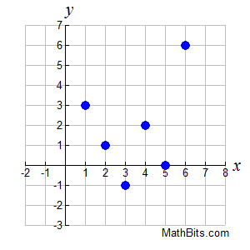
Part 8 – Discrete versus Continuous
Which of the following formats works to convey Domain and Range?
 | Discrete (Dots) | Continuous (Line)
Words
Set Notation
Interval Notation
Number Line
List

Part 9 – Textbook Practice
Pg 301 #1-3

