L27 - Math 10C - Domain and Range Asn.
NAME
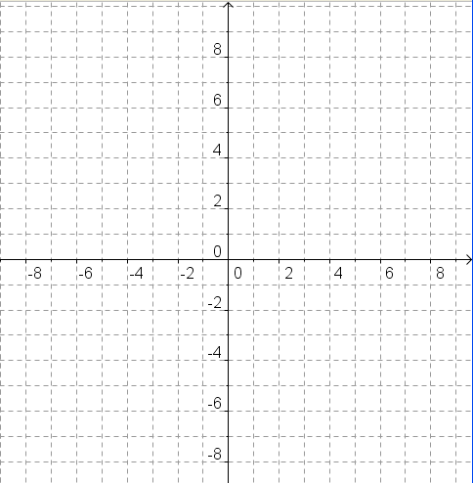
- Plot the following points on the grid provided.
A(-4,1) B(-4,3) C(5,1) D(4,0) E(1,-3)
F(3,-2) G(-2,5) H(3,3) I(3,1) J(-3,-1)
K(1,5) L(4,1) M(-1,-3) N(2,1)

What letter do they form?

- Write the domain and range of the following relations as a LIST.
  - (3,2), (2,3), (3,3) b. (5,-2), (3,2), (6,2), (-4,3)

- Write the domain and range of the following relations as a NUMBER LINE.
  - The domain is all integer values of x greater than or equal to negative seven.

  - The range is all whole values of y less than eleven.

- Write the domain and range of the following relations as WORDS.
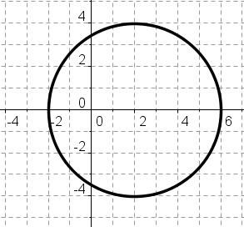
  - b. (2, -5), (6,-1), (10,3), (4, 5), (8,-3), (4,1)

- Write the domain and range of the following relations in SET NOTATION.
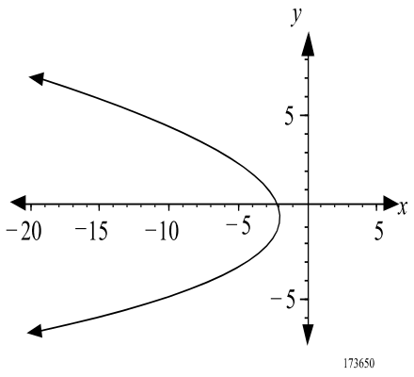
  - b.

Domain: _________________
Range: __________________
Domain: _________________
Range: __________________

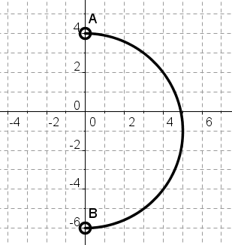
Domain: _________________
Range: __________________

- Write the domain and range for the following in INTERVAL NOTATION.
  - The set of all real x values greater than negative two and less than or equal to five.

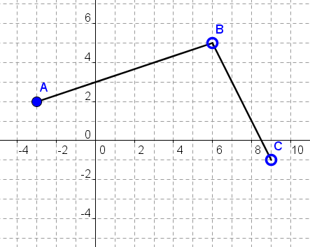
Domain: _________________
Range: __________________

- Write a possible domain and range for the following scenarios.
  - Temperature in Stettler throughout the year.

  - Speed of a snowboarder throughout the day at Lake Louise.

  - Potential winnings of a 50/50 draw at a local hockey game.

  - The volume of fuel in a car over distance traveled.

- A rodeo clown earns $35/hour plus $200 hazardous pay.

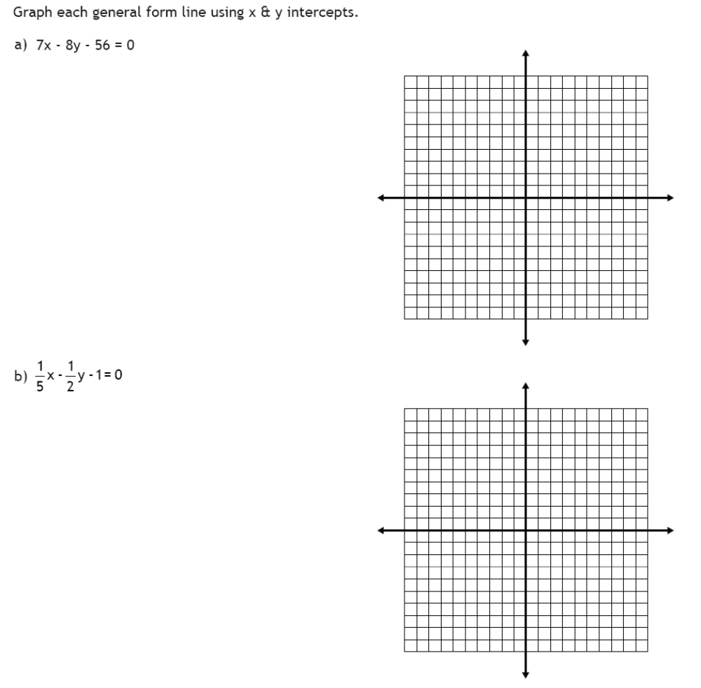
  - Create a table of values and graph the function.
Hours | Pay

  - State the domain and range.

  - How many hours does the clown need to work in order to make $655.00?

