First Name:____________________________ Last Name:______________________________

L28 - Math 10C – 6.3 Domain and Range Formative Quiz
Use the following relation to answer questions Q1.
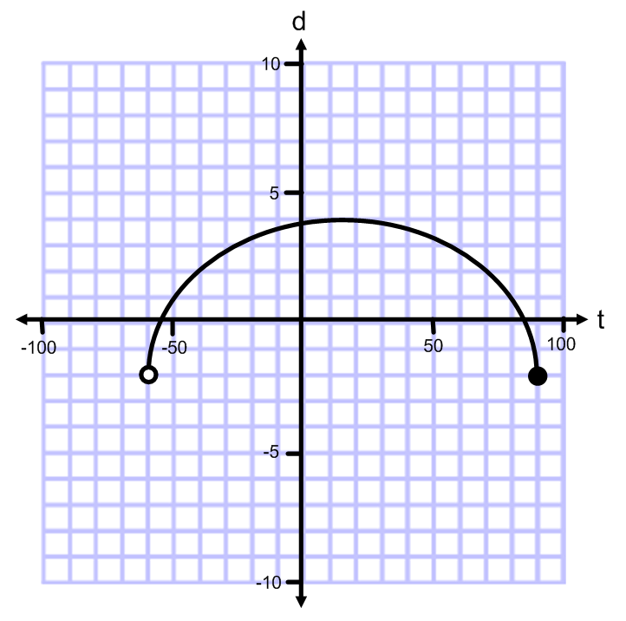
Q1: Fill in the chart (4 marks)
Domain |  | Range
 | Words
 | Number Line
 | Set Notation
 | Interval Notation

Use the following relation to answer questions Q2.
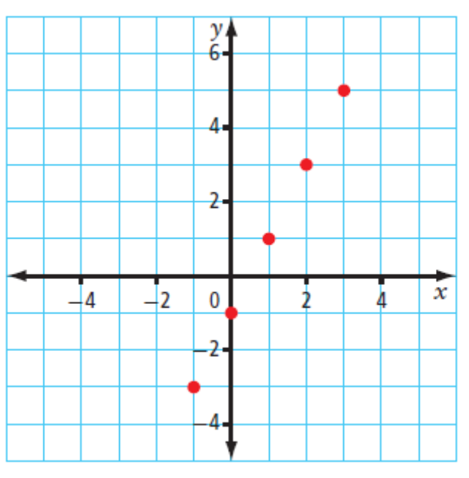
Q2: Fill in the chart (3 marks)

Domain |  | Range
 | Words
 | Number Line
 | List

MARKING:
Beginning 0 - 3
Progressing 3.5 - 4
Competent 4.5 - 5.5
Exemplary 6 - 7

