L28&29 – 8.1 Solving Systems of Equations Graphically
Key Ideas
System of Linear-Quadratic Equations: A linear equation and a quadratic equation involving some variables. A graph of the system will involve a line and a parabola.
System of Quadratic-Quadratic Equations: Two quadratic equations involving the same variables. The graph involves two parabolas.
Any coordinate (x,y) that satisfies both equations in a Linear-Quadratic or Quadratic-Quadratic system is considered a solution.
Basic Rules:
- No points of intersection = No solution.
- One point of intersection = One solution.
- Two points of intersection = Two solutions.
Where the two graphs cross, those are your point(s) of intersection, which are your solution(s).
Forms of a Quadratic Equation Forms of a Linear Equation
$y=ax^{2}+bx+c$ $y=mx+b$
$y=a{(x-h)}^{2}+k$ $Ax+By+C=0$
$\left(y-y_{1}\right)=m(x-x_{1})$

Part 1 – System of Linear-Linear (Math 10C Review)
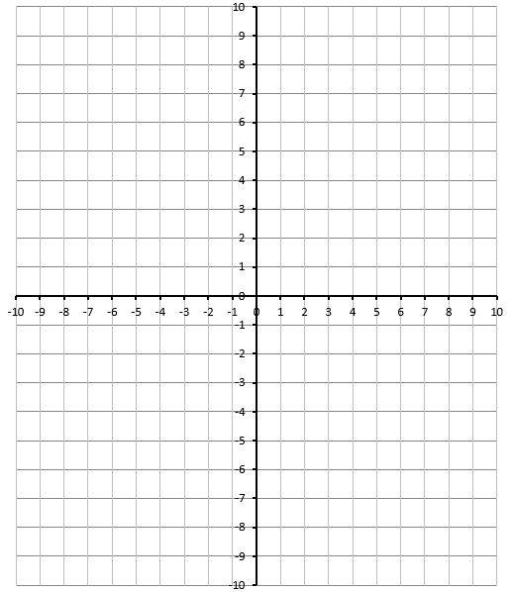
Q1: Solve the system of equations graphically.
$$f\left(x\right)=-\frac{1}{2}x+1$$
$$g\left(x\right)=x+4$$
Verify using your calculator.

Part 2 – System of Linear-Quadratic (Vertex Form)
Q2: Solve the system of equations graphically.
$$f\left(x\right)=1{(x-2)}^{2}-5$$
$$g\left(x\right)=x-1$$
Verify using your calculator.

Q3: Solve the system of equations graphically.
$$f\left(x\right)=-1{\left(x+3\right)}^{2}+6$$
$$g\left(x\right)=2x+9$$
Verify using your calculator.

Q4: Solve the system of equations graphically.
$$f\left(x\right)=2{(x-7)}^{2}-9$$
$$g\left(x\right)=-2x+5$$
Verify using your calculator.

Part 3 – System of Linear-Quadratic (Standard Form)
Q5: Solve the system of equations graphically.
$$f\left(x\right)=\frac{1}{4}x^{2}+2x+1$$
$$g\left(x\right)=\frac{1}{2}x+5$$
Verify using your calculator.

Part 4 – System of Linear-Quadratic (Building the Equations)
Q6: A straight line passes through the points
(-3,8) and (1,4).
A parabola has a vertex at (4,7) and passes through the point (6,3).
What are the solution(s) to this system of equations?
Verify using your calculator.

Today’s Assignment: Pg435 #3,4ab,8,10,13
Tomorrow’s Assignment: Pg435#4d,7,15
Part 5 – System of Quadratic-Quadratic
Q7: Solve the system of equations graphically.
$$f\left(x\right)=1{(x+1)}^{2}-5$$
$$g\left(x\right)=-1{\left(x+5\right)}^{2}+5$$
Verify using your calculator.

Q8: Solve the system of equations graphically.
$$f\left(x\right)=1{(x+1)}^{2}+3$$
$$g\left(x\right)=-1{\left(x+3\right)}^{2}+7$$
Verify using your calculator.

Today’s Assignment: Pg435#4d,7,15

