L28&29 – Worksheet – 8.1 Solving Systems of Equations Graphically
Part 1 – Easy Questions
Graph the following relations, and determine the solution(s) to the system of equations:
$f\left(x\right)={(x+2)}^{2}+4$ $f\left(x\right)={(x+2)}^{2}+4$
$g\left(x\right)=2x+8$ $g\left(x\right)=2x+7$
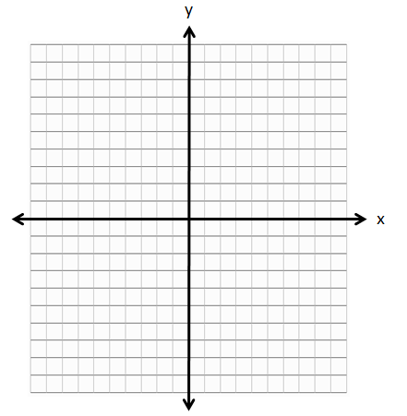

Part 2 – Textbook Questions
Pg 435 #3: What type of system of equations in represented in each graph? Give solution(s) to the system.
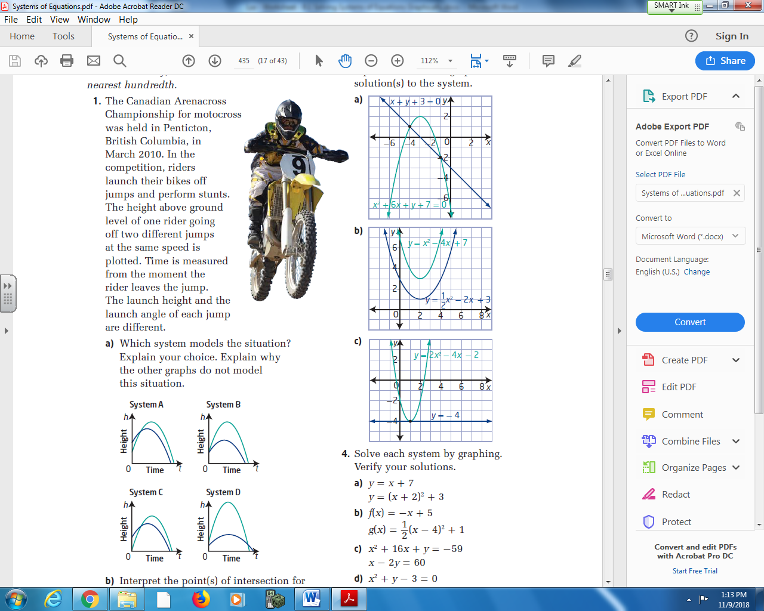

Pg 435 #4a: Solve each system by graphing. Verify your solutions.
$$y=x+7$$
$$y={\left(x+2\right)}^{2}+3$$

Pg 435 #4b: Solve each system by graphing. Verify your solutions.
$$f\left(x\right)=-x+5$$
$$g(x)={\frac{1}{2}\left(x-4\right)}^{2}+1$$
Pg 435 #4d: Solve each system by graphing. Verify your solutions.
$$x^{2}+y-3=0$$
$$x^{2}-y+1=0$$

Pg 435 #7: For each situation, sketch a graph to represent a system of quadratic-quadratic equations with two real solutions, so that the two parabolas have
- The same axis of symmetry b. The same axis of symmetry and the same y-intercept

- Different axis of symmetry but the same y-intercept d. The same x-intercepts

Pg 435 #8: Given the graph of a quadratic function as shown, determine the equation of a line such that the quadratic function and the line form a system that has
- No real solution b. One real solution c. Two real solutions
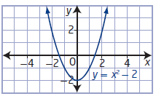

Pg 435 #10: Vertical curves are used in the construction of roller coasters. One downward-sloping grade line, modelled by the equation $=-0.04x+3.9$ , is followed by an upward-sloping grade line modlled by the equation $y=0.03x+2.675$ . The vertical curve between the two lines is modelled by the equation $=0.001x^{2}-0.04x+3.9$ . Determine the coordinates of the beginning and the end of the curve.
HINT: Graph all three lines using your calculator.
Graphed Domain: [-10,50]
Graphed Range: [2,5]

Pg 435 #13: The sum of two integers is 21. Fifteen less than double the square of the smaller integer gives the larger integer.
- Model this information with a system of equations.
- Solve the system graphically. Interpret the solution.
- Verify your solution.

Pg 435 #15: A frog jumps to catch a grasshopper. The frog reaches a maximum height of 25 cm and travels a horizontal distance of 100 cm. A grasshopper, located 30cm in front of the frog, starts to jump at the same time as the frog. The grasshopper reaches a maximum height of 36cm and travels a horizontal distance of 48 cm. The frog and the grasshopper both jump in the same direction.
- Consider the frog’s starting position to be at the origin of a coordinate grid. Draw a diagram to model the given information.
- Determine a quadratic equation to model the frog’s height compared to the horizontal distance it travelled and a quadratic equation to model the grasshopper’s height compared to the horizontal distance it travelled.
- Solve the system of two equations.
- Interpret your solution in the context of this problem.
