First Name:__________________________ Last Name:__________________________

L29 – FQ – 6.3 Domain and Range
Use the following information to answer Q1-Q4:
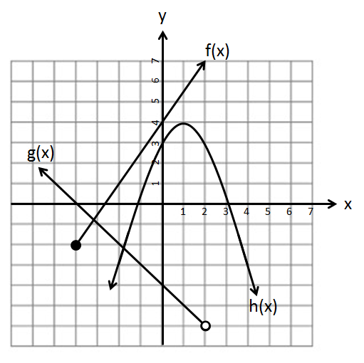

Q1: How many of the lines in the graph above are linear?
(Record your one digit answer in the Numerical Response boxes below)

Q2: Using interval notation, which best describes the domain of the “f(x)” equation?
- (-4,∞)
- [-4,∞)
- (-2,∞)
- [-2,∞)

Use the following information to answer Q1-Q4:

Q3: The domain for the “g(x)” line can be written as $\left\{x|x<a, x∈R\right\}$, and the range can be written as $\left\{y|y>-b,y∈R\right\}$, where a and b are ___ and ___.
(Record your two digit answer in the Numerical Response boxes below)

Q4: (Long Answer) Write the domain and range of the “h(x)” line using Set Notation. (2 marks)

MARKING:
Beginning 0.0 – 2.0
Progressing 2.5 – 3.0
Competent 3.5 – 4.5
Exemplary 5.0
Extra Time? Try factoring the following: $2x^{3}-50x$

