L29 – 6.4 Function Notation
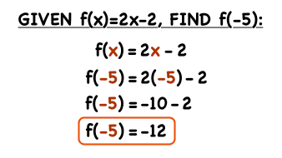
Part 1 – What is a Function?
A function is a relation in which each value of the independent variable is associated with exactly one value of the dependent variable.
“Each value of x has only one value for y”
Functions:
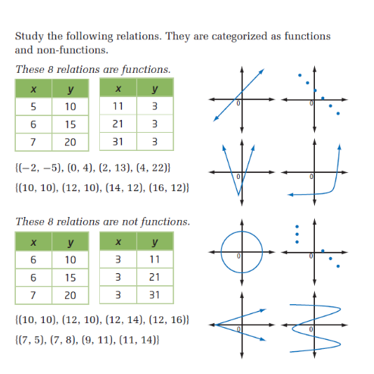
Not Functions:
Both Functions and Non-Functions are still relations, and relate x-values to y-values.
Vertical Line Test – If any vertical line intersects the graph at more than one point, the relation is not a function.

Determine whether each relation is a function or is not a function. Give reasons for your answer.

(4, 1), (5, –2), (6, –5), (7, –8), (6, –11), (5, –14), (4, –17)

x | y
–2 | –2
–1 | 4
0 | –8
1 | 16
2 | –32

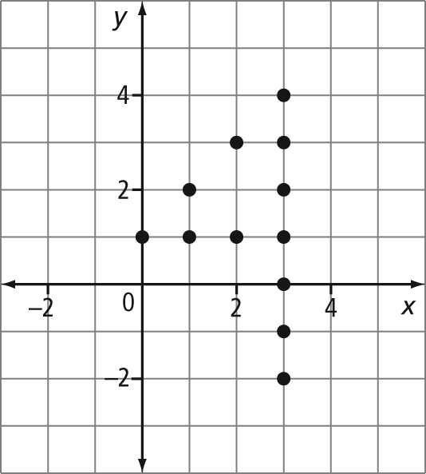
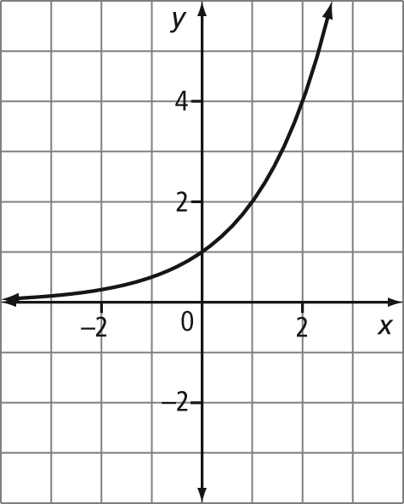
Part 2 – What is Function Notation?
Use the following graph to answer the next few questions:
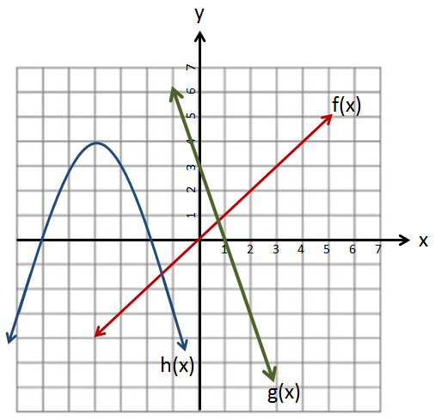
Q1: What is y when x=-3 for the red graph?
Q2: What is y when x=-1 for the blue graph?
What is the problem with asking questions this way?

Use the following equations to answer the next few questions:
$y=x$ $y=-3x+3$ $y=-\frac{7}{9}x^{2}-\frac{56}{9}x-\frac{76}{9}$

Q3: What is y when x=-3 for the red equation?
Q4: What is y when x=-1 for the blue equation?
What is the problem with asking questions this way?

Part 3 – Function Notation – Solving for “y”
Functions can be written in a different notation where y is replaced with f(x):

$$y=4x+1$$
$$f\left(x\right)=4x+1$$

Use the following equations to answer the next few questions:
$f(x)=x$ $g(x)=-3x+3$ $h(x)=-\frac{7}{9}x^{2}-\frac{56}{9}x-\frac{76}{9}$
Q5: What is f(-3) = ?

Q6: What is h(-1) = ?

Q7: What is g(4) = ?

Q8: What is h(-4) =?

Part 4 – Function Notation – Solving for “x”
Use the following equations to answer the next few questions:
$f(x)=x$ $g(x)=-3x+3$ $h(x)=-\frac{7}{9}x^{2}-\frac{56}{9}x-\frac{76}{9}$
Q9: What is x if f(x) = 7?

Q10: What is x if g(x) = 18?

Q11: What is x if g(x) = 10?

Q12: What is x if g(x) = 20?

Q13: What is x if h(x) = 0?
(Hint: You’ll need to look at the graph on Pg 3… you can’t do this algebraically until Ma20-1 or Ma20-2)

Part 5 – Problem Solving
The height of a diver on a board can be described by the function h(t) = 32 – 4.905t², where h is the diver’s height above the water, in metres, t seconds after jumping off the board.
a) Determine the diver’s height after 1.5 s.
b) Estimate how long the diver is in the air.
c) Determine an appropriate domain and range.

Part 6 – Textbook Practice
Pg. 311 #1,5,6,8,11,12a

