L30 – FQ - 8.1 Solving Systems of Equations Graphically
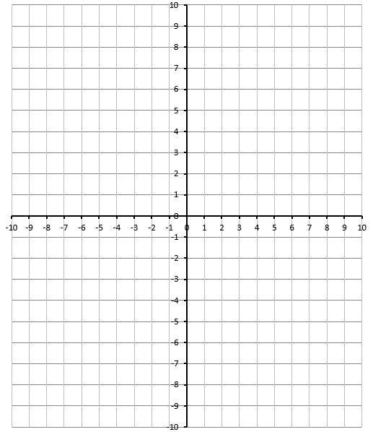
Q1: Solve the system of equations graphically.
$$f\left(x\right)=\frac{1}{2}{(x+3)}^{2}-5$$
$$g\left(x\right)=2x+1$$

Q2: Solve the system of equations graphically.
$$f\left(x\right)=-2x^{2}+x+5$$
$$g\left(x\right)=2x^{2}+3x-1$$

MARKING:
Beginning 0.0 – 2.5
Progressing 3.0 – 4.0
Competent 4.5 – 5.5
Exemplary 6.0

