L30&31 – Worksheet – 8.2 Solving Systems of Equations Algebraically
Part 1 – Easy Questions (Factorable)
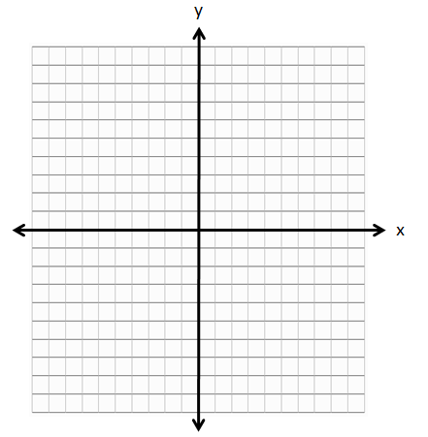
Q1: Graph the following equations:
$$f\left(x\right)=-1{\left(x+2\right)}^{2}+6 \\ g\left(x\right)=2x+7$$

Q2: Using Substitution, algebraically determine the solution(s) to this system of equations (i.e. the coordinates of the points of intersection).

Part 2 – Hard Questions (Radicals)
Q3: Using Substitution, algebraically determine the exact solution(s) to this system of equations:
$$f\left(x\right)=\frac{1}{2}x^{2}+2x+4 \\ g\left(x\right)=-x+2$$

Part 3 – Textbook Questions
Pg 451 #3ac: Solve each system of equations by substitution, and verify your solution(s).
$x^{2}-y+2=0$ $7d^{2}+5d-t-8=0$
$4x=14-y$ $10d-2t=-40$

Pg 451 #4ac: Solve each system of equations by elimination, and verify your solution(s).
$6x^{2}-3x=2y-5$ $2p^{2}=4p-2m+6$
$2x^{2}+x=y-4$ $5m+8=10p+5p^{2}$

Pg 451 #6: Alex and Kaela are considering the two equations $n-m^{2}=7$ and $2m^{2}-2n=-1$. Without making any calculations, they both claim that the system involving these two equations has no solution.
Alex’s reasoning:
If I double every term in the first equation and then use the elimination method, both of the variables will disappear, so the system does not have a solution.
Kaela’s reasoning:
If I solve the first equation for n and substitute into the second equation, I will end up with an equation without any variables, so the system does not have a solution.
- Is each person’s reasoning correct?
- Verify the conclusion graphically.

Pg 451 #8: Determine the values of m and n if (2,8) is a solution to the following system of equations.
$$mx^{2}-y=16 \\ mx^{2}+2y=n$$

Pg 451 #9: The perimeter of the right triangle is 60 m. The area of the triangle is 10y square meters.
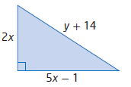
- Write a simplified expression for the triangle’s perimeter in terms of x and y.

- Write a simplified expression for the triangle’s area in terms of x and y.

- Write a system of equations and explain how it relates to this problem.

- Solve the system for x and y. What are the dimensions of the triangle?

- Verify your solution.

Pg 451 #10: Two integers have a difference of -30. When the larger integer is increased by 3 and added to the square of the smaller integer, the results is 189.
- Model the given information with a system of equations.
- Determine the value of the integers by solving the system.
- Verify your solution.
HINT: Let y be the larger integer and x be the smaller integer. This way you are assigning the same variables as the answer key.

Pg 451 #17: The monthly economic situation of a manufacturing firm is given by the following equations.
$$R=5000x-10x^{2} \\ R_{M}=5000-20x \\ C=300x+\frac{1}{12}x^{2} \\ C_{M}=300+\frac{1}{4}x^{2}$$
Where x represents the quantity sold, R represents the firm’s total revenue, R_{M} represents marginal revenue, C represents total cost, and C_{M} represents the marginal cost. All costs are in dollars.
- Maximum profit occurs when marginal revenue is equal to marginal cost. How many items should be sold to maximize profit?
- Profit is total revenue minus total cost. What is the firm’s maximum monthly profit?

