First Name:___________________________ Last Name:______________________________
L31 – FQ – 6.5 Slope
Q1: Find the slope of each line. Indicate the rise and the run.
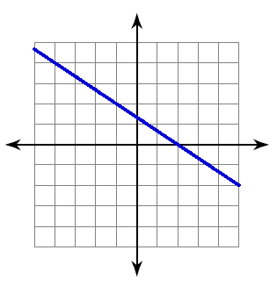


Q2: Find the slope of the line through each pair of points:
- (20,8) , (9,16) b) (19,-2) , (-11,10)

Q3: Garrett has been pedal biking across Canada. On day 5 he has travelled a total of 400 km. On day 22 he has travelled a total of 1760km. Determine the number of kilometers Garrett travels each day.

MARKING:
Beginning 0 - 1.5
Progressing 2 - 2.5
Competent 3 - 3.5
Exemplary 4

