First Name:______________________________ Last Name:______________________________

L32 – FQ – Chapter 6 Review

Q1: Fill in the chart (4 marks)
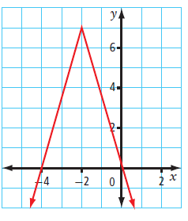
Domain |  | Range
 | Words
 | Number Line
 | Set Notation
 | Interval Notation

Q2: (Long Answer) A line passes through the points (3,-8) and (7,14). Calculate the slope. (2 marks)

Use the following information to answer Q3-Q6:
$f\left(x\right)=2x^{2}+1$ $g\left(x\right)=3x+1$ $h\left(x\right)= -\frac{1}{5}x+4$

Q3: f(4) =
- 1.2
- 9
- 33
- 65

Q4: h(10) =
(Record your one digit answer in the Numerical Response boxes below)

Q5: If g(x) = 8, then $x=\frac{a}{b}$ , where a and b are ___ and ___.
(Record your two digit answer in the Numerical Response boxes below)

Q6: (Short Answer) Which of the functions are linear? (1 mark)

Q7: (Long Answer) Graph the line that goes through the point (-3, 5) and has a slope of $\frac{-2}{5}$ (2 marks)
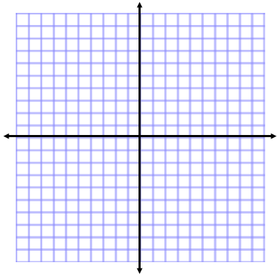

MARKING:
Beginning 0.0 – 5.5
Progressing 6.0 – 8.5
Competent 9.0 – 11.5
Exemplary 12.0

