L32 – Word Problems
Key Ideas
Linear Functions can be built in Slope y-Intercept form:
$$y=mx+b$$
where the slope can be calculated as
$$m=\frac{y_{2}-y_{1}}{x_{2}-x_{1}}$$
and the y-intercept can be calculated using the slope and a single data point, (x,y).
Quadratic Functions can be built in Vertex Form:
$$y=a{(x-h)}^{2}+k$$
where the vertex is located at (h,k)
and the a-value can be calculated using a single data point, (x,y).

Part 1 – Linear – Quadratic Systems
Use the following information to answer Q1-Q3:
A sloth jumps into the air, reaching a maximum height of 8m after a horizontal distance of 4m. It lands further up the hill.
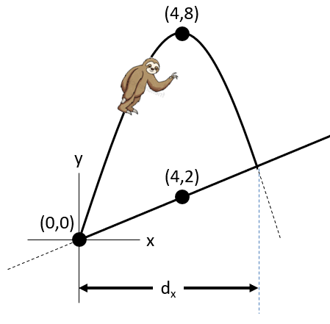

Q1: Write a linear equation that models the hill.

Q2: Write a quadratic equation, in Standard Form, that models the jump of the sloth.

Q3: Find the horizontal distance that the sloth covers prior to landing.

Use the following information to answer Q4-Q5:
A baby grasshopper jumps upward. It’s height, h(x), as a function of horizontal distance, x, is modelled by the equation
$$h\left(x\right)=-x^{2}+6x$$
where x and h(x) are modelled in centimeters.
A larger cannibal grasshopper jumps upward, snagging the baby grasshopper in midair. The equation of the cannibal grasshopper is models by the equation
$$g\left(x\right)=-2x^{2}+8x+3$$
Q4: Sketch both quadratic functions below.

Q5: Algebraically solve for the coordinates where the grasshoppers’ paths intersect.

