Math 10-C L32 - Chapter 6 Review
NAME

- For each scenario, state the dependent variable, independent variable and the rate of change. Write the equation.
  - The football team generates a revenue of R dollars by selling n football cards at $20 each.
    - The dependent variable is_____________.
    - The independent variable is ____________.
    - The rate is _______________.
    - The equation is ________________________.

  - The number of pushups, p, Mr. Siemens can do in m minutes if he can do 15 in 10 seconds.
    - The dependent variable is_____________.
    - The independent variable is ____________.
    - The rate is _______________.
    - The equation is ________________________.

- For each relation, complete the table of values and draw the graph. State if the relation in linear or non-linear.
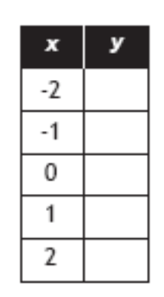
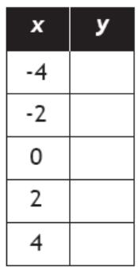

  - $y=x^{2}$ b. $y=\frac{3}{4}x-2$

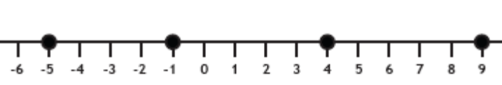
- Write the domain of each number line.

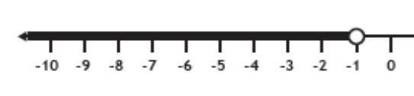

- Write the domain and range for each graph.
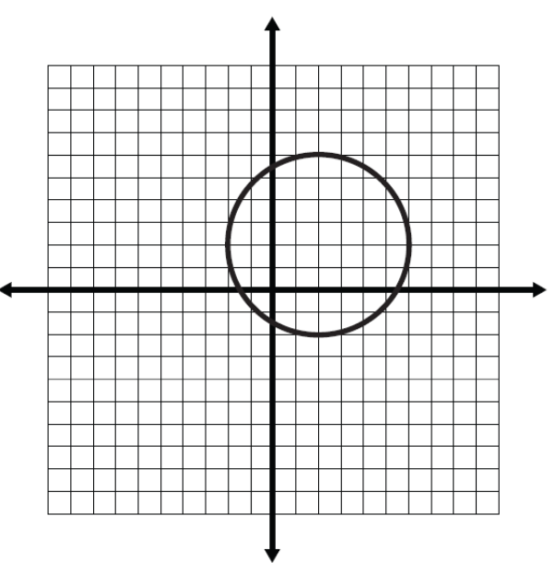
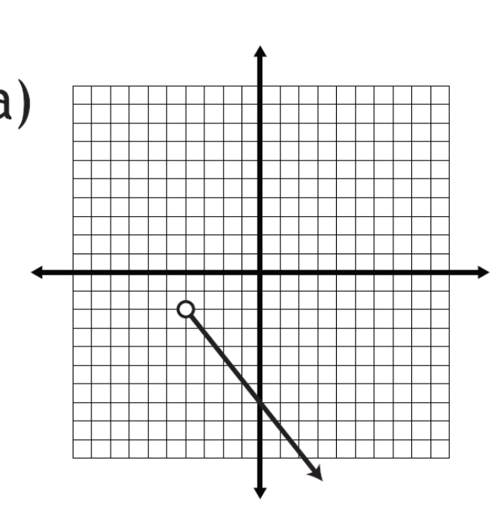
  - b.

- Identify if the following is a function or non-function. Explain why.
x | f(x)
-4 | 16
-2 | 4
0 | 0
2 | 4
4 | 16
  - {(2,3),(3,6),(4,10),(5,10)} b.

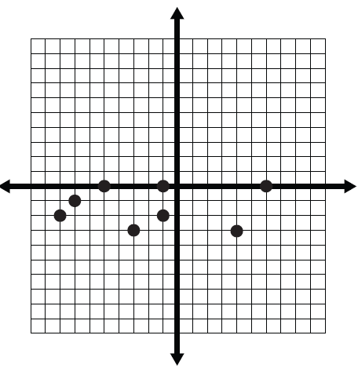
x | f(x)
16 | -4
4 | -2
0 | 0
4 | 2
16 | 4
- d.

- For each function, calculate f(-3).
  - $f\left(x\right)=-3x+7$ b. $f\left(x\right)=\frac{4}{3}x-2$

- $f\left(x\right)=x^{2}-x$ d. $f\left(x\right)=2x^{3}+3x^{2}-2x+10$

- Solve the following.
  - Given $d\left(t\right)=4t+5$, find $t$ when $d\left(t\right)=37$.

  - Given $f\left(x\right)=-\frac{1}{2}x-2$, the point $(k, 2)$ exists. Find k.

  - Does the point $(12, -7)$ exist on the graph $f\left(x\right)=\frac{2x}{x-6}-3$?

  - The function $f\left(x\right)=2x+k$ has a point $(4, 7)$. Find the value of k.

- For each pair of points calculate the slope.
  - (-3, 7) and (9,-1) b. ( 10, -2) and (5, 4)

- (3, 7) and (-4, 6) d. (-5,3) and (2,3)

- Draw each of the following lines.
  - Slope = $-\frac{1}{3}$ b. slope = $3$
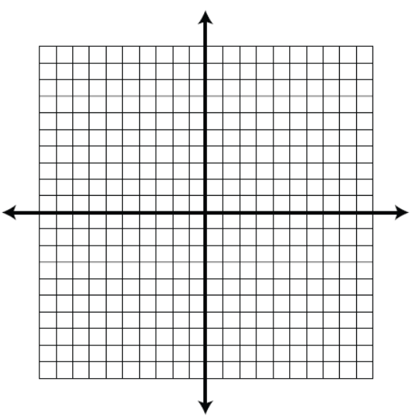
Point (2,-3) Point (-3, 5)

- A cylindrical tank holding 600L of water can be drained at 12L/min.
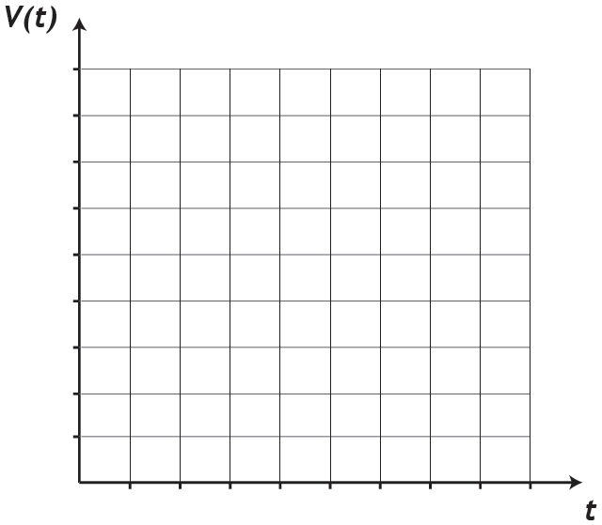
  - Graph the volume of the tank. b. Write a function to represent the scenario

- What does each intercept represent?

- State the domain and range.

- When will the tank have 300L?

- When will the tank be empty?

