L32 – Worksheet – Review of Systems of Equations
Part 1 – Concept Review
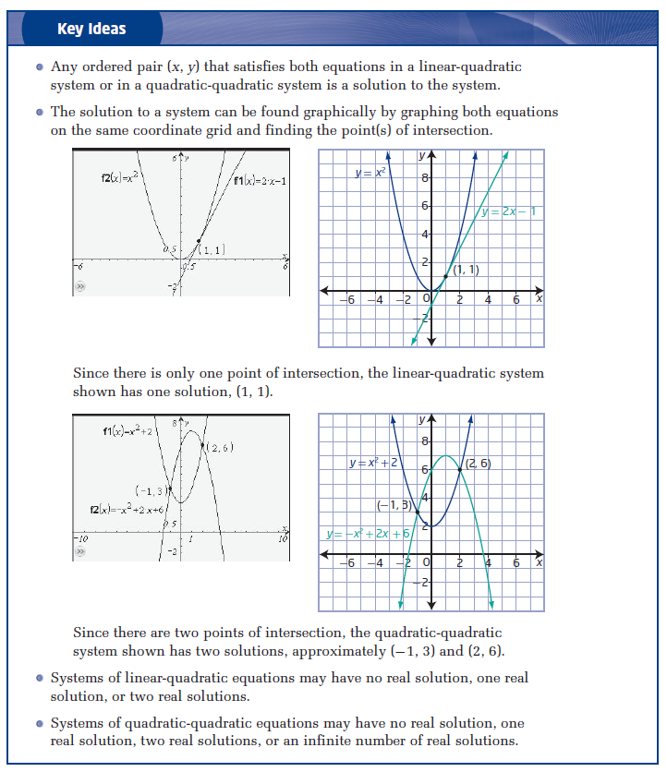
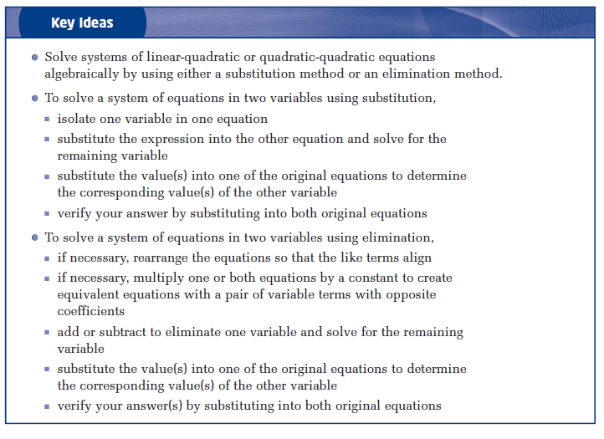
Part 2 – Easy Questions
Use the following equations for Q1-Q5:
$$f\left(x\right)=2x^{2}+3x-10$$
$$g\left(x\right)=x^{2}+3x-6$$

Q1: Convert each equation into Vertex form.

Q2: Determine the coordinates of the vertex and the zeroes for each function.

Q3: Graph each function to determine the solution to the system of equations.
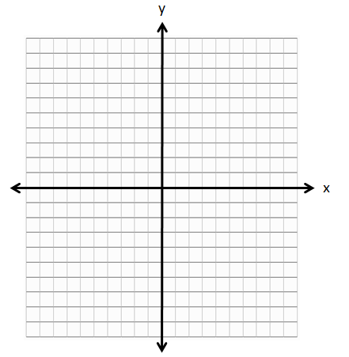

Q4: Use Elimination to determine the solution to the system of equations.

Q5: Use Substitution to determine the solution to the system of equations.

Part 3 – Medium Questions
Use the following equations for Q6-Q10:
$$f\left(x\right)=-2x^{2}+6x+5$$
$$g\left(x\right)=x+2$$

Q6: Convert $f\left(x\right)=-2x^{2}+6x+5$ into Vertex form.

Q7: Determine the coordinates of the vertex and the zeroes of f(x).

Q8: Graph each function to determine the solution to the system of equations.

Q9: Use Elimination to determine the solution to the system of equations.

Q10: Use Substitution to determine the solution to the system of equations.

Part 4 – Harder Questions (Exact Values)
Use the following equations for Q11:
$$f\left(x\right)=2x^{2}+5x-10$$
$$g\left(x\right)={-x}^{2}+3x+7$$

Q11: Use Elimination to determine the exact solution to the system of equations.

Part 5 – Word Problems
A kangaroo is jumping horizontally. The height as a function of horizontal distance, in meters, is:
$$h\left(x\right)=-x^{2}+5x$$
The kangaroo is jumping uphill. The height of the hill as a function of horizontal distance, in meters, is:
$$g\left(x\right)=\frac{1}{2}x$$
The quick sketch of the jump is as follows:
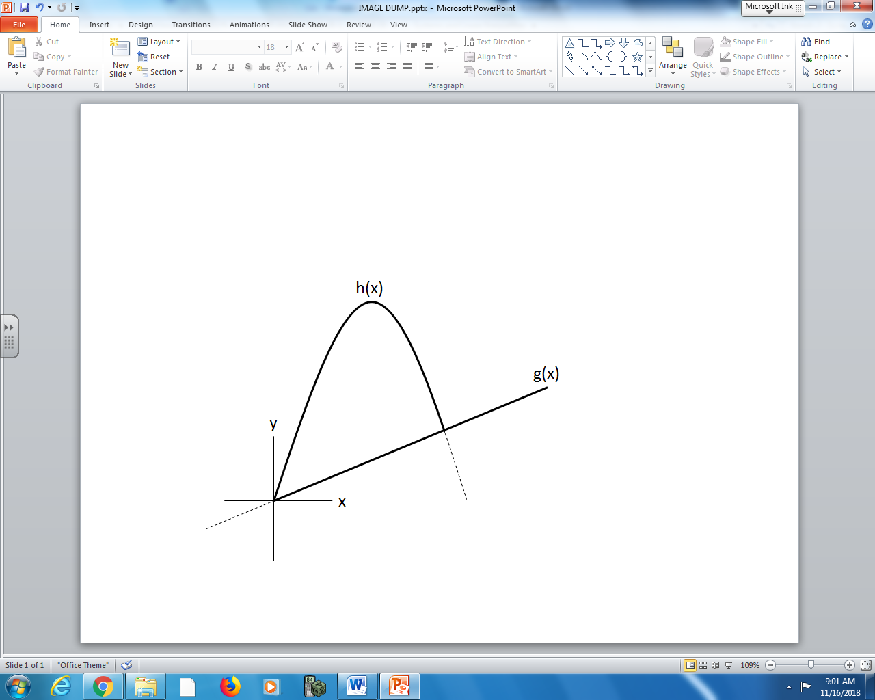

Q12: Algebraically determine the horizontal distance travelled by the kangaroo.

A frog jumps off of a 4cm tall ledge onto a downward sloped hill, per the diagram below.
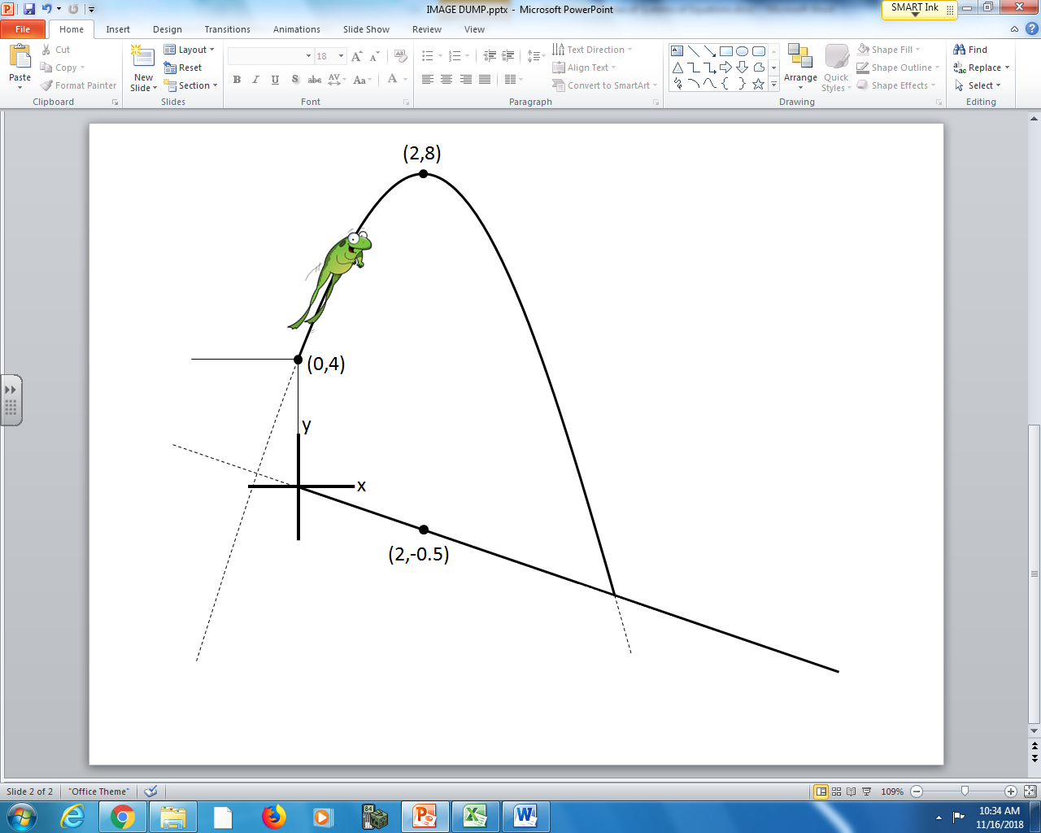
All coordinates are in centimeters.

Q13: The frog lands on the hill after travelling a horizontal distance of a.bc centimeters, where a, b, and c are ___, ___, and ___.
(Record your 3-digit answer in the Numerical Response boxes below)

