L34 – 7.1 Slope y-Intercept
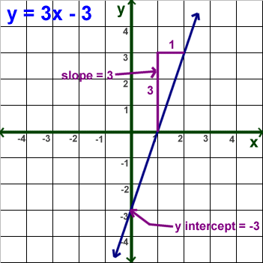
In order to write an equation in slope y-intercept form, you need to find two things:
- Slope –

- y-Intercept –

Part 1 – Understanding Slope y-Intercept Form
Use the following information to answer Q1-Q3:
$$y=\frac{1}{2}x-4$$

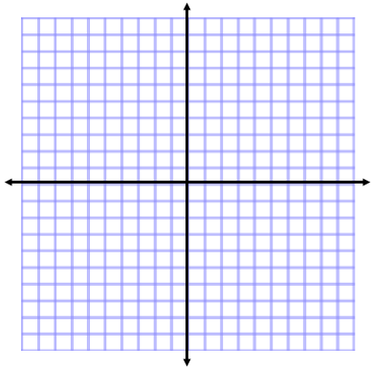
Q1: Complete the table of values and graph the line.
x | y
0
1
2
3
4

Q2: What is the slope of the line? Q3: What is the y-intercept of the line?

Part 2 – Slope y-Intercept Form in Colorado PhET Simulation
Colorado PhET – “Graphing Lines”
https://phet.colorado.edu/sims/html/graphing-lines/latest/graphing-lines_en.html
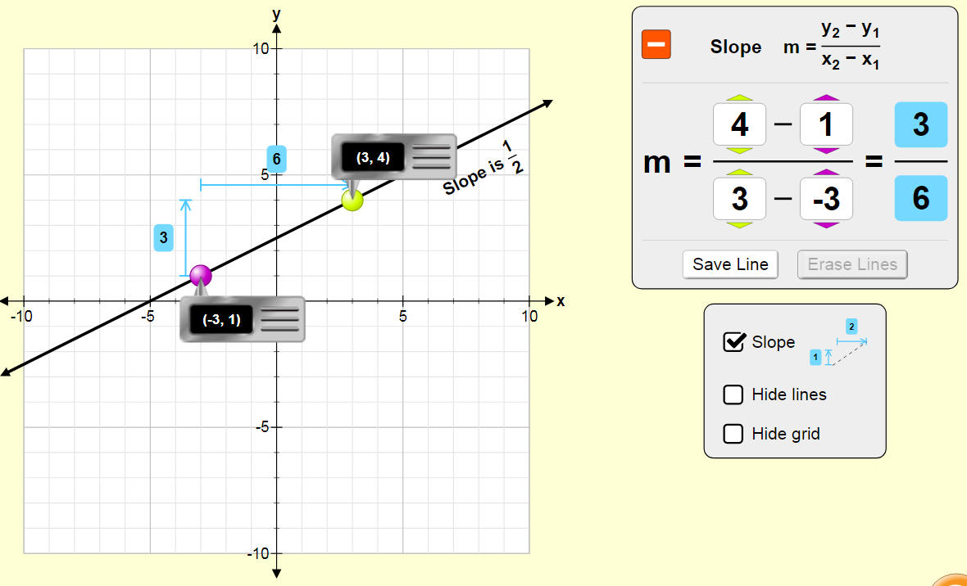
Note that we will be spending an entire day using this simulation in Lesson 40.
Part 3 – Graphing a Line using Slope-Point Form
Q4: Given the equation $f(x)=-\frac{2}{3}x+3$ , graph the relationship.

Part 4 – Determining the Equation from a Graph
Use the following information to answer Q5-Q6:
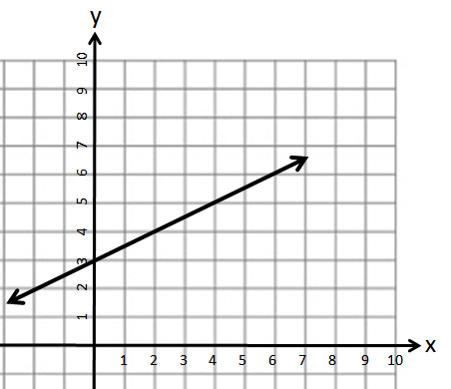

Q5: Determine the equation of the line in Slope y-Intercept form.

Q6: What is f(200) = ?

Part 5 – Determining the Equation from Two Coordinates
Q7: Write the equation of a line in Slope y-Intercept form that passes through the points (6,1) and (9,-1).

Q8: Write the equation of a line in Slope y-Intercept form that passes through the points (4,6) and (7,-3).

Part 5 – Manipulating an Equation to Slope y-Intercept Form
Q9: What is the slope of the line $3x-2y-12=0$ ?

Q10: A line has the same slope as $5x+6y=8$ and has an x-intercept of -2. Find the equation of the line in Slope y-Intercept form.

Part 6 – Textbook Practice
Pg. 349 #1bdf, 3ace, 5 (pick 4), 9ac, 10ac, 14

