L34 – 9.1 Linear Inequalities in Two Variables
Key Ideas in Chapter 9
Solution Region: All the points in the cartesian plane that satisfy an inequality. Also known as the “Solution Set”.
Boundary: A line or curve that separates the cartesian plane into two regions and may or may not be part of the solution region. Draw as a solid line and include in the solution region if the inequality involves $≥$ or $≤$. Draw as a dashed line and don’t include in the solution region if the inequality involves > or <.
Test Point: A point not on the boundary of the graph of an inequality that is representative of all the points in a region. A point that is used to determine whether the points in a region satisfy the inequality.
Key Ideas in Chapter 9.1
Linear Equation in 2 Variables may be in one of these 4 forms:
$Ax+By<C$ $Ax+By>C$
$Ax+By≤C$ $Ax+By≥C$
If $≤$ or $≤$ then the line is solid, and includes the “=” values.
If < or > then the line is dashed, and does not include the “=” values.
Shade the region that satisfies the equation.
To confirm your shaded region, use two test points, one above the line, one below the line. Only the shaded region should satisfy the equation.
If you are given a graph and you need to determine the equation, build it in Slope y-Intercept form.

Part 1 – Graphing in Slope y-Intercept Form
Q1: Graph the following equations:
$y=3x-2$ $y=-\frac{5}{2}x+4$
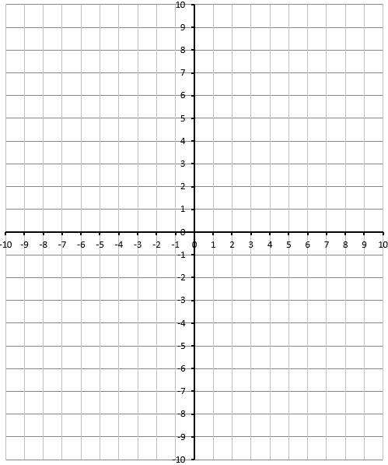
Q2: Graph the following equations:
$y≥2x+5$ $y>\frac{1}{2}x+6$
Q3: Graph the following equations:
$y=-x+4$ $y≤-x+4$
Q4: Graph the following equations:
$y≤\frac{2}{3}x-7$ $y>-\frac{1}{3}x+1$

Part 2 – Test Points and Slope y-Intercept Form
Q5: Graph the function $y≥\frac{2}{3}x+4$ , and determine if the point (-3,5) is part of the solution.
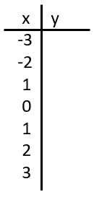

Part 3 – Graphing in Standard Form, Confirm with Test Points
Q6: Graph each function and determine if (2,3) is part of the solution.
$5x+3y≥15$
$2x-3y>6$

