L34 – Worksheet – 9.1 Linear Inequalities in Two Variables
Part 1 – Easy Questions (from Kuta Software – Graphing Linear Inequalities 1)
Q1: Determine the inequalities that corresponds to each graph.
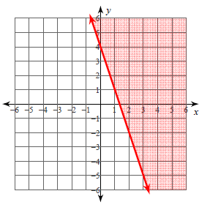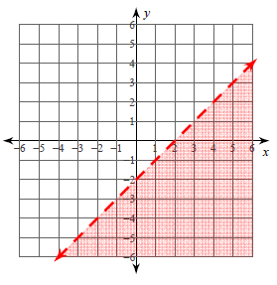

Q2: Graph each inequality.
$y>-x-5$ $y≤\frac{3}{5}x-5$
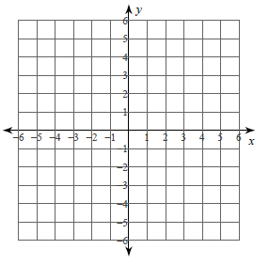

Part 2 – Textbook Questions
Pg 472 #1ad: Which of the ordered pairs are solutions to the given inequality?
$y<x+3$ $2x+y≥6$
{ (7,10) , (-7,10) , (6,7) , (12,9) } { (0,0) , (3,1) , (-4,-2), (6,-4) }

Pg 472 #3ace: Consider each inequality.
- Express y in terms of x, if necessary. Identify the slope and y-intercept.
- Indicate whether the boundary should be a solid line or a dashed line.
$y≤x+3$ $4x+y>7$ $4x+5y≥20$

Pg 472 #5ac: Graph each inequality using technology.
$6x-5y≤18$ $-5x+12y-28>0$

Pg 472 #9acd: Determine the inequality that corresponds to teach graph.
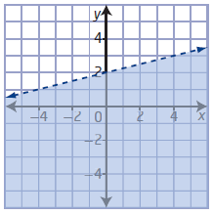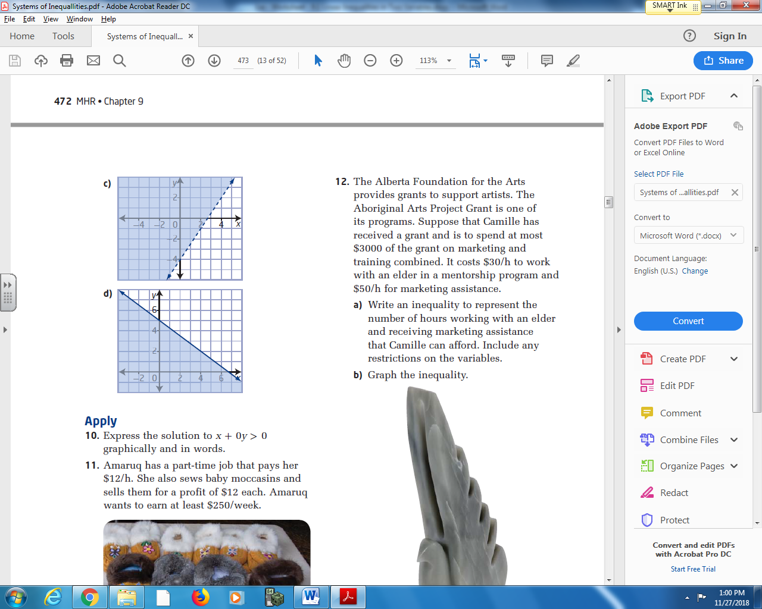

Pg 472 #11: Amaruq has a part-time job that pays her $12/h. She also sews baby moccasins and sells them for a profit of $12 each. Amaruq wants to earn at least $250/week.
- Write an inequality that represents the number of hours that Amaruq can work and the number of baby moccasins she can sell to earn at least $250. Include any restrictions on the variables.

- Graph the inequality.
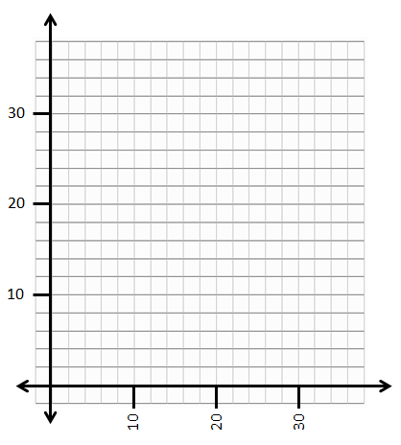
- List three different ordered pairs in the solution.

- Give at least one reason that Amaruq would want to earn income from her part-time job as well as her sewing business, instead of focusing on one method only.
Pg 472 #17: Masha is a video game designer. She treats the computer screen like a grid. Each pixel on the screen is represented by a coordinate pair, with the pixel in the bottom left corner of the screen as (0,0). For one scene in a game she is working on, she needs to have a background like the one shown.
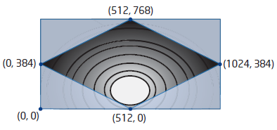
The shaded region (4 corners) on the screen is made up of four inequalities. What are the four inequalities?

