L35 – FQ – 9.1 Linear Inequalities in Two Variables
Q1: Write the equation that models the linear Q2: Sketch the linear inequality $y>\frac{2}{3}x+1$
inequality. (2 mark) below. (2 mark)
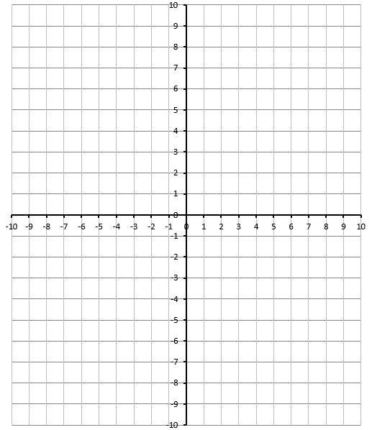
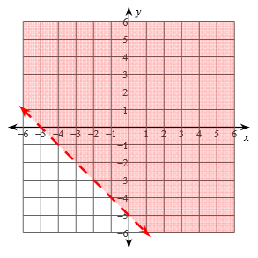

Q3: Is the point (-3,4) part of the solution to $5x+2y≤4$ ? (2 mark)

MARKING:
Beginning 0.0 – 2.5
Progressing 3.0 – 4.0
Competent 4.5 – 5.5
Exemplary 6.0

