L35 – 9.2 Quadratic Inequalities in One Variable
Key Ideas
The solution to a quadratic inequality in one variable is:
- No values
- One value
- Infinite values
If the roots are easy to identify, use those values to identify the domain.
If roots are not easy to identify, then use the Quadratic Formula to solve for the roots, and use those roots to identify the domain.

Part 1 – Solving a Quadratic Inequality in One Variable using Graphing
Q1: The equation $y=0.5x^{2}+2x-6$ is graphed below:
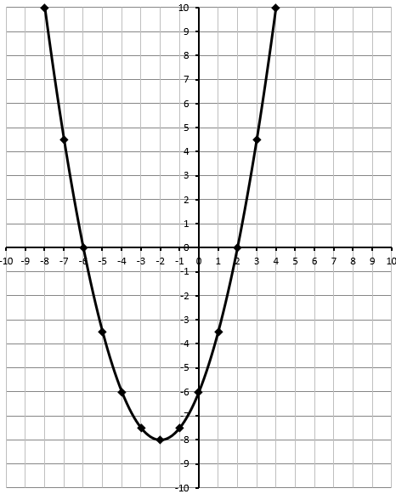
Use this graph to solve the following linear inequalities:
$0.5x^{2}+2x-6≥0$ $0.5x^{2}+2x-6≤0$

$0.5x^{2}+2x-6>0$ $0.5x^{2}+2x-6<0$

Q2: The equation $y=-x^{2}-10x-21$ is graphed below:
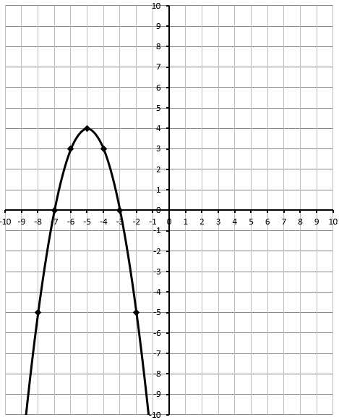
Use this graph to solve the following linear inequalities:
$-x^{2}-10x-21≥0$ $-x^{2}-10x-21≤0$

$-x^{2}-10x-21>0$ $-x^{2}-10x-21<0$

Q3: Graph the equation $y=x^{2}-8x+7$ to solve several linear inequalities.
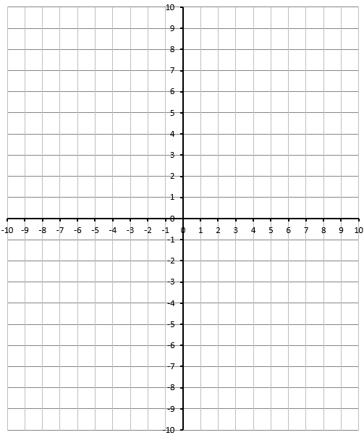
Use this graph to solve the following linear inequalities:
$x^{2}-8x+7 ≥0$ $x^{2}-8x+7 ≤0$

$x^{2}-8x+7 >0$ $x^{2}-8x+7 <0$

Q4: Use graphing to solve the inequality $-2x^{2}+12x-10≥0$.
Part 2 – Solving a Quadratic Inequality in One Variable using Factoring and Sketching
Q5: Use sketching to solve the inequality $x^{2}-x-12<0$.

Q6: Use sketching to solve the inequality $2x^{2}-x-15≥0$.

Q7: Use sketching to solve the inequality $2x^{2}-2x-24≤0$.

Q8: Use sketching to solve the inequality $x^{2}+4x+4≤0$.

Part 3 – Solving a Quadratic Inequality in One Variable using Factoring and Test Points
Q9: Use test points to solve the inequality $x^{2}+12x+32≤0$.

Q10: Use test points to solve the inequality $-x^{2}+13x-40<0$.

Part 4 – Solving a Quadratic Inequality in One Variable using Quadratic Formula and Sketching
Q11: Determine the solutions to the inequality $x^{2}+4x+2≤0$.

