L35 – Worksheet – 9.2 Quadratic Inequalities in One Variable
Part 1 – Basic Concept
Graphed below is the function $y=x^{2}+2x-8$ .
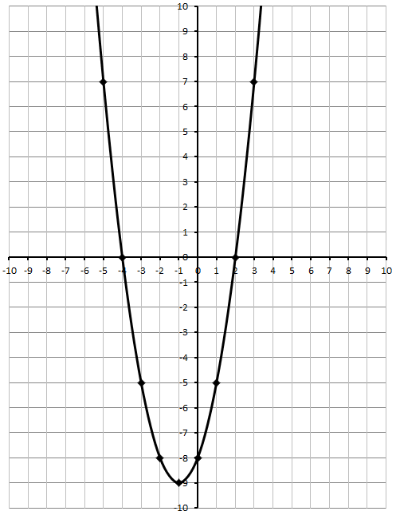
Q1: Use your knowledge of this graph to determine the x-values that satisfy the following inequalities:
- $x^{2}+2x-8≥0$
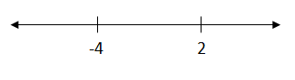

- $x^{2}+2x-8>0$

- $x^{2}+2x-8≤0$

- $x^{2}+2x-8<0$
Part 2 – Easy Questions
Q2: Solve the inequality ${-x}^{2}-7x≥10$
$…solved as-x^{2}-7x-10≥0$ $…solved as 0≥x^{2}+7x+10$
$…or x^{2}+7x+10≤0$

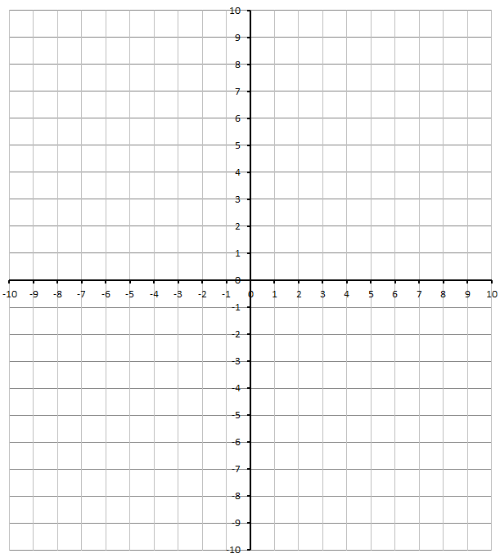
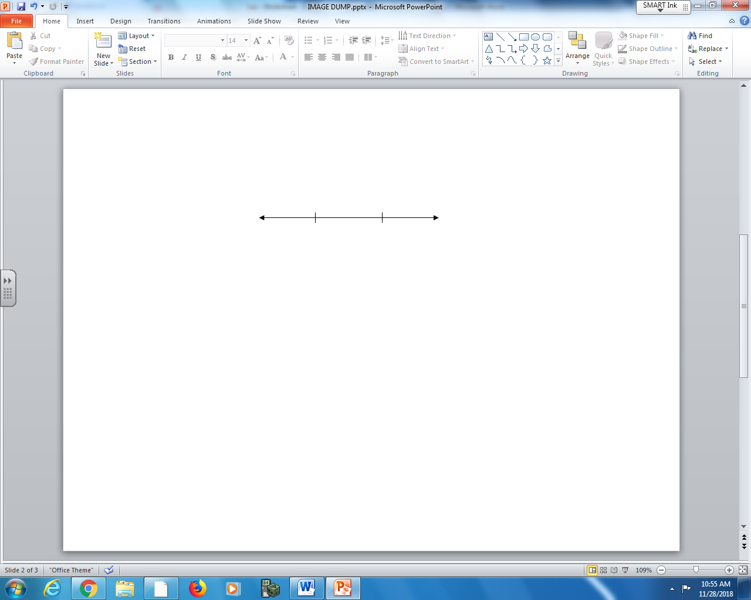

Part 3 – Textbook Questions
Pg 484 #1: Consider the graph of the quadratic function $\left(x\right)=x^{2}-4x+3$ .
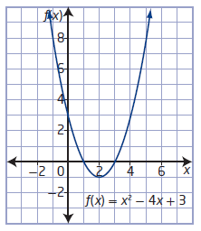
What is the solution to
- $x^{2}-4x+3≤0$

- $x^{2}-4x+3≥0$

- $x^{2}-4x+3>0$

- $x^{2}-4x+3<0$

Pg 484 #3ab: Is the value of x a solution to the given inequality?
$x=4 for x^{2}-3x-10>0$ $x=1 for x^{2}+3x-4≥0$

Pg 484 #3cd: Is the value of x a solution to the given inequality?
$x=-2 for x^{2}+4x+3<0$ $x=-3 for {-x}^{2}-5x-4≤0$

Pg 484 #4bd: Use roots and test points to determine the solution to each inequality.
- $x(x+6)≥40$

- $-x^{2}-14x-24<0$

- $6x^{2}>11x+35$

- $8x+5≤-2x^{2}$

Pg 484 #5bd: Determine the solution to each inequality.
$x^{2}+3≥-4x$ $-6x≥x^{2}-16$

Pg 484 #6bd: Determine the solution to each inequality.
$x^{2}+13x>-12$ $2x^{2}≥8-15x$

Pg 484 #7bd: Determine the solution to each inequality.
$x^{2}≥3x+28$ $4x(x-1)>63$

Pg 484 #9ab: Solve each inequality.
- $x^{2}-3x+6≤10x$

- $2x^{2}+12x-11>x^{2}+2x$+13

Pg 484 #9cd: Solve each inequality.
- $x^{2}-5x<3x^{2}-18x+20$

- $-3\left(x^{2}+4\right)≤3x^{2}-5x-68$

Pg 484 #11: Many farmers in Southern Alberta irrigate their crops. A center-pivot irrigation system spreads water in a circular pattern over a crop.
- Suppose that Murray has acquired rights to irrigate up to 63 ha (hectares) of his land. Write an inequality to model the maximum circular area, in square meters, that he can irrigate.
- What are the possible radii of circles that Murray can irrigate? Express your answer as an exact value.
- Express your answer in part B) to the nearest hundredth of a meter.
Hint: 1 hectare = 10,000 m²

Pg 484 #15abc: For each of the following, give an inequality that has the given solution.
- $-2≤x≤7$

- $x<1 or x>10$

- $\frac{5}{3}≤x≤6$

Pg 484 #15defg: For each of the following, give an inequality that has the given solution.
- $x<-\frac{3}{4} or x>-\frac{1}{5}$

- $x≤-3-\sqrt{7} or x≥-3+\sqrt{7}$

- $x∈R$

- $No solution$

