L36 – FQ – 9.2 Quadratic Inequalities in One Variable
Use the following information to answer Q1-Q2:
Quadratic Inequality in One Variable:
$$\frac{3}{2}{\left(x-2\right)}^{2}-6≥0$$

Q1: Graph the function $=\frac{3}{2}{\left(x-2\right)}^{2}-6$ . (1 mark)
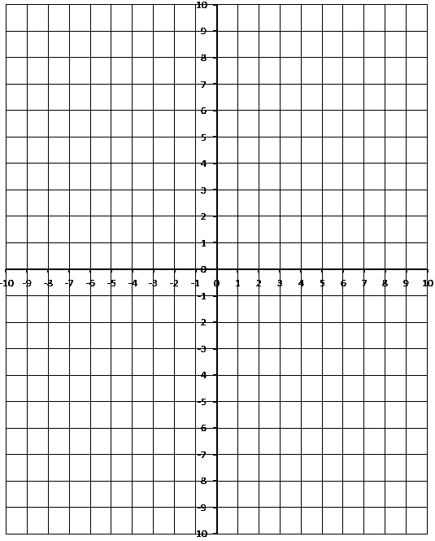
Q2: For which values of x is $\frac{3}{2}{\left(x-2\right)}^{2}-6≥0$ ?
- $\left\{x\right| 0<x<4, x∈R\}$
- $\left\{x\right| 0≤x≤4, x∈R\}$
- $\left\{x\right| x<0 and x>4, x∈R\}$
- $\left\{x\right| x≤0 and x≥4, x∈R\}$

Use the following information to answer Q3:
Linear Inequality in Two Variables:
$$y<\frac{1}{2}x-3$$

Q3: Sketch the linear inequality below. (2 marks)
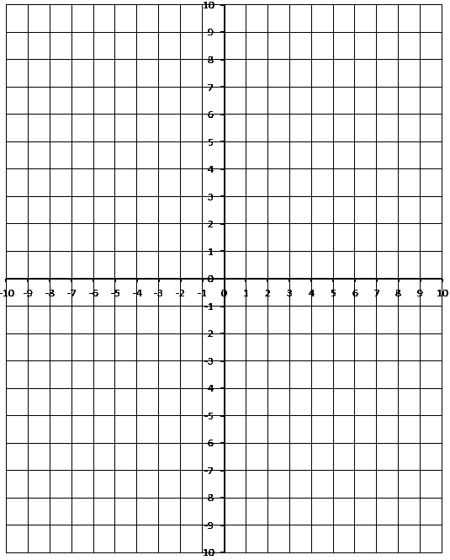

MARKING:
Beginning 0.0 – 1.5
Progressing 2.0 – 2.5
Competent 3.0 – 3.5
Exemplary 4.0

