L36 – 7.2 General Form
General Form – The equation of a line in the form $Ax+By+C=0$ , where A, B, and C are integers, and A and B are not both zero.
By convention, A is a whole number.
Part 1 – Finding Intercepts to Graph
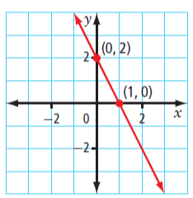
x – intercept: The x - coordinate of the point where a line or curve crosses the x – axis. The value of x when y=0.

y – intercept: The y - coordinate of the point where a line or curve crosses the y – axis. The value of y when x=0.

Q1: $2x+3y-12=0$
x-Intercept (Set y=0)

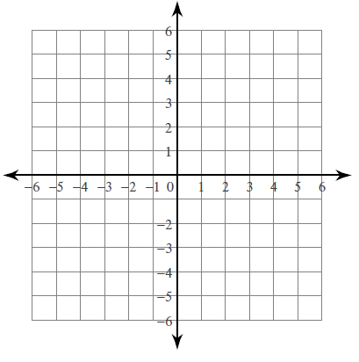
y-Intercept (Set x=0)

Q2: $5x-2y+10=0$
x-Intercept (Set y=0)

y-Intercept (Set x=0)

Q3: $2x-4y-8=0$
x-Intercept (Set y=0)

y-Intercept (Set x=0)

Part 2 – Transforming between General Form and Slope y-Intercept Form
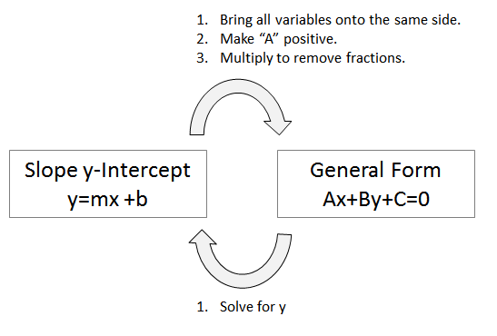
Q4: Write the equation $y=2x-5$ in General Form.

Q5: Write the equation $y=\frac{2}{3}x+4$ in General Form.

Q6: Write the equation $4x+5y+20=0$ in Slope y-Intercept Form.

Part 3 – Graphing Vertical and Horizontal Lines
Q7: Graph the following lines below:
$x=-3$ $x=4$ $y=6$

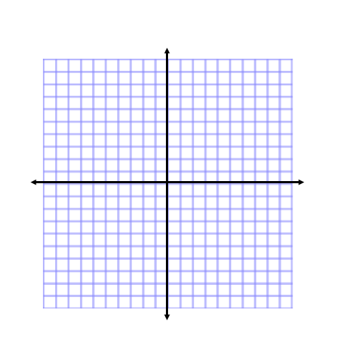

Part 4 – Determining the Equation from a Graph
Q8: Write the equation in (a) Slope y-Intercept form and (b) General form.
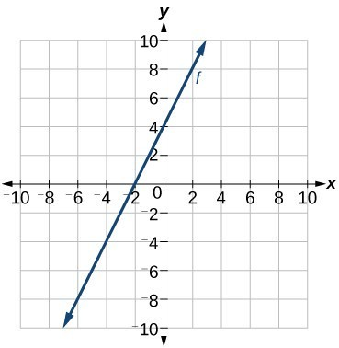
Part 6 – Textbook Practice
Pg. 365 #1, 2ace, 3aceg, 4, 6

