L36 – 9.3 Quadratic Inequalities in Two Variables
Part 1 – Three Basic Concepts (9.1, 9,2 , 9.3)
$y≥\frac{3}{2}x-2$ $x^{2}+3x-4>0$ $y≤0.1x^{2}-0.5x-4$
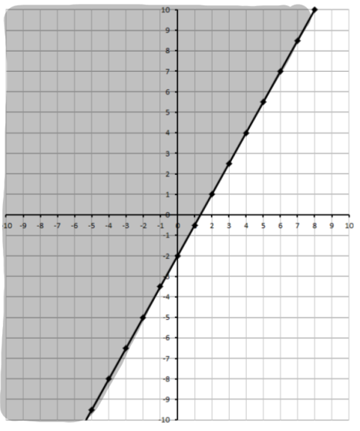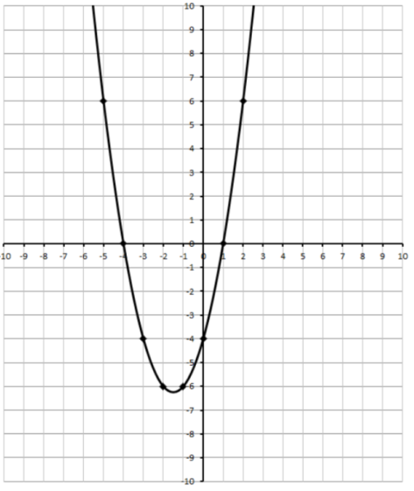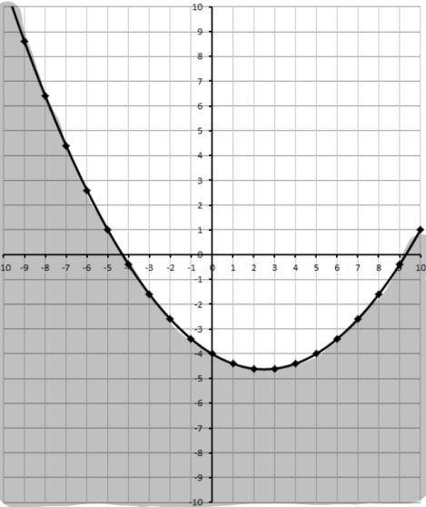
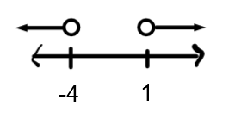
Part 2 – Solving a Quadratic Inequality in Two Variables
Q1: Graph the following equations:
$y={(x+3)}^{2}-4$ $y≥{(x+3)}^{2}-4$
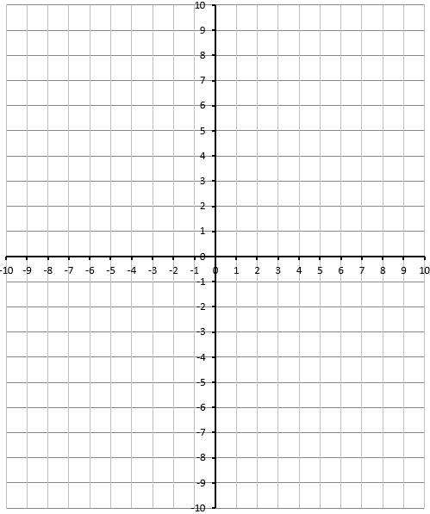
$y>{(x+3)}^{2}-4$ $y<{(x+3)}^{2}-4$

Part 3 – Quadratic Equations in One Variable versus Two Variables
Q2: Solve the inequality $\frac{1}{2}x^{2}+2x-6<0$ Q3: Graph the inequality $y<\frac{1}{2}x^{2}+2x-6$

Q4: Solve the inequality $-x^{2}-10x-21≥0$ Q5: Graph the inequality $y≥-x^{2}-10x-21$

Part 4 – Ordered Pairs
Q6: Which of the following ordered pairs is a solution to the inequality $≤x^{2}-6x+12$ ?
- (2,5) b. (2,2) c. (-1,6) d. (3,3)

