L36 – Worksheet – 9.3 Quadratic Inequalities in Two Variables
Part 1 – Three Basic Concepts (9.1, 9,2 , 9.3)
$y≥\frac{3}{2}x-2$ $x^{2}+3x-4>0$ $y≤0.1x^{2}-0.5x-4$
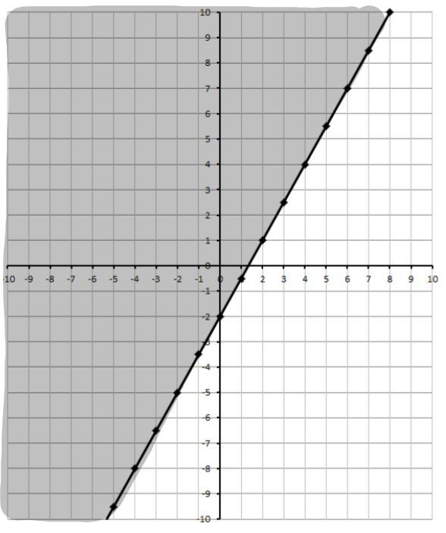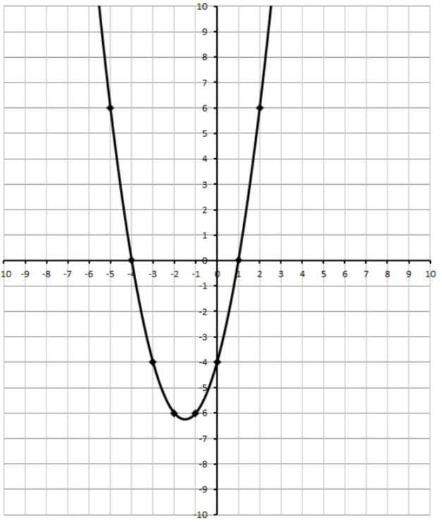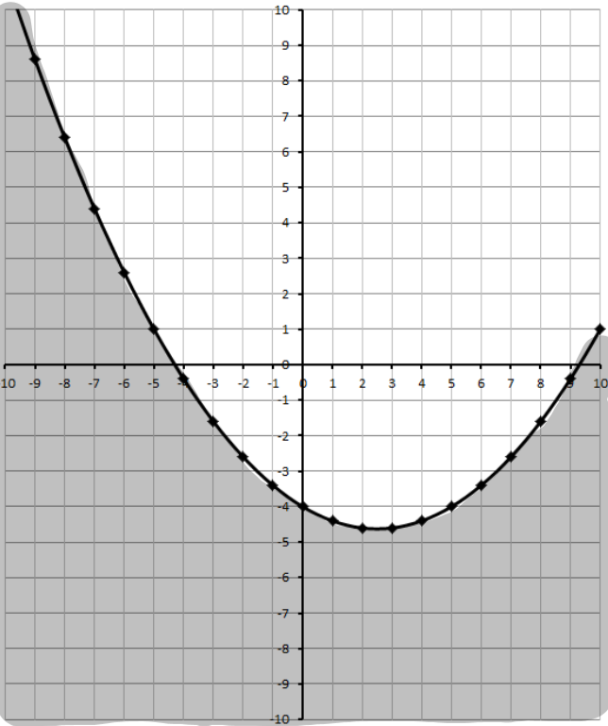
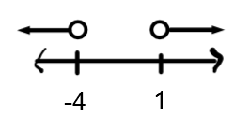
Part 2 – Textbook Questions
Pg 496 #1: Which of the ordered pairs are solutions to the inequality?
$$y<x^{2}+3$$
{ (2,6) , (4, 20) , (-1,3) , (-3,12) }

$$y≤{-x}^{2}+3x-4$$
{ (2,-2) , (4, -1) , (0,-6) , (-2,-15) }

$$y>{2x}^{2}+3x+6$$
{ (-3,5) , (0, -6) , (2,10) , (5, 40) }

$$y≥-\frac{1}{2}x^{2}-x+5$$
{ (-4,2) , (-1, 5) , (1,3.5) , (3 ,2.5) }

Pg 496 #3abc: Write an inequality to describe each graph given the function defining the boundary parabola.
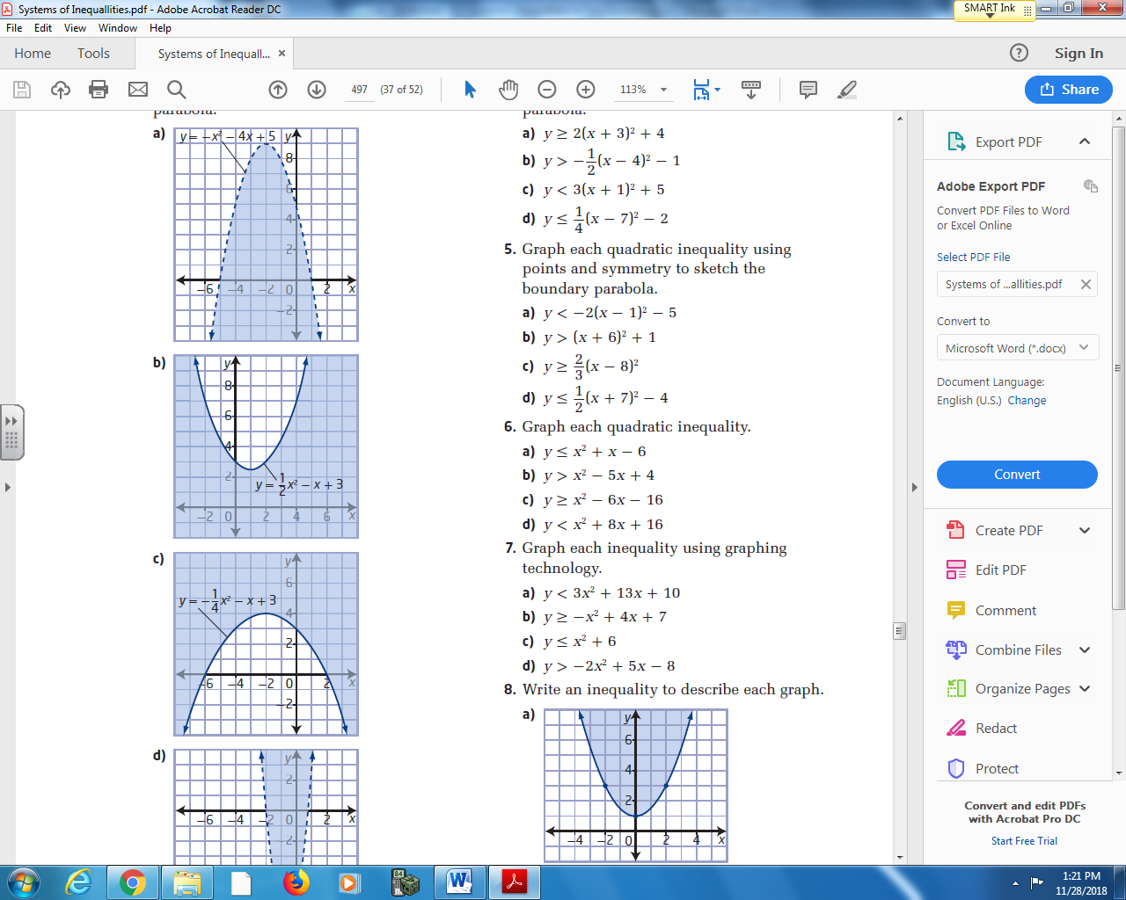

Pg 496 #4bd: Graph each quadratic inequality using transformations to sketch the boundary parabola.
$y>-\frac{1}{2}{\left(x-4\right)}^{2}-1$ $y≤\frac{1}{4}{\left(x-7\right)}^{2}-2$

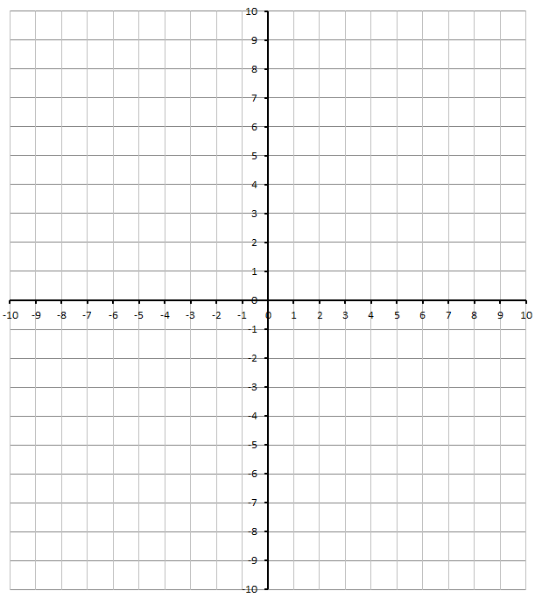
Pg 496 #5bd: Graph each quadratic inequality using points and symmetry to sketch the boundary parabola.
$y>{\left(x+6\right)}^{2}+1$ $y≤\frac{1}{2}{\left(x+7\right)}^{2}-4$

Pg 496 #6bd: Graph each inequality.
$y>x^{2}-5x+4$ $y<x^{2}+8x+16$

Pg 496 #7bd: Graph each inequality using graphing technology.
$y≥{-x}^{2}+4x+7$ $y>-2x^{2}+5x-8$

Pg 496 #9: When a dam is built across a river, it is often constructed in the shape of a parabola. A parabola is used so that the force that the river exerts on the dam helps hold the dam together. Suppose a dam is to be built as shown in the diagram.
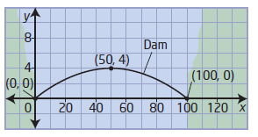
- What is the quadratic function that models the parabolic arch of the dam?
- Write the inequality that approximates the region below the parabolic arch of the dam.

Pg 496 #13: A highway goes under a bridge formed by a parabolic arch, as shown. The highest point of the arch is 5 m high. The road is 10 m wide, and the minimum height of the bridge over the road is 4 m.
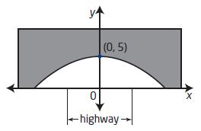
- Determine the quadratic function that models the parabolic arch of the bridge.
- What is the inequality that represents the space under the bridge in quadrants I and II?

Pg 496 #15: Oil is often recovered from a formation bounded by layers of rock that form a parabolic shape. Suppose a geologist has discovered such an oil-bearing formation. The quadratic functions that model the rock layers are $y=-0.0001x^{2}-600$ and $=-0.0002x^{2}-700$ , where x represents the horizontal distance from the center of the formation and y represents the depth below ground level, both in meters. Write the inequality that describes the oil-bearing formation.
