First Name:______________________________ Last Name:______________________________

L36 – Worksheet – Graphing Lines in General Form

Q1: $x+y+4=0$
x-Intercept (Set y=0)
$$x+\left(0\right)+4=0$$
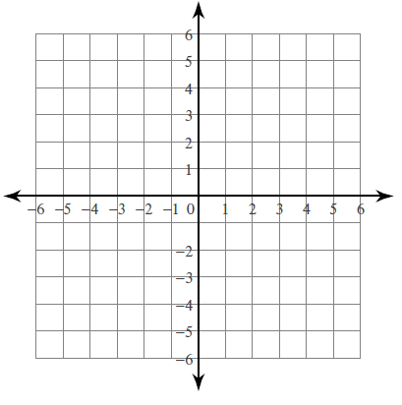
y-Intercept (Set x=0)
$$(0)+y+4=0$$
Q2: $2x+y-1=0$
x-Intercept (Set y=0)

y-Intercept (Set x=0)

Q3: $x-y+1=0$
x-Intercept
y-Intercept

Q4: $2x+y-4=0$

Q5: $x-3y-6=0$
Q6: $x+2y-8=0$
Q7: $x-2y+4=0$
Q8: $2x+3y-6=0$
Q9: $5x-2y-10=0$
Q10: $x=5$
Q11: $y=-4$
Q12: $x+2y=0$

Use the following information to answer Q13-Q15:
$$2x+3y-6=0$$

Q13: Determine the x-intercept and y-intercept.

Q14: Write the equation in the form $y=mx+b$

Q15: Graph the equation.
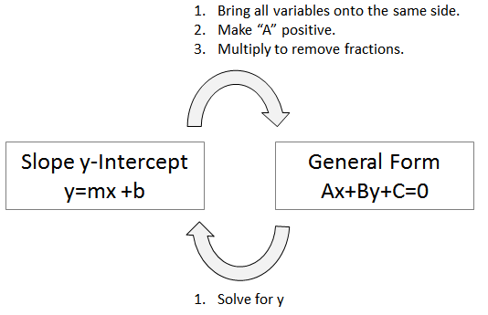

Use the following information to answer Q16-Q18:
$$3x-y+6=0$$

Q16: Determine the x-intercept and y-intercept.

Q17: Write the equation in the form $y=mx+b$

Q18: Graph the equation.

