L37 – 73 Slope Point Form
Part 1 – Understanding Slope y-Point Form
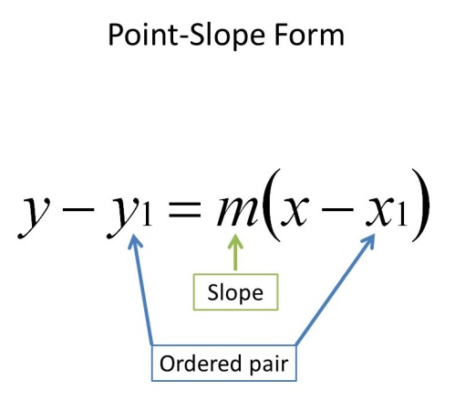
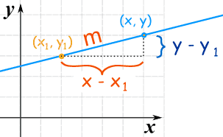

Derivation:

Slope Point Form:
It is called slope-point form because we need the slope and one point in order to write the equation:
- .

- .

Part 2 – Slope y-Intercept Form in Colorado PhET Simulation
Colorado PhET – “Graphing Lines”
https://phet.colorado.edu/sims/html/graphing-lines/latest/graphing-lines_en.html
Note that we will be spending an entire day using this simulation in Lesson 38.

Part 3 – Slope y-Intercept Form in Colorado PhET Simulation
Q1: Use slope-point form to write an equation of the line through (4,3) with a slope of -2.
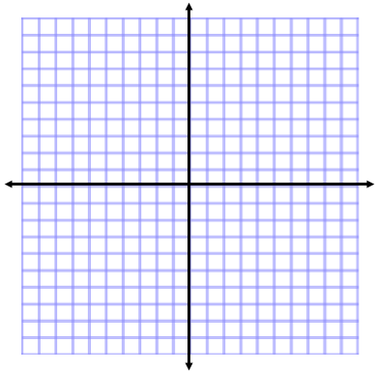

Q2: Use slope-point form to write an equation of a line that passes through (5,-7) with a slope of 2/3.

Q3: Use slope-point form to write an equation of a line that passes through (2,-4) and (-3,6).

Q4: The line $\left(y-5\right)=4(x+3)$ passes through the point:
- (3,5)
- (-3,5)
- (3,-5)
- (-3,-5)

Part 4 – Equations from a Graph
Q5: Write the equation of the graph:
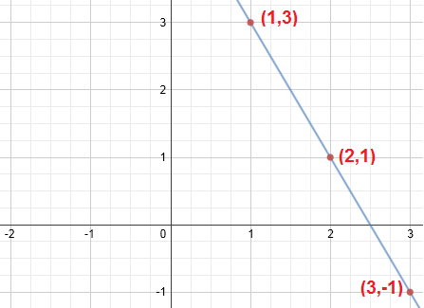

Part 6 – Changing the Form of an Equation
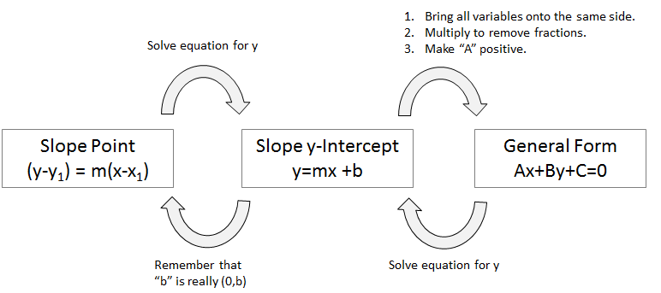
Q6: Rewrite the slope-point equation in slope y-intercept form and general form.
$$y - 2 = -4 ( x + 3)$$

Q7: Rewrite the general equation in slope y-intercept form and slope-point form.
$$2x + 3y - 9 =0$$

Q8: Rewrite the slope y-intercept equation in general form and slope-point form.
$$y =\frac{5}{2} x - 1$$

Part 6 – Textbook Practice
Pg. 377 #1-3, 6 (complete half), 7, 14, 15

