L37 – Handout – Word Problems
Part 1 – Three Basic Concepts (9.1, 9,2 , 9.3)
$y≥\frac{3}{2}x-2$ $x^{2}+3x-4>0$ $y≤0.1x^{2}-0.5x-4$
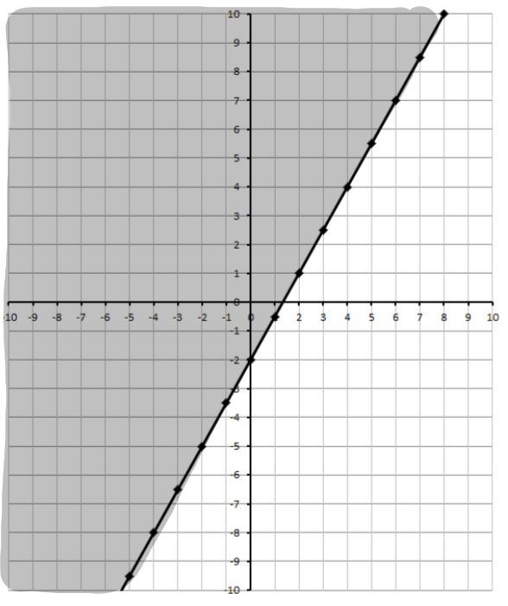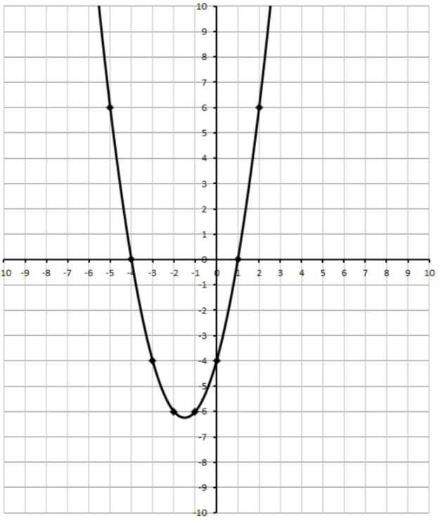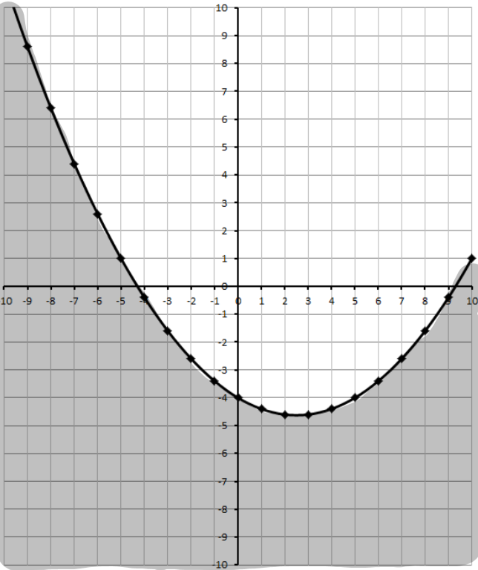
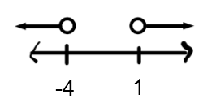
Part 2 – Quick Review
$y<\frac{3}{2}x+2$ $\frac{1}{2}x^{2}+5x+\frac{9}{2}≥0$ $y<-x^{2}+12x-27$


Part 3 – Word Problems
Pg 472 #11: Amaruq has a part-time job that pays her $12/h. She also sews baby moccasins and sells them for a profit of $12 each. Amaruq wants to earn at least $250/week.
- Write an inequality that represents the number of hours that Amaruq can work and the number of baby moccasins she can sell to earn at least $250. Include any restrictions on the variables.

- Graph the inequality.
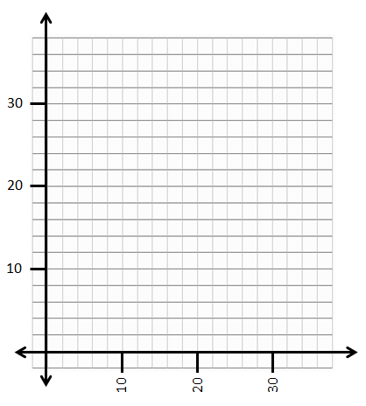
- List three different ordered pairs in the solution.

- Give at least one reason that Amaruq would want to earn income from her part-time job as well as her sewing business, instead of focusing on one method only.
Pg 472 #17: Masha is a video game designer. She treats the computer screen like a grid. Each pixel on the screen is represented by a coordinate pair, with the pixel in the bottom left corner of the screen as (0,0). For one scene in a game she is working on, she needs to have a background like the one shown.
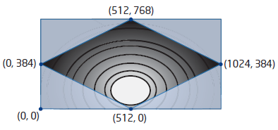
The shaded region (4 corners) on the screen is made up of four inequalities. What are the four inequalities?

Pg 484 #11: Many farmers in Southern Alberta irrigate their crops. A center-pivot irrigation system spreads water in a circular pattern over a crop.
- Suppose that Murray has acquired rights to irrigate up to 63 ha (hectares) of his land. Write an inequality to model the maximum circular area, in square meters, that he can irrigate.
- What are the possible radii of circles that Murray can irrigate? Express your answer as an exact value.
- Express your answer in part B) to the nearest hundredth of a meter.
Hint: 1 hectare = 10,000 m²

Pg 496 #9: When a dam is built across a river, it is often constructed in the shape of a parabola. A parabola is used so that the force that the river exerts on the dam helps hold the dam together. Suppose a dam is to be built as shown in the diagram.
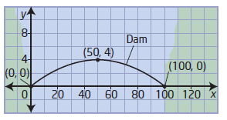
- What is the quadratic function that models the parabolic arch of the dam?
- Write the inequality that approximates the region below the parabolic arch of the dam.

Pg 496 #13: A highway goes under a bridge formed by a parabolic arch, as shown. The highest point of the arch is 5 m high. The road is 10 m wide, and the minimum height of the bridge over the road is 4 m.
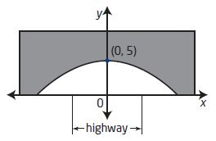
- Determine the quadratic function that models the parabolic arch of the bridge.
- What is the inequality that represents the space under the bridge in quadrants I and II?

Pg 496 #15: Oil is often recovered from a formation bounded by layers of rock that form a parabolic shape. Suppose a geologist has discovered such an oil-bearing formation. The quadratic functions that model the rock layers are $y=-0.0001x^{2}-600$ and $=-0.0002x^{2}-700$ , where x represents the horizontal distance from the center of the formation and y represents the depth below ground level, both in meters. Write the inequality that describes the oil-bearing formation.
