First Name:________________________________ Last Name:______________________________

L41 – FQ – All Forms of an Equation of a Line

Use the following information to answer Q1:
A line passes through the points (-6,-3) and (2,2).

Q1: The equation of the line, in Slope y-Intercept Form, is $y=\frac{d}{e}x+\frac{f}{g}$ , where d, e, f and g are ___, ___, ___and ___.
(Record your four digit answer in the Numerical Response boxes below)

Q2: (Long Answer) Write the equation $4x+3y-14=0$ in Slope y-Intercept Form. (2 marks)
Use the following information to answer Q3-Q4:
A line has a y-intercept of 5 and an x-intercept of -3.

Q3: The slope of the line is
- $\frac{3}{5}$
- $-\frac{3}{5}$
- $\frac{5}{3}$
- $-\frac{5}{3}$

Q4: The line can be written in the form $ax-by+cd=0$, where a, b, c, and d are ___, ___, ___, and ___.
(Record your four digit answer in the Numerical Response boxes below)

Q5: (Long Answer) A line has the same slope as the linear function graphed below, but has an x-intercept of -2. Write the equation of the line in general form. (2 marks)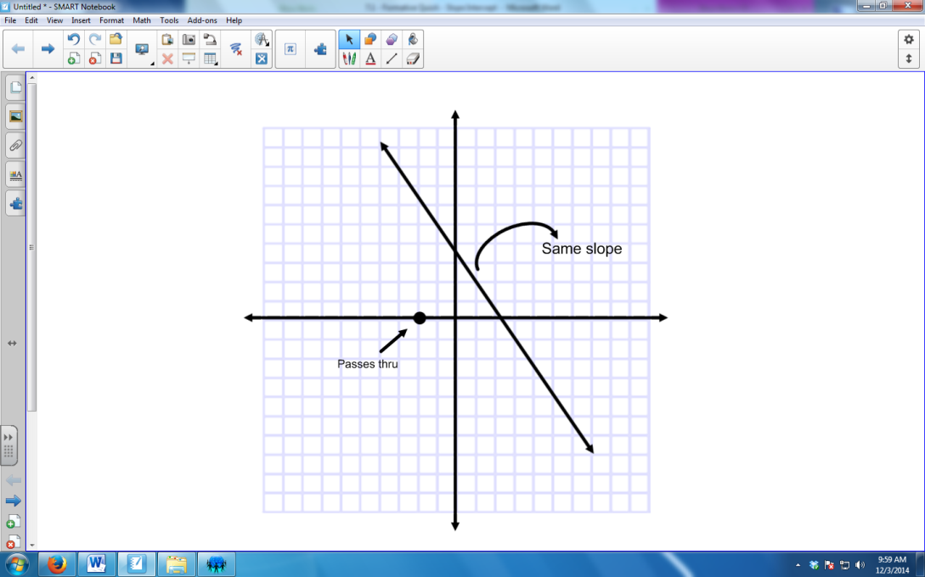

Q6: (Long Answer) Graph the line that is perpendicular to $\left(y-5\right)=\frac{2}{5}(x+1)$ and that passes through the point (4,4). (2 marks)
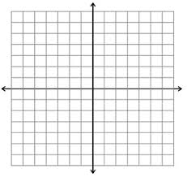

MARKING:
Beginning 0.0 – 4.0
Progressing 4.5 – 6.5
Competent 7.0 – 8.5
Exemplary 9.0

