L41 – 7.1 Absolute Values
Key Ideas
The absolute value of a real number x is the non-negative value of x without regard to its sign.
- |5| = 5
- |-5| = 5
In terms of Physics, the absolute value is analogous to the magnitude of the vector (how big the number is, regardless of sign/direction).
Part 1 – Absolute Value of Numbers
Q1: Evaluate the following:
|4| |-3| |16| |-200|

|-35| |22| |-0.56| |3x10²|

Part 2 – Expressions with Absolute Values
Q2: Evaluate the following:
$\left|5-8\right|$ $\left|4\right|-5$ $\left|3^{2}-15\right|-12$

$2\left|5-8\right|+2$ $\frac{2}{3}\left|2^{3}-14\right|$ $9-\frac{7}{2}\left|2-6\right|$

Part 3 – Calculating Differences using Absolute Values
Use the following information to answer Q3:
Distances along a running path are marked, with a central gazebo marked as “0 km”.
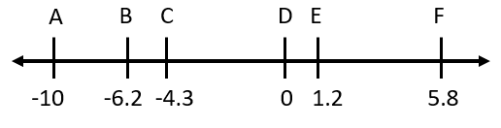
Q3: Determine the following distances:
A to B B to A E to F

A to E C to E F to B

