L41 – Worksheet – 7.1 Absolute Value
Part 1 – Textbook Questions
Pg 363 #1: Evaluate.
$\left|9\right|$ $\left|0\right|$ $\left|-7\right|$ $\left|-4.728\right|$ $\left|6.25\right|$ $\left|-5\frac{1}{2}\right|$

Pg 363 #3: Order the numbers from greatest to least.
$$-2.4 , \left|1.3\right| , \left|-\frac{7}{5}\right| , -1.9 , \left|-0.6\right| , \left|1\frac{1}{10}\right| , 2.2$$

Pg 363 #5: Use absolute value symbols to write an expression for the distance between each pair of specified points on the number line. Determine the distance.
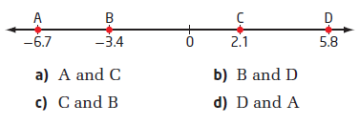

Pg 363 #6abc: Determine the value of each absolute value.
$2\left|-6-(-11)\right|$ $\left|-9.5\right|-\left|12.3\right|$ $3\left|\frac{1}{2}\right|+5\left|-\frac{3}{4}\right|$

Pg 363 #6de: Determine the value of each absolute value.
$\left|3{(-2)}^{2}+5\left(-2\right)+7\right|$ $\left|-4+13\right|+\left|6-(-9)\right|-\left|8-17\right|+\left|-2\right|$

Pg 363 #8: Southern Alberta often experiences dry chinook winds in winter and spring that can change temperatures by a large amount in a short time. On a particular day in Warner, Alberta, the temperature was -11⁰C in the morning. A chinook wind raised the temperature to +7⁰C by afternoon. The temperature dropped to -9⁰C during the night. Use absolute value symbols to write an expression for the total change in temperature that day. What is the total change in temperature that day?

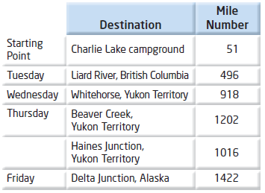
Pg 363 #10: The Alaska highway runs from Dawson Creek, British Columbia, to Delta Junction, Alaska. Travel guides along the highway mark historic mileposts, from mile 9 in Dawson Creek to mile 1422 in Delta Junction. The table shows the Ramsay family’s trip along this highway.
Use an expression involving absolute value symbols to determine the total distance. In miles, that the Ramsay family travelled in these four days.

Pg 363 #16: As part of a scavenger hunt, Toby collects items along a specified trail. Starting at the 2-km marker, he bicycles east to the 7-km marker, and then turns around and bicycles west back to the 3-km marker. Finally, Toby turns back east and bicycles until the total distance he has travelled is 15km.
- How many kilometers does Toby travel in the last interval?
- At what kilometer marker is Toby at the end of the scavenger hunt?

Pg 363 #19: Julia states, “To determine the absolute value of any number, change the sign of the number.” Use an example to show that Julia is incorrect. In your own words, correctly complete the statement, “To determine the absolute value of a number, …”

