L42 – 7.2 Absolute Value Functions
Key Ideas
Absolute Value brackets can be found in your calculator (MATH > NUM > 1. Abs)
Working with Absolute Value Functions Graphically:
- Input into your calculator graphing using the Abs(), then use 2nd CALC to find your y-intercept, x-intercept, minimum or maximum values, Domain and Range.
Working with Absolute Value Functions Algebraically:
- A piecewise function $y=\left\{\begin{aligned}f\left(x\right), if f(x)≥0 \\ -f\left(x\right), if f(x)<0\end{aligned}\right.$
- Domain of y=|f(x)| is the same as f(x)
- Range of y=|f(x)| depends on the range of y=f(x)
For the Absolute Value of a linear or quadratic function, the range will generally be, but not always, $\{y|y≥0, y∈R\}$
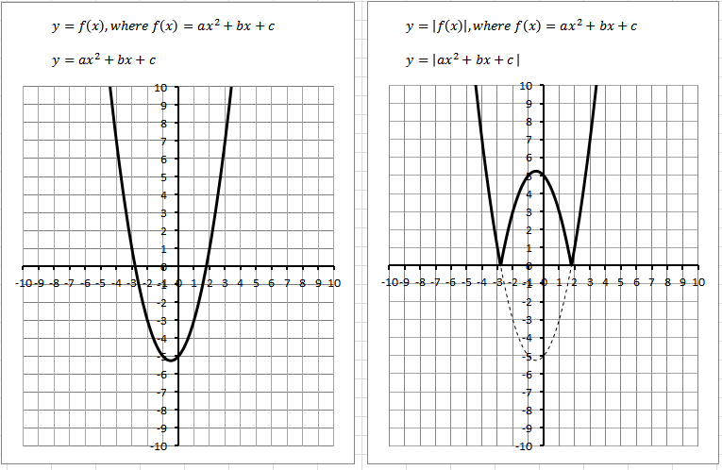
See “L41 – Tool – Absolute Value and Reciprocal Functions” Excel sheet.

Part 1 – Mirror Images
Complete the images. Ensure the missing side is a mirror image of the given side.
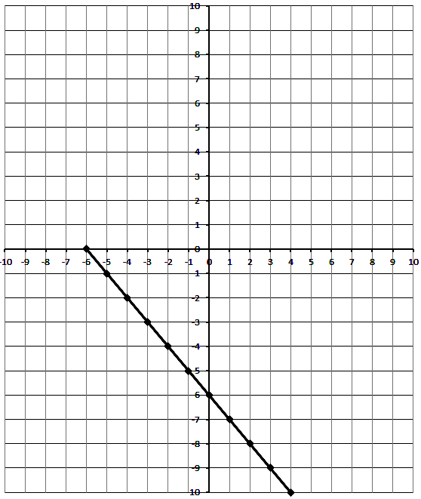
Part 2 – Absolute Value Functions
Q1: Complete the table and sketch the graph for $y=\left|x+1\right|$
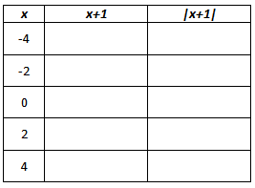
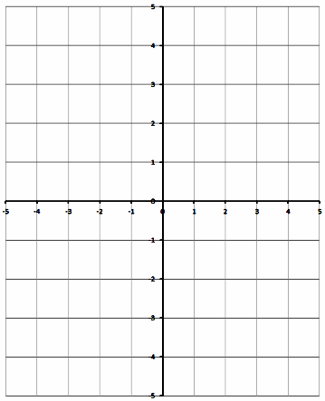

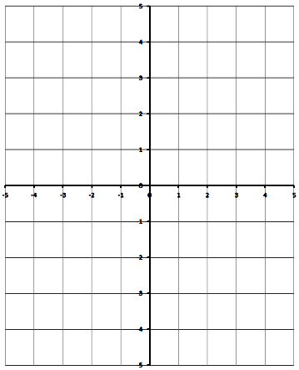
Q2: Complete the table and sketch the graph for $y=\left|x^{2}-4\right|$
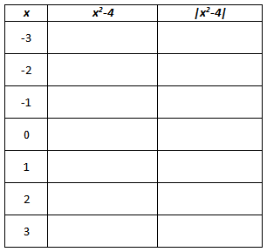

Q3: Given the function, sketch the absolute value function on the same graph paper.
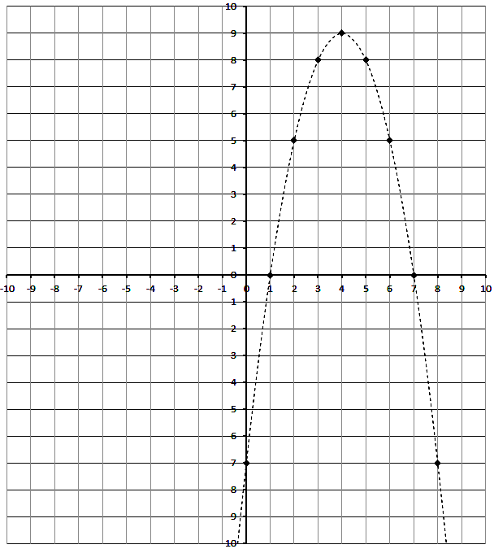
Q4: For the given graph, determine the piecewise function.
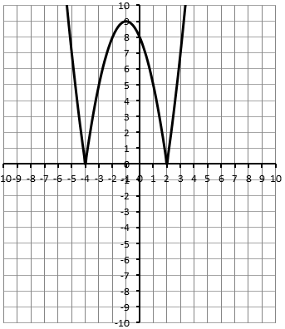
Q5: For the given graph, determine the piecewise function.
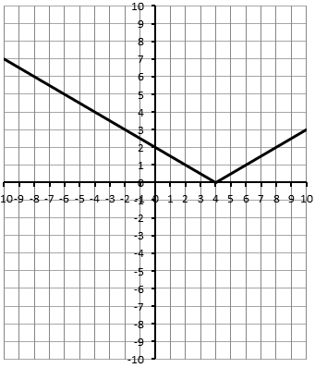
Part 3 – Graphing Absolute Value Functions using a T.I. Calculator
Q6: Graph the two functions using your T.I. Calculator
$$f\left(x\right)=x^{2}-5x+4$$
$$g\left(x\right)=\left|x^{2}-5x+4\right|$$
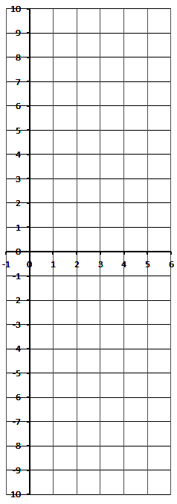
Build a table of values for each:
