L42 – Chapter 7 Review
Part 1 – Slope y-Intercept Form (y=mx+b)
Q1: Write the equation of the line in Slope y-Intercept Form.
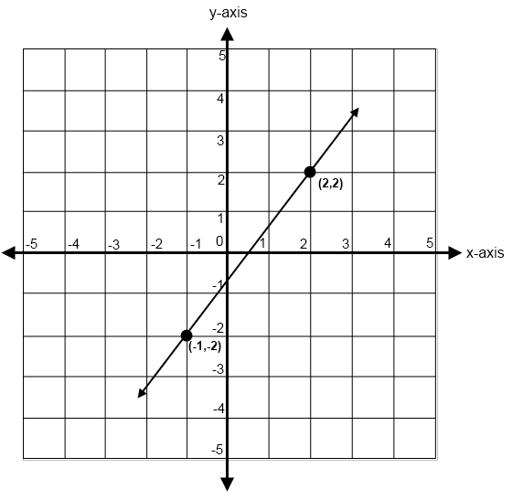
Part 2 – General Form (Ax+By+C=0)
Q2: Graph the line 5x+2y-20=0
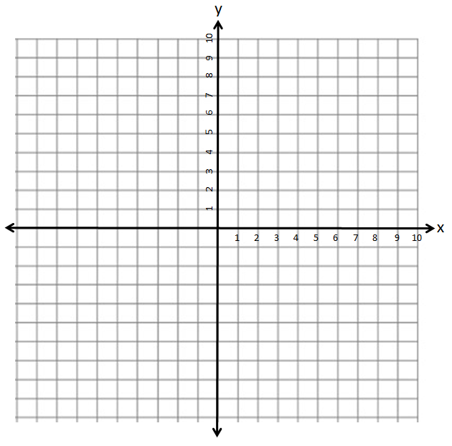
Part 3 – Slope-Point Form (y-y₁)=m(x-x₁)
Q3: Write the equation of the line in Slope Point Form.
Part 4 – Transitioning Forms
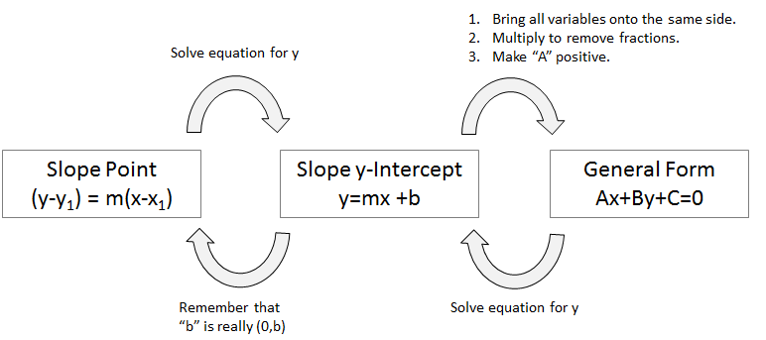

Part 5 – Parallel and Perpendicular
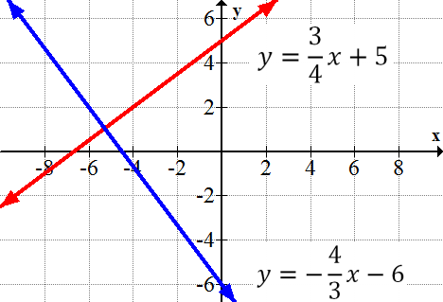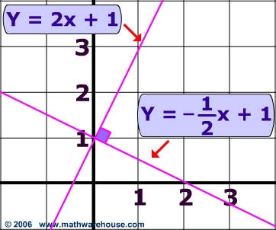

Parallel:

Perpendicular:

Part 6 – Word Problems
Q4: Bill decides that every week he is going to put his allowance in his piggy bank. After 5 weeks he has $93. After 9 weeks he has $153. How much money did Bill start with?

