L42 – Worksheet – 7.2 Absolute Value Functions
Part 1 – Overview
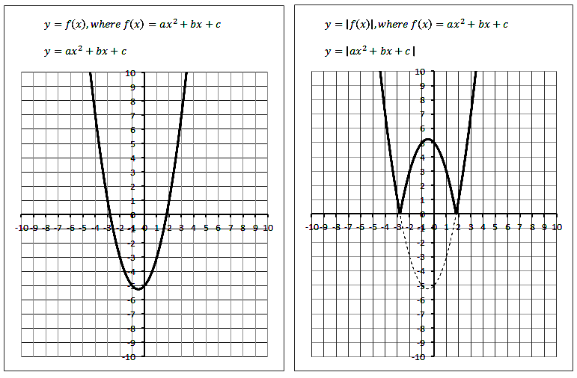
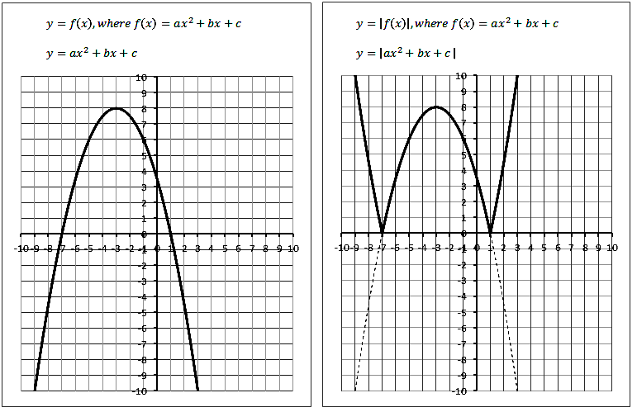
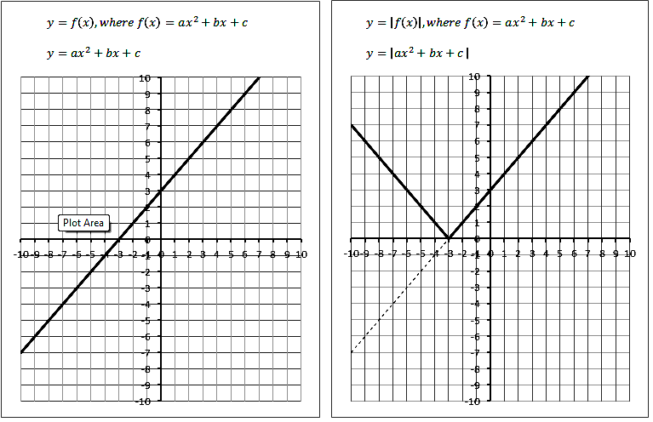
Part 2 – Textbook Questions
Pg 375#3: The graph of $y=f(x)$ has an x-intercept of 3 and a y-intercept of -4. What are the x-intercept and the y-intercept of the graph of $=\left|f(x)\right|$ ?
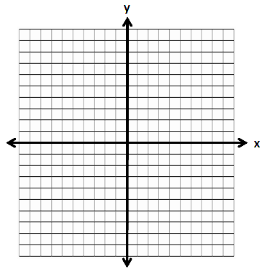

Pg 375#5: Below is a graph of $y=f(x)$. On the same set of axes, sketch the graph of $y=\left|f(x)\right|$.
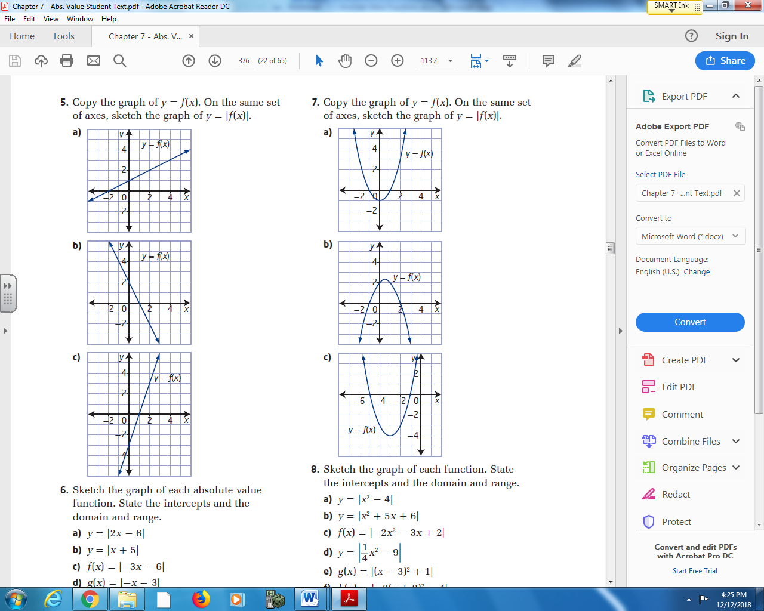

Pg 375#6ac: Sketch the graph of each absolute value function. State the intercepts and the domain and range.
$y=\left|2x-6\right|$ $f\left(x\right)=\left|-3x-6\right|$

Pg 375#e: Sketch the graph of each absolute value function. State the intercepts and the domain and range.
$y=\left|\frac{1}{2}x-2\right|$
Pg 375#7: Below is a graph of $y=f(x)$. On the same set of axis, sketch the graph of $y=\left|f(x)\right|$.
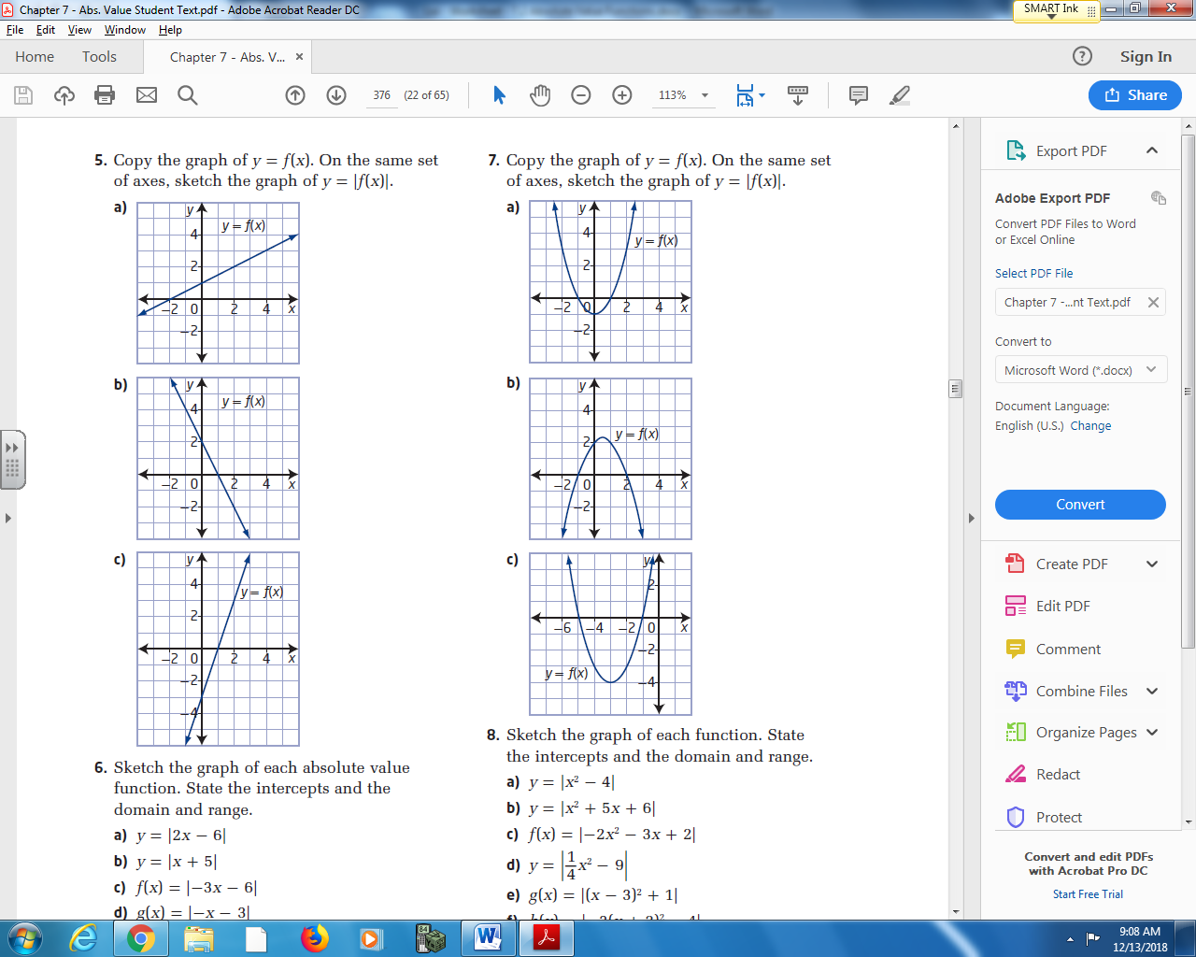

Pg 375#8ae: Sketch the graph of each function. State the intercepts and the domain and range.
$y=\left|x^{2}-4\right|$ $g\left(x\right)=\left|{\left(x-3\right)}^{2}+1\right|$

Pg 375#8c: Sketch the graph of each function. State the intercepts and the domain and range.
$f(x)=\left|-2x^{2}-3x+2\right|$
Pg 375#9: Write the piecewise function that represents each graph.
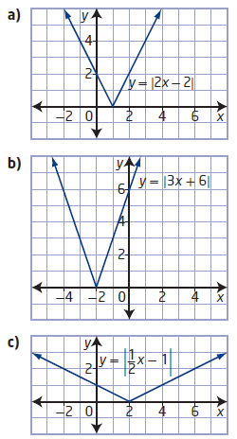
Pg 375#10: What piecewise function could you use to represent each graph of an absolute value function?
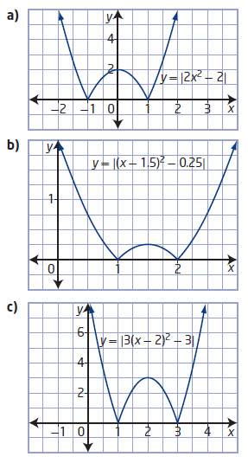

Pg 375#13: Consider the function $g\left(x\right)=\left|x^{2}-2x-8\right|$.
- What are the y-intercept and x-intercepts of the graph of the function?

- Graph the function.

- What are the domain and range of g(x)?

- Express the function as a piecewise function.

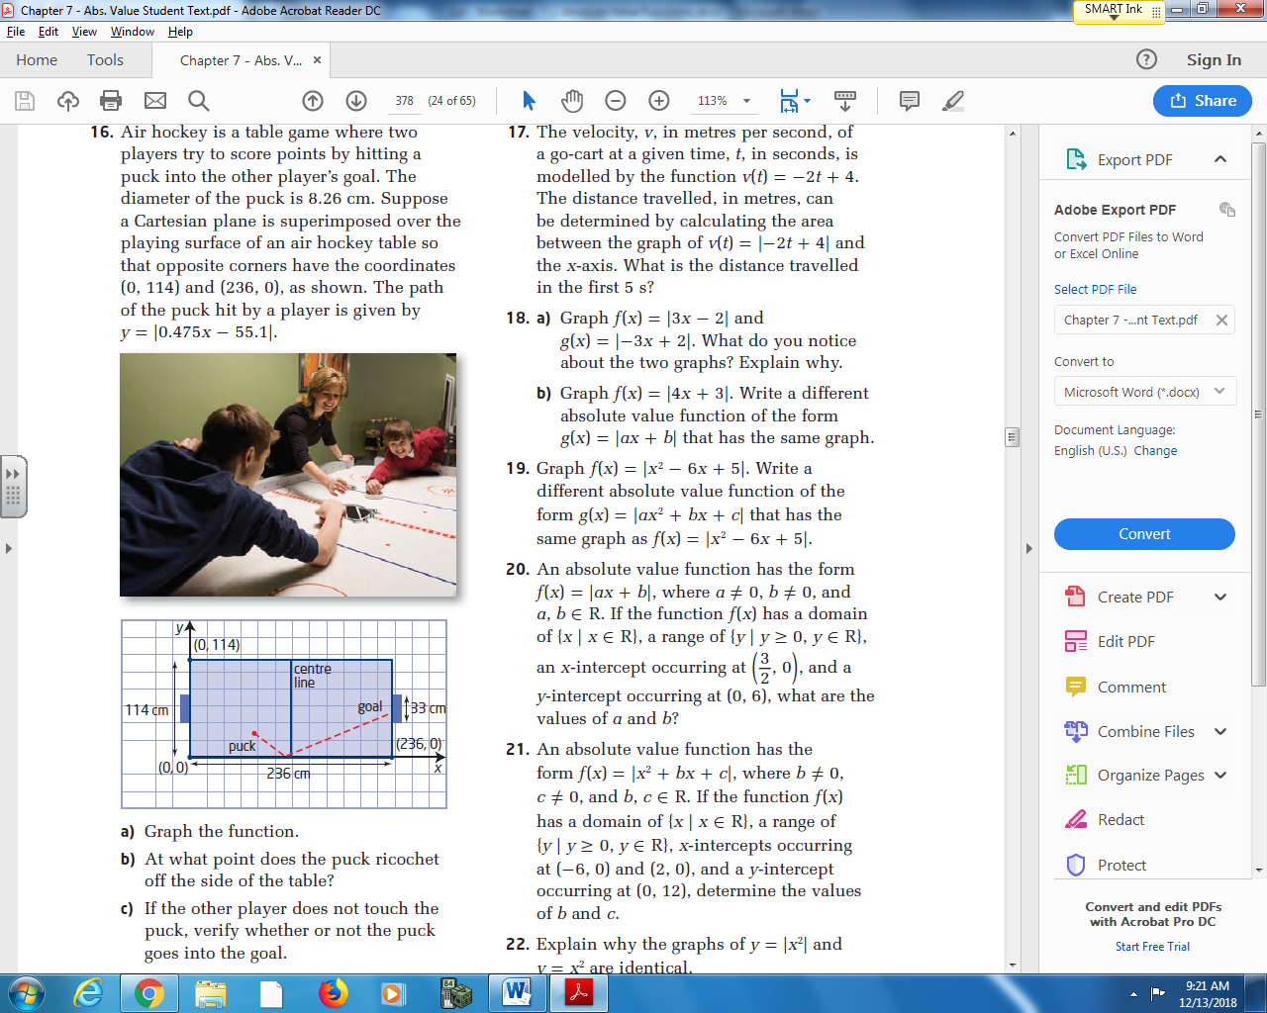
Pg 375#16: Air hockey is a table game where two players try to score points by hitting a puck into the other player’s goal. The diameter of the puck is 8.26cm. Suppose a Cartesian plane is superimposed over the playing surface of an air hockey table so that opposite corners have the coordinates (0,114) and (236,0), as shown. The path of the puck hit by a player is given by $y=\left|0.475x-55.1\right|$.
This is not an accurate representation of the function.
- Graph the function.
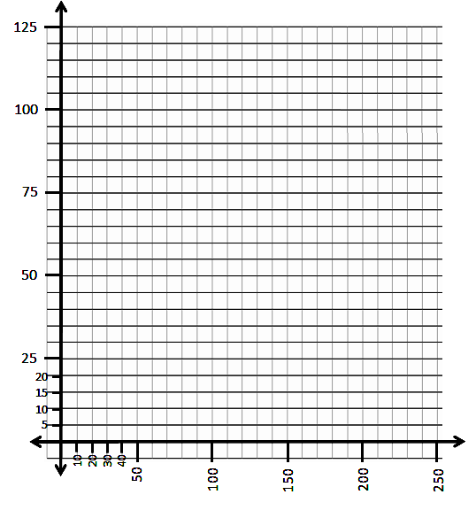

- At what point does the puck ricochet off the side of the table?

- If the other player does not touch the puck, verify whether or not the puck goes into the goal.

