L43 – FQ – 7.2 Absolute Value Functions
Q1: Evaluate each of the following: (1/2 mark each; 2 marks total)
$\left|-3^{2}\right|$ $\left|2-8\right|-10$ $2\left|5-3^{2}\right|+2$ ${\left(2-\left|7-3\right|\right)}^{3}$

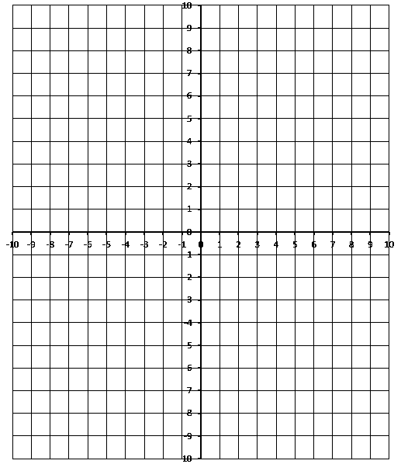
Q2: Sketch the function (1 mark)
$$f\left(x\right)=\left|x^{2}+3x-4\right|$$

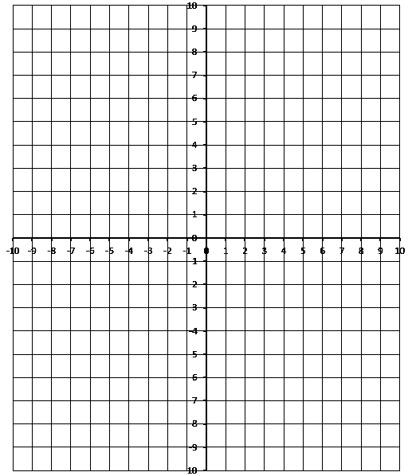
Q3: Sketch the function (1 mark)
$$f\left(x\right)=\left|{-x}^{2}+4x-6\right|$$

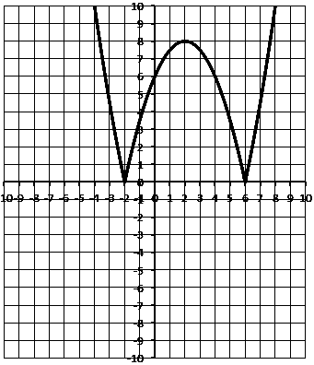
Q4: Write the piecewise function for the graph represented. (2 marks)

MARKING:
Beginning 0.0 – 2.5
Progressing 3.0 – 4.0
Competent 4.5 – 5.5
Exemplary 6.0

