L43 – 7.3 Absolute Value Equations
Key Ideas
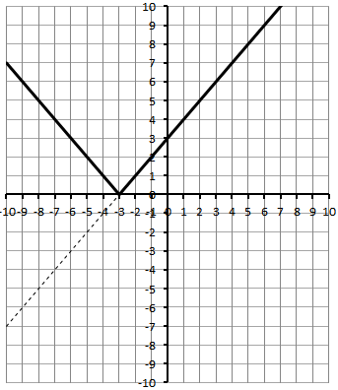
To solve Absolute Value Equations (i.e. $\left|x+3\right|=6$ )…
…By Graphing…
- Graph the left side (i.e. $y=|x+3|$ )
- Graph the right side (i.e. $y=6$ )
- Find any points that the lines intersect using 2nd – CALC – Intersect on your calculator.
…Algebraically…
- Consider the two separate cases, corresponding to the two points of the piecewise function.
  - $\left|x+3\right|=\left\{\begin{aligned}x+3, if x≥-3 \\ -x-3, if x<-3\end{aligned}\right.$
  - $x+3=6 and -x-3=6$
  - Solve for roots (the points where the two lines cross when graphing).
  - Verify the roots by substitution of the value into the original equation.
  - Any roots that do not satisfy the original equation are referred to as Extraneous Roots.
Any Absolute Value equation of the form $\left|f\left(x\right)\right|=a$, where $a<0$, has no solution since by definition $|f\left(x\right)|≥0$.
Part 1 – Easy Absolute Value Equations
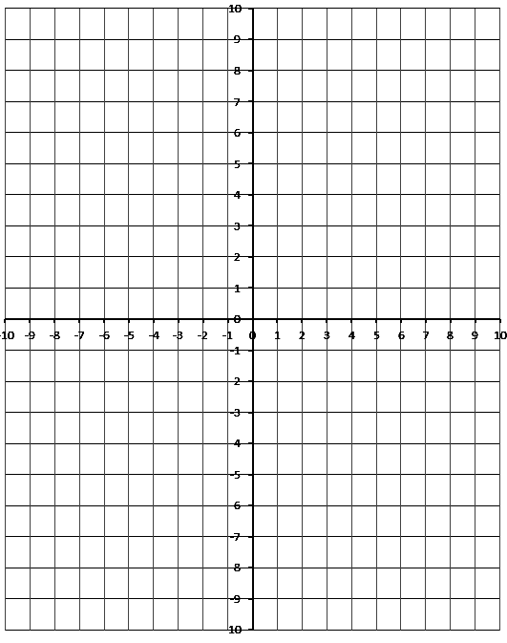
Q1: Solve $\left|x+4\right|=2$

Q2: Solve $\left|-\frac{1}{2}x-1\right|=3$

Q3: Solve $\left|x-6\right|+2=0$

Part 2 – Harder Absolute Value Equations
Q4: Solve $\left|x^{2}+4x-6\right|=6$

Q5: Solve $\left|-\frac{1}{2}x^{2}+2x+2\right|=x-2$

Q6: Solve $\left|-x^{2}+4x+5\right|=-x^{2}-6x-1$

