L43 – Linear Relations Activity
Purpose: Students will investigate three different stations, collect data and graph it. They will then build the equation in Slope y-Intercept Form and answer several questions about the station.
Location: Biology lab, Hallway (between labs), and Physics lab

Station #1 – Marbles and Water
Location: Biology Lab
Step #1: Fill a 100mL graduated cylinder with tap water to exactly 60mL.
Step #2: Add a pair of marbles. Record the new height of the water.
Step #3: Continue to add marbles, recording the height after each pair is added. Stop when either
- the marbles stick out of the water,
- the water reaches over 100mL, or
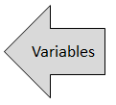
- you’ve successfully added 20 marbles.

Number of Marbles | Water Level in mL
0
2
4
6
8
10
12
14
16
18
20
Q1: Using your variables, complete the following sentence:
____________________ depends on _____________________.
Dependent Variable Independent Variable
Station #1 – Marbles and Water
Q2: Graph your data in the chart below:
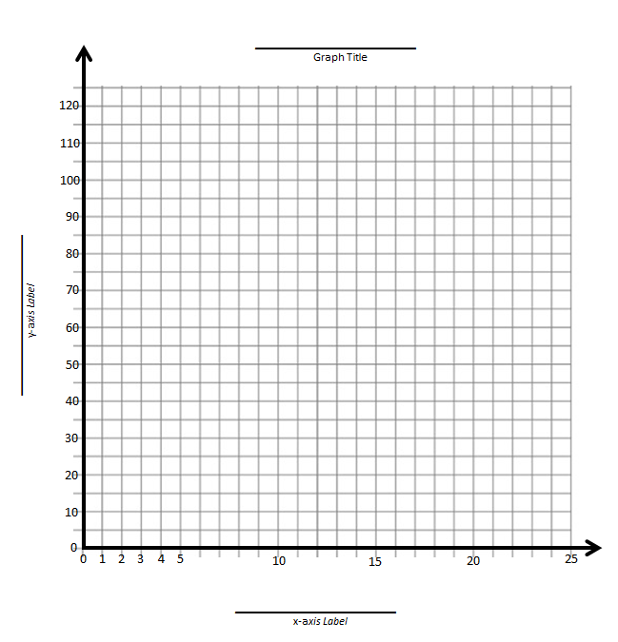
Q3: Is the graph linear? Yes / No Q4: Is the graph a function? Yes / No

Q5: Write the equation of the line in Slope y-Intercept form.

Q6: State the Domain and Range using Set Notation.
Station #2 – Bouncy Ball
Location: Hallway
Step #1: Using paper tape, roll a 2 meter tall vertical line onto the wall. Mark the heights indicated on the table below.
Step #2: Before timing, do a “practice bounce” at each height so you know where the maximum height after bounce is.
Step #3: Measure the time it takes to fall and bounce back to maximum height. Do this twice (Trial #1 and Trial #2).
Step #4: Average these two trial values (add together and divide by 2). Record this in the table below.

 | Time to fall and bounce back to maximum height (seconds)
Height off ground (cm) | Trial #1 | Trial #2 | Average time to bounce back to maximum height (seconds)
25
50
75
100
125
150
175
200

Q1: Using your variables, complete the following sentence:
____________________ depends on _____________________.
Dependent Variable Independent Variable

Station #2 – Bouncy Ball
Q2: Graph your data in the chart below:
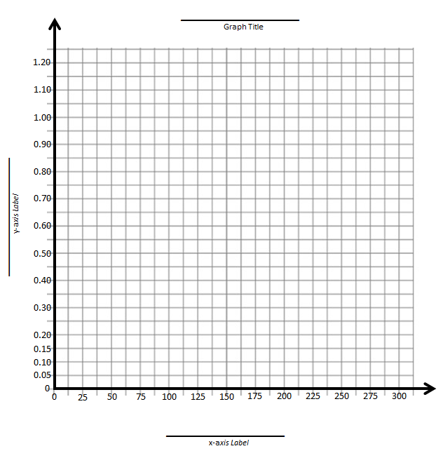

Q3: Is the graph linear? Yes / No Q4: Is the graph a function? Yes / No

Station #3 – Hanging Masses and Force Scales
Location: Physics Lab
Step #1: Grab a cylindrical Force Scale (red or yellow) and rotate the white bolt until the scale reads “0 N” on the side with the white text when hanging without any weights. Check with the teacher to make sure you’ve done this correctly.
Step #2: Hang a single mass from the Force Scale. Record how many “Newtons” of force the scale is reading in the table below.
Step #3: Continue to hang masses until you have filled in the table below. HINT: You can hang additional masses off of the bottom of others.

Hanging mass (g) | Force (N)
0
50
100
200
500
750
1000
1250
1500
Q1: Using your variables, complete the following sentence:
____________________ depends on _____________________.
Dependent Variable Independent Variable

Station #3 – Hanging Masses and Force Scales
Q2: Graph your data in the chart below:
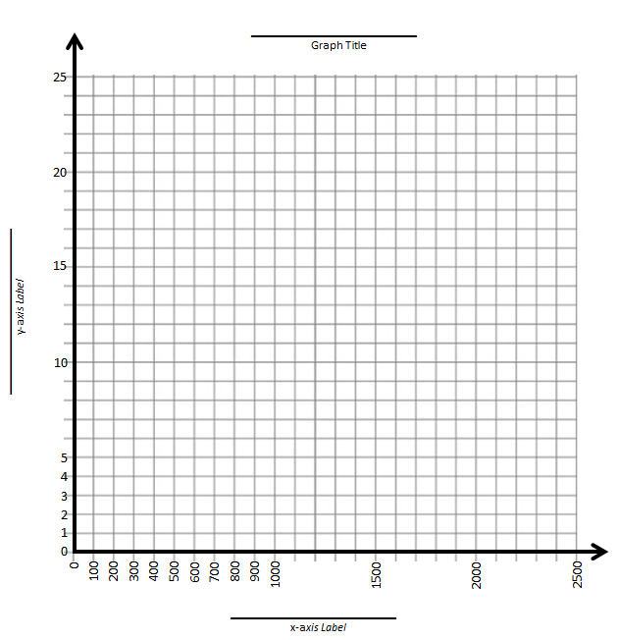
Q3: Is the graph linear? Yes / No Q4: Is the graph a function? Yes / No

Q5: Write the equation of the line in Slope y-Intercept form.

Q6: State the Domain and Range using Set Notation.

