L43 – Worksheet – 7.3 Absolute Value Equations
Part 1 – Overview
Be aware that even if your quadratic has multiple solutions, you need to verify all of them.
$\left|2x\right|={0.5x}^{2}+1$ $\left|2x-1\right|={0.5x}^{2}+1$ $\left|2x\right|{=x}^{2}+1$
has 4 solutions. has 3 solutions. has 2 solutions.
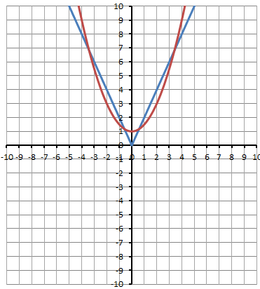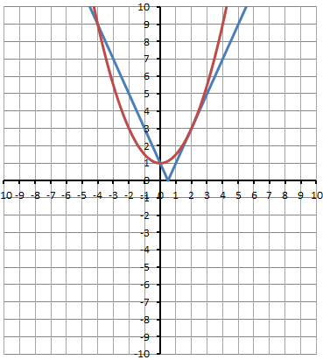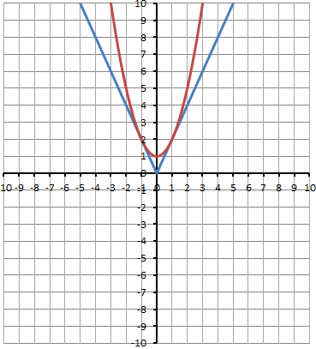
Part 2 – Overview
Q1: Given $x^{2}+12x+24=\left|2x\right|$
- Solve the equation algebraically.

- Using technology, solve the equation graphically.
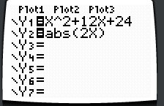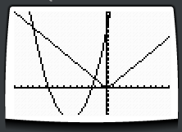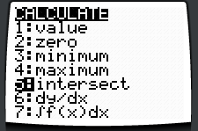
X: -15 → 10 (-2,4)
Y: -10 → 30 (-12,24)
Part 3 – Textbook Questions
Pg 389 #2ab: Solve each absolute value equation by graphing.
$\left|x-4\right|=10$ $\left|x+3\right|=2$

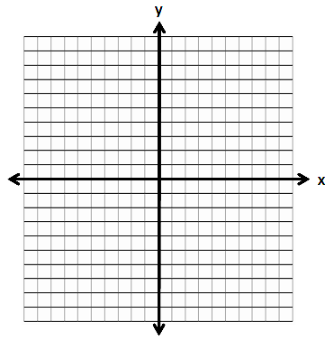
Pg 389 #2cd: Solve each absolute value equation by graphing.
$6=\left|x+8\right|$ $\left|x+9\right|=-3$

Pg 389 #3ab: Determine an absolute value equation in the form $\left|ax+b\right|=c$ given its solutions on the number line.
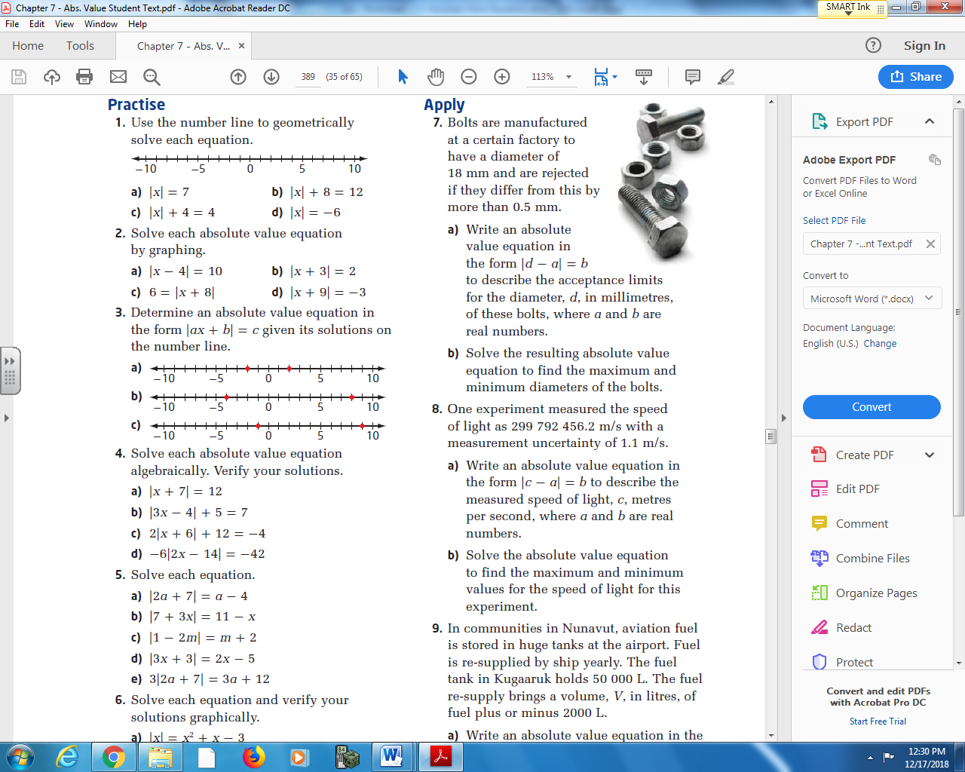

Pg 389 #4ab: Solve each absolute value equation algebraically. Verify your solutions.
$\left|x+7\right|=12$ $\left|3x-4\right|+5=7$

Pg 389 #4cd: Solve each absolute value equation algebraically. Verify your solutions.
$2\left|x+6\right|+12=-4$ $-6\left|2x-14\right|=-42$

Pg 389 #5ab: Solve each equation.
$\left|2a+7\right|=a-4$ $\left|7+3x\right|=11-x$

Pg 389 #5cd: Solve each equation.
$\left|1-2m\right|=m+2$ $\left|3x+3\right|=2x-5$

Pg 389 #6ab: Solve each equation and verify your solutions graphically.
$\left|x\right|=x^{2}+x-3$ $\left|x^{2}-2x+2\right|=3x-4$

Pg 389 #6cd: Solve each equation and verify your solutions graphically.
$\left|x^{2}-9\right|=x^{2}-9$ $\left|x^{2}-1\right|=x$

Pg 389 #8: One experiment measured the speed of light as 299,792,456.2 m/s with a measurement uncertainty of 1.1 m/s.
- Write an absolute value equation in the form $\left|c-a\right|=b$ to describe the measured speed of light, c, in meters per second, where a and b are real numbers.
- Solve the absolute value equation to find the maximum and minimum values for the speed of light for this experiment.

Pg 389 #10: Consider the statement $x=7±4.8.$
- Describe the values of x.
- Translate the statement into an equation involving absolute value.

Pg 389 #14: Solve each equation for x, where a, b, c ƐR.
$\left|ax\right|-b=c$ $\left|x-b\right|=c$

