L44 – FQ – 7.3 Basics of Absolute Value Equations
We’re going to solve the equation $\left|x^{2}+2x-2\right|={-x}^{2}+4x+2$
Q1: Graph the following: Q2: Graph the following:
$y=x^{2}+2x-2$ $y={-x}^{2}-2x+2$
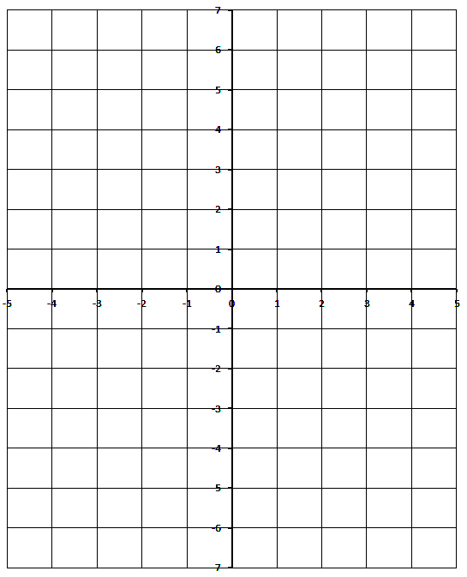
$y=-x^{2}+4x+2$ $y=-x^{2}+4x+2$

Q3: Graph the following:
$$y=\left|x^{2}+2x-2\right|$$
$$y=-x^{2}+4x+2$$

