L44 – Worksheet – Review of Absolute Values
Part 1 – 7.1 Absolute Value
Q1: Evaluate the following expressions:
$|-3+2|$ $\left|5-9\right|+2$ $6-2\left|4-3^{2}\right|$ $9+\left|2^{3}-5\right|+1$

Part 2 – 7.2 Absolute Value Functions
Q2: Graph $y=\left|x+2\right|$
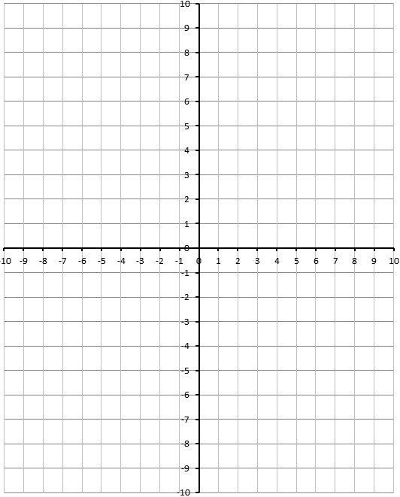

Q3: Graph $y=\left|x^{2}-4x-5\right|$
Q4: Graph $y=\left|\frac{1}{2}{(x+4)}^{2}-2\right|$
Q5: Write the piecewise function to describe the graph below.
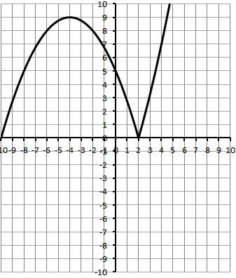

Part 3 – 7.3 Absolute Value Equations
Q6: Solve $\left|x^{2}+2x-3\right|=5$ algebraically. Verify your answers. Confirm by graphing.

Q7: Solve $\left|2x-8\right|=-2x^{2}+6x+2$ algebraically. Verify your answers. Confirm by graphing.

Q8: Solve $\left|x^{2}-8\right|=x^{2}+x+2$ algebraically. Verify your answers. Confirm by graphing.

