L45 – 7.4 Reciprocal Functions
Key Ideas
If $y=f(x)$, then the inverse function is $y=\frac{1}{f(x)}$ .
Important Points:
- Where the original function has $y=0$, the new function has a “Non-Permissible Value”, and there is a vertical asymptote.
- Where the original function has $y=±1$, the new function has $y=±1$. This is referred to as a “Invariant Point”.
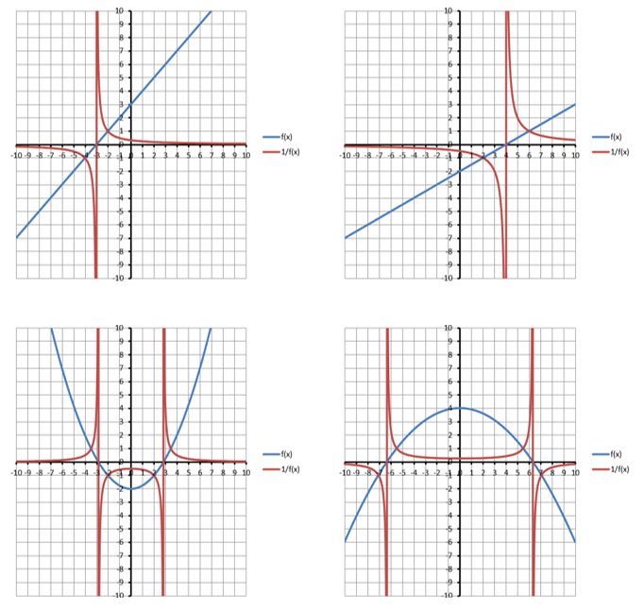
Part 1 – Reciprocal Functions of Linear Functions
Q1: Given the function $f(x)=x$
- Build a table for $y=f(x)$ and $y=\frac{1}{f(x)}$ .
$$x$$ | $$y=f(x)$$ | $$y=\frac{1}{f(x)}$$
-3
-2
-1
0
1
2
3

- Sketch both functions on the graph paper.
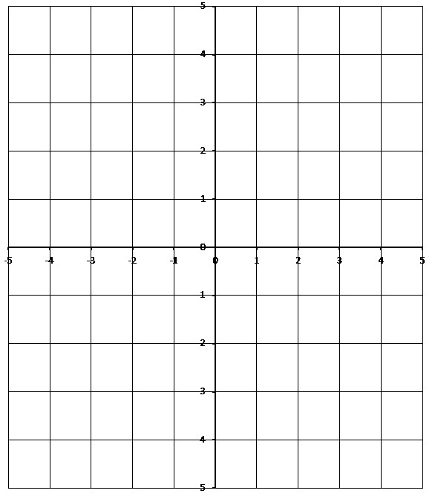

- Identify (a) the NPV’s for the reciprocal function, (b) the equation of the vertical asymptote of the reciprocal function, (c) the Invariant Point(s).
Q2: Given the function $f(x)=x$ (again)
- Build a table for $y=f(x)$ and $y=\frac{1}{f(x)}$ .
$$x$$ | $$y=f(x)$$ | $$y=\frac{1}{f(x)}$$ |  | $$x$$ | $$y=f(x)$$ | $$y=\frac{1}{f(x)}$$
-1.0 |  |  |  | 0.2
-0.8 |  |  |  | 0.4
-0.6 |  |  |  | 0.6
-0.4 |  |  |  | 0.8
-0.2 |  |  |  | 1.0
0

- Sketch both functions on the graph paper.
Q3: Given the function $f\left(x\right)=2x+1$
- Build a table for $y=f(x)$ and $y=\frac{1}{f(x)}$ .
$$x$$ | $$y=f(x)$$ | $$y=\frac{1}{f(x)}$$
-3
-2
-1
0
1
2
3

- Sketch both functions on the graph paper.

- Identify (a) the NPV’s for the reciprocal function, (b) the equation of the vertical asymptote of the reciprocal function, (c) the Invariant Point(s).

Q4: Determine the equation of the function shown:
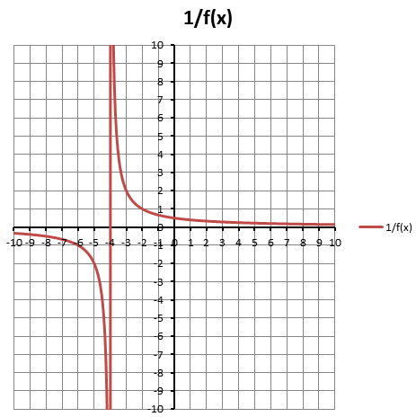

Q5: Given the function $f\left(x\right)=x^{2}+2x-3$
- Write the Reciprocal Function
- Determine the Non-Permissible Values
- Determine the equation of the vertical asymptote(s)
- Graph the Reciprocal Function

