L45 – Worksheet – 7.4 Reciprocal Functions
Part 1 – Textbook Questions
Pg 403 #1: Given the function $y=f(x)$, write the corresponding reciprocal function.
$y=-x+2$ $y=3x-5$ $y=x^{2}-9$ $y=x^{2}-7x+10$

Pg 403 #2: Complete the table:
 | State the zeroes. | Write the reciprocal function. | State the non-permissible values fo the corresponding rational expression. | Explain how the zeroes of the original function are related to the non-permissible values of the reciprocal function. | State the equation(s) of the vertical asymptote(s).
$$f\left(x\right)=x+5$$
$$g\left(x\right)=2x+1$$
$$h\left(x\right)=x^{2}-16$$
$$t\left(x\right)=x^{2}+x-12$$
Pg 403 #3ab: State the equation(s) of the vertical asymptote(s) for each function.
$f\left(x\right)=\frac{1}{5x-10}$ $f\left(x\right)=\frac{1}{3x+7}$

Pg 403 #3cd: State the equation(s) of the vertical asymptote(s) for each function.
$f\left(x\right)=\frac{1}{(x-2)(x+4)}$ $f\left(x\right)=\frac{1}{x^{2}-9x+20}$

Pg 403 #5ab: What are they x-intercept(s) and the y-intercept of each function?
$f\left(x\right)=\frac{1}{x+5}$ $f\left(x\right)=\frac{1}{3x-4}$

Pg 403 #5ab: What are they x-intercept(s) and the y-intercept of each function?
$f\left(x\right)=\frac{1}{x^{2}-9}$ $f\left(x\right)=\frac{1}{x^{2}+7x+12}$

Pg 403 #7ab: Sketch the graphs of $y=f(x)$ and $y=\frac{1}{f(x)}$ on the same set of axes. Label the asymptotes, the invariant points, and the intercepts.
$f\left(x\right)=x-4$ $f\left(x\right)=2x+4$
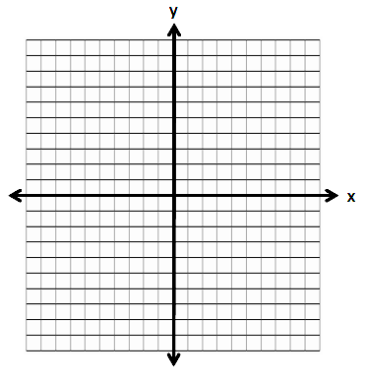

Pg 403 #7cd: Sketch the graphs of $y=f(x)$ and $y=\frac{1}{f(x)}$ on the same set of axes. Label the asymptotes, the invariant points, and the intercepts.
$f\left(x\right)=2x-6$ $f\left(x\right)=x-1$

Pg 403 #8ab: Sketch the graphs of $y=f(x)$ and $y=\frac{1}{f(x)}$ on the same set of axes. Label the asymptotes, the invariant points, and the intercepts.
$f\left(x\right)=x^{2}-16$ $f\left(x\right)=x^{2}-2x-8$

Pg 403 #8cd: Sketch the graphs of $y=f(x)$ and $y=\frac{1}{f(x)}$ on the same set of axes. Label the asymptotes, the invariant points, and the intercepts.
$f\left(x\right)=x^{2}-x-2$ $f\left(x\right)=x^{2}+2$

Pg 403 #9: Match the graph of the function with the graph of its reciprocal.
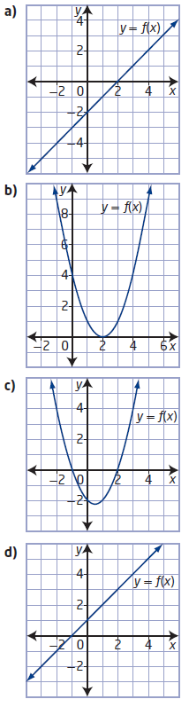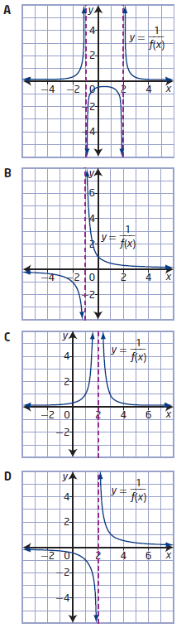

Pg 403 #10a: The following is a graph of a reciprocal function, $y=\frac{1}{f(x)}$.
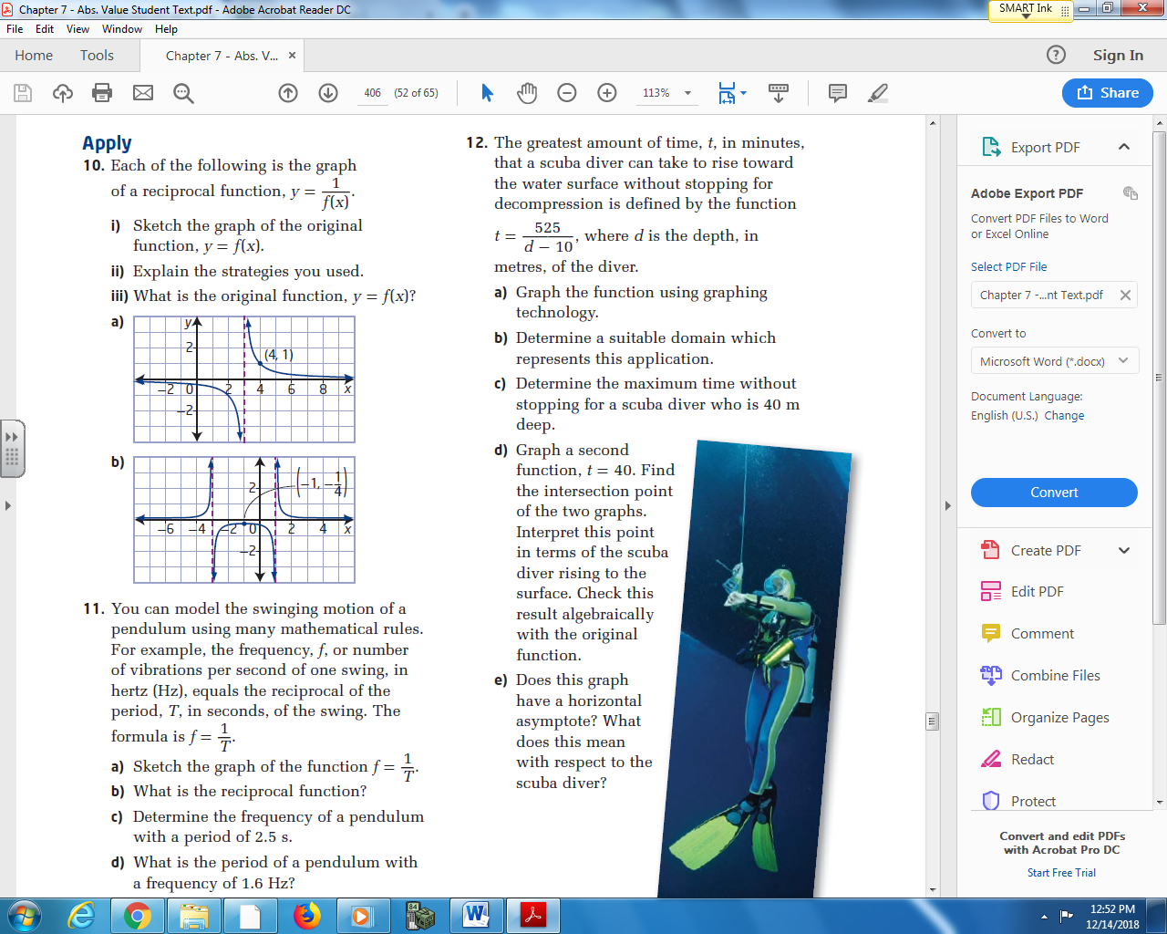
- Sketch the graph of the original function, $y=f(x)$.
- Explain the strategies you used.

- What is the original function, $y=f(x)$?

Pg 403 #10b: The following is a graph of a reciprocal function, $y=\frac{1}{f(x)}$.
- Sketch the graph of the original function, $y=f(x)$.
- Explain the strategies you used.

- What is the original function, $y=f(x)$?

Pg 403 #12: The greatest amount of time, t, in minutes, that a scuba diver can take to rise toward the water surface without stopping for decompression is defined by the function $=\frac{525}{d-10}$ , where d is the depth, in meters, of the diver.
- Graph the function using graphing technology.

- Determine a suitable domain which represents this application.

- Determine the maximum time without stopping for a scuba diver who is 40m deep.

- Graph a second function, t = 40. Find the intersection point of the two graphs. Interpret this point in terms of the scuba diver rising to the surface. Check this result algebraically with the original function.

- Does this graph have a horizontal asymptote? What does this mean with respect to the diver?

