First Name:______________________________ Last Name:______________________________

L46 – Cumulative Review Worksheet

Part 1: Chapter 4 Radicals (Number Competency)
Use the following information to answer Q1-Q2:
The number 2025 can be prime factored to determine if it is a perfect square, a perfect cube, both, or neither.

Q1: The number 2025 can be prime factored to the form $a^{b}c^{d}$, where a, b, c, and d are ___, ___, ___, and ___.
(Record your four digit answer in the Numerical Response boxes below)

Q2: The number 2025 is
- A perfect square
- A perfect cube
- Both
- Neither

Q3: The expression $\frac{{10x}^{4}y^{-6}z^{5}}{25x^{3}z^{-3}}$ can be simplified to the form $\frac{2x^{a}z^{c}}{5y^{b}}$ , where a, b, and c are ___, ___, and ___.
(Record your three digit answer in the Numerical Response boxes below)

Q4: The expression $\frac{{\left(x^{\frac{1}{2}}\right)}^{\frac{4}{3}}}{x^{-\frac{1}{4}}}$ can be written as $x^{\frac{ab}{cd}}$ , where a, b, c, and d are ___, ___, ___, and ___.
(Record your four digit answer in the Numerical Response boxes below)

Use the following information to answer Q5:
As a New Year’s resolution, Bob decides he is going to do 1 sit-up on “Day 0” of his workout journey, and double this amount every day.

Q5: How many situps does Bob do on Day 10?
(Record your four digit answer in the Numerical Response boxes below)

Q6: The entire radical $\sqrt[3]{24x^{5}y^{2}z^{6}}$ can be written as a mixed radical in the form $2xz^{a} \sqrt[3]{3x^{b}y^{c}}$ , where a, b, and c are ___, ___, and ___.
(Record your three digit answer in the Numerical Response boxes below)

Q7: The mixed radical $5x^{2}\sqrt{3x}$ can be written as an entire radical in the form $\sqrt{abx^{c}}$ , where a, b, and c are ___, ___, and ___.
(Record your three digit answer in the Numerical Response boxes below)

Q8: The expression $5^{\frac{1}{2}}x^{2} \sqrt[3]{{5x}^{2}}$ can be written as a simplified power in the form $5^{\frac{a}{b}}x^{\frac{c}{d}}$ , where a, b, c, and d are ___, ___, ___, and ___.
(Record your four digit answer in the Numerical Response boxes below)

Part 2: Chapter 5 Polynomials (Algebra Competency)
Use the following information to answer Q9-Q12:
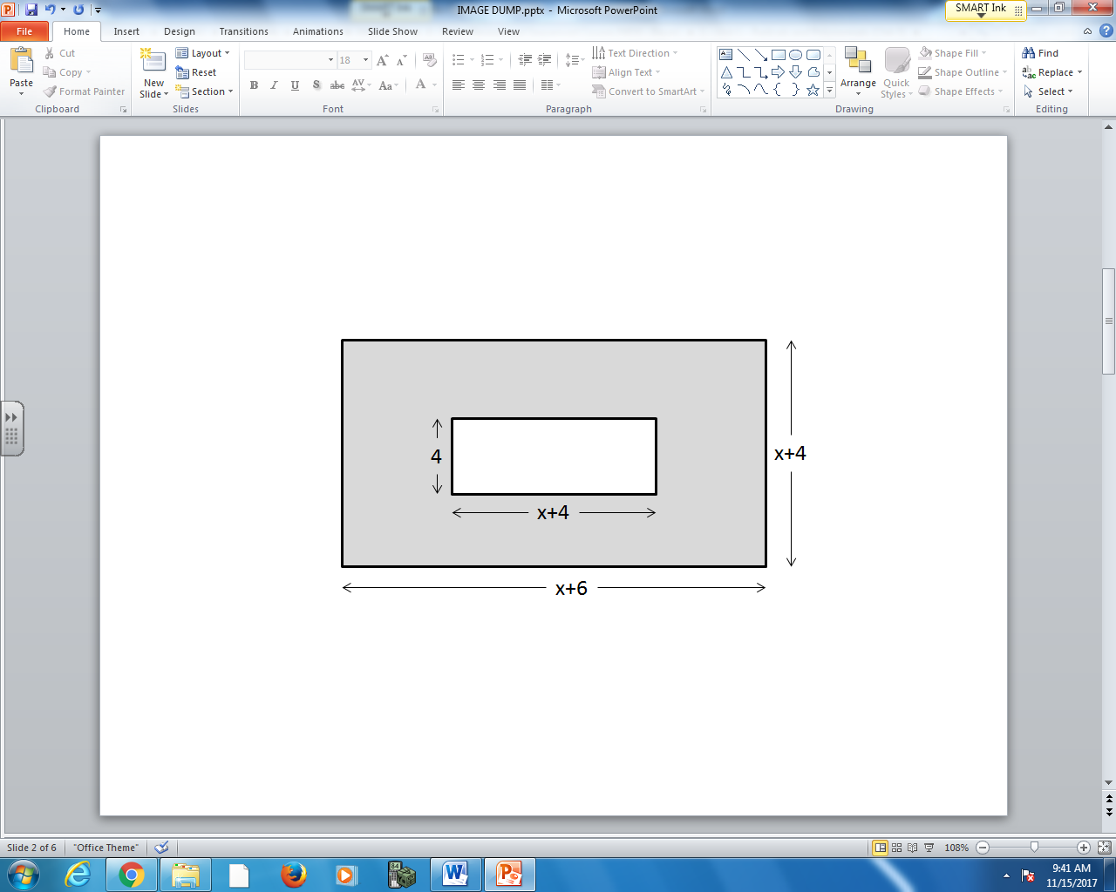

Q9: The perimeter of the larger rectangle is $x+bc$ , where a, b, and c is ___, ___, and ___.
(Record your three digit answer in the Numerical Response boxes below)

Q10: The area of the larger rectangle is $x^{2}+dex+fg$ , where d, e, f, and g are ___, ___, ___, and ___.
(Record your four digit answer in the Numerical Response boxes below)

Use the following information to answer Q9-Q12:

Q11: The area of the smaller rectangle is $x+ij$ , where h, i, and j are ___, ___, and ___.
(Record your three digit answer in the Numerical Response boxes below)

Q12: The area of the shaded region, in factored form, is $\left(x+a\right)\left(x+b\right)$ , where a and b are ___ and ___.
(Record your two digit answer in the Numerical Response boxes below)

Part 3: Chapter 6 Linear Relations (Algebra and Graphing Competencies)
Use the following information to answer Q13-Q14:
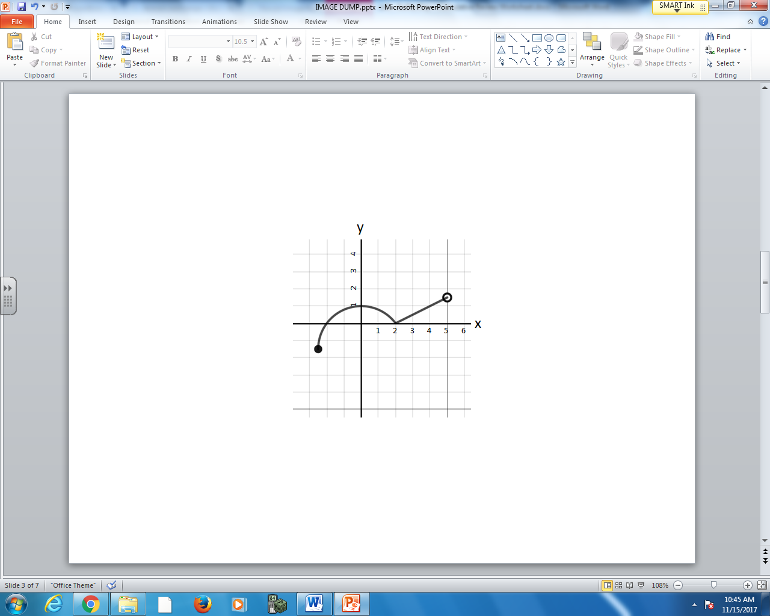

Q13: (Short Answer) Write the Domain in Set Notation. (1 mark)

Q14: (Short Answer) Write the Range in Interval Notation. (1 mark)

Q15: (Long Answer) A line connects the points (-4,6) and (5,4). Calculate the slope of the line. (2 marks)

Use the following information to answer Q16-Q18:
$f\left(x\right)=x^{2}-1$ $g\left(x\right)=-3x+2$

Q16: f(4) =
(Record your two digit answer in the Numerical Response boxes below)

Q17: g(-5)=
(Record your two digit answer in the Numerical Response boxes below)

Q18: (Long Answer) If g(x)=8, x=? (2 marks)

