L46 – Worksheet – Absolute Values and Reciprocal Functions
Part 1 – 7.1 Absolute Value
Q1: Evaluate the following expressions:
$|9-3|$ $\left|5-11\right|+4$ $9-3\left|9-5^{2}\right|$

Q2: The expression $6-\left|7-3^{2}\right|$ evaluates to _____.
(Record your answer in the Numerical Response boxes below)

Part 2 – 7.2 Absolute Value Functions
Q3: Graph $y=\left|x-3\right|$
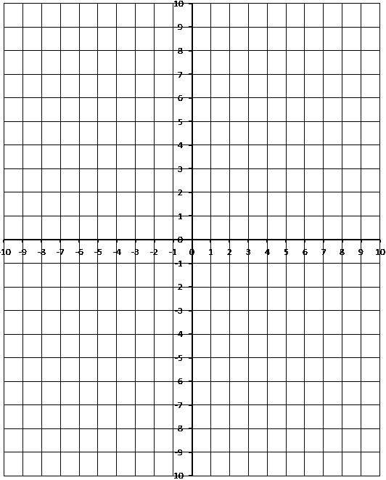
Use the following information to answer Q4:
A absolute value function is graphed below:
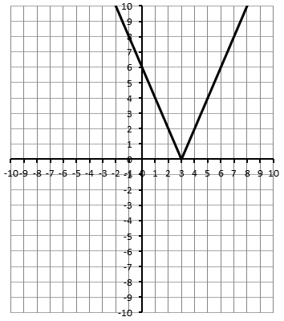

Q4: A piecewise function can be written for this function as
$$f\left(x\right)=\left\{\begin{aligned}-ax+b, &x<3 \\ cx-d, &x≥3\end{aligned}\right.$$
Where a, b, c, and d are ___, ___, ___, and ___.
(Record your four digit answer in the Numerical Response boxes below)

Use the following information to answer Q5:
A absolute value function is graphed below:
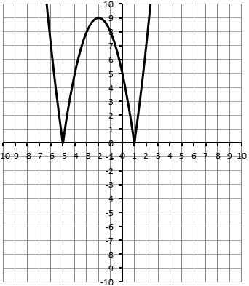

Q5: A piecewise function can be written for this function as
$$f\left(x\right)=\left\{\begin{aligned}a{(x+b)}^{2}-c, &x<-5, x>1 \\ -a{\left(x+b\right)}^{2}+c, &-5≤x≤1\end{aligned}\right.$$
Where a, b, and c are ___, ___, ___, and ___.
(Record your three digit answer in the Numerical Response boxes below)

Part 3 – 7.3 Absolute Value Equations
Q6: Solve $\left|x^{2}+2x-8\right|=x+4$ algebraically. Verify your answers. Confirm by graphing.

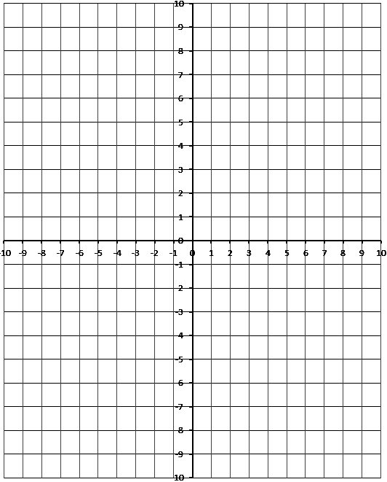
Part 4 – 7.4 Reciprocal Functions
Use the following information to answer Q7:
The graph below depicts an inverse function, $y=\frac{1}{f(x)}$
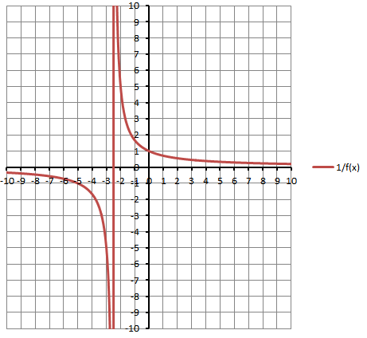

Q7: The original function can be written as $\left(x\right)=\frac{a}{b}x+c$ , where a, b, and c are ___, ___, and ___.
(Record your three digit answer in the Numerical Response boxes below)

Q8: If $\left(x\right)=-\frac{1}{2}x^{2}+2x$ , graph the reciprocal function $y=\frac{1}{f(x)}$
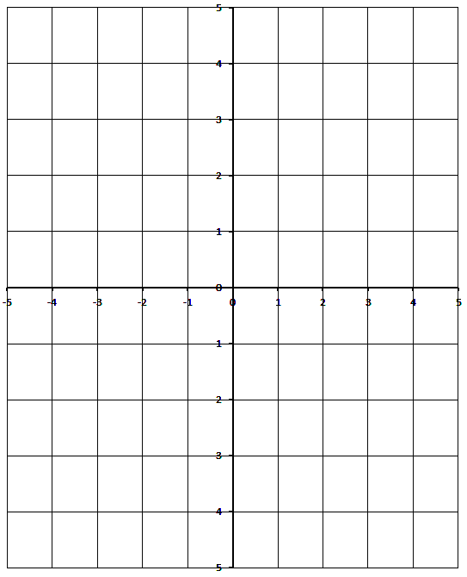

Q9: A student is building a table of values to graph a reciprocal function. Complete the table.
x | $$y=f(x)$$ | $$y=\frac{1}{f(x)}$$
0 | -8
1 | -5
2 | 0
3 | 7

