L47 – 8.1 Graphing Linear Systems of Equations
Part 1 – Graphing Slope y-Intercept Form (y=mx+b)
Q1: Graph the line $y=-\frac{3}{2}x+7$
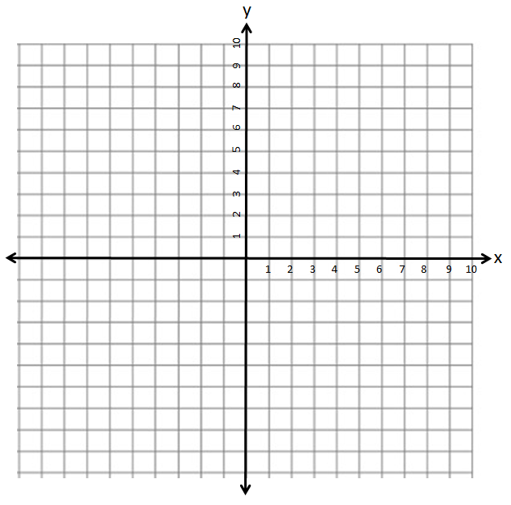
Part 2 – Graphing General Form (Ax+By+C=0)
Q2: Graph the line $4x-2y+16=0$

Part 3 – Graphing Slope-Point Form (y-y₁)=m(x-x₁)
Q3: Graph the line $\left(y-4\right)=\frac{1}{2}(x+6)$
Part 4 – Solutions to System of Equations
System of Linear Equations: Two or more linear equations involving common variables.
Solution(to a system of linear equations):
- A point of intersection of the lines on a graph.
- An ordered pair that satisfies both equations.
Q4: Given the lines $y=\frac{3}{4}x$ and $y=-2x+11$ , which of the following points is a solutionto the system of equations?
(4,3) (2,7)

Q5: Graph the lines $y=\frac{3}{4}x$ and $y=-2x+11$ to confirm the solution to the system of equations.
Q6: Graph the lines $\left(y-6\right)=-2(x+2)$ and $y=\frac{2}{3}x-6$ to determine the solution to the system of equations.
Q7: Graph the lines $2x+5y+10=0$ and $y=x-5$ to determine the solution to the system of equations.
Q8: Confirm your answer to Q7 by checking to see if the point exists on each line.

Q9: Graph the lines $\left(y-3\right)=-\frac{2}{3}(x-4)$ and $2x+3y-6=0$ to determine the solution to the system of equations.

Q10: Graph the lines $x-3y+3=0$ and $y=-3x+3$ to determine the solution to the system of equations.

Part 5 – Textbook Practice
Pg. 427 #6,7,8,10

