First Name:______________________________ Last Name:______________________________
L48 – FQ – 8.1 Graphing Linear Systems of Equations
Q1: Solve the system of equations by graphing on the grid below: (3 marks)
$y=x+1$ $y=-\frac{1}{3}x-3$

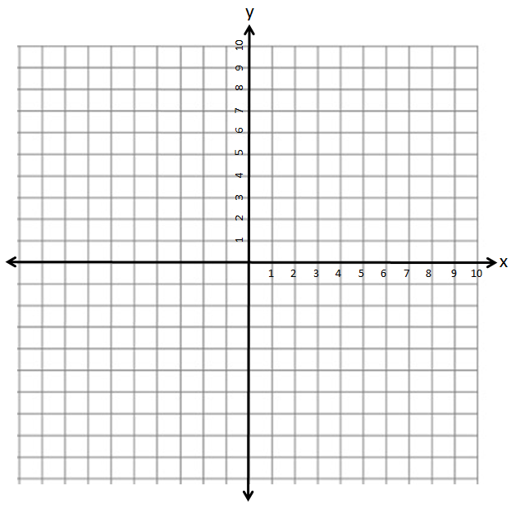
Q2: Solve the system of equations by graphing on the grid below: (3 marks)
$2x-1y+12=0$ $y=4$

MARKING:
Beginning 0.0 – 2.5
Progressing 3.0 – 4.0
Competent 4.5 – 5.5
Exemplary 6.0

